Text in red font are parts that require completing by the ABMC. Please replace text as required and format before submitting the plan.

Document Name: | Bushfire Risk Management Plan Template | Current version: | 2
Prepared by: | Strategic Operational Planning Unit & the Office of Bushfire Mitigation
 |  | Date of review | Version
Reviewed by: | Office of Bushfire Mitigation | January 2026 | 2
Authorised by: | Deputy Chief Officer Peter Hollier | February 2026 | 2

This template is maintained in electronic form, with the approved version available from the Office of Bushfire Mitigation (OBM) - Queensland Fire Department (QFD). It is the responsibility of the user to verify that this copy is the latest version.

Disclaimer
This plan is based on the best available information at the time of preparation and intended to guide coordinated bushfire risk mitigation within a Local Government Area (LGA). Bushfire risk and risk profiles are dynamic and may change due to seasonal conditions, land use, and emerging intelligence. While this plan aims to inform mitigation planning and support coordinated risk reduction, it does not eliminate all bushfire risk nor guarantee the protection of life, property or assets. Risk owners, land managers and community members remain responsible for implementing appropriate preparedness and mitigation measures. Information, data and assessments have been compiled in good faith.

Bushfire Risk Mitigation Plan (BRMP) Availability
For further information about this BRMP or the ABMC please contact:
<Name of ABMC Chair>, Chairperson for ABMC <LGA>
E: <insert email:>

<Update the table of contents at completion of the BRMP – delete this text when completed>
Contents
Bushfire Risk Mitigation Plan (BRMP) Availability 1
Bushfire Risk Mitigation Plan Status 3
Part 1: Introduction 4
1.1 Aim and purpose of the BRMP 4
1.2 Principles 4
1.3 BRMP objectives 4
Part 2: Governance 5
2.1 Roles and Responsibilities 5
Part 3: Bushfire Risk Mitigation Planning 7
Part 4: Bushfire Risk Treatment 8
4.1 Treatment register 8
4.2 Residual Risk 8
Part 5: Monitor and Review 9
5.1 Ongoing monitoring 9
ATTACHMENT A 11
ATTACHMENT B 1

Bushfire Risk Mitigation Plan Status

Date | Position | Status | Date of Review | Version number
 | ABMC Chair | Draft
 | ABMC Members (see Appendix A) | Endorsed
 | ABMC Chair | Approved
 | LDMG | Noted
 | DBC Chair | Provided
Next Review | <date>

This plan has been prepared by the ABMC <LGA>, informed by discussions at the ABMC meeting held at <Location>, and encompasses all land within the <LGA>. The BRMP has been developed with input from the ABMC to ensure a coordinated and informed approach to managing bushfire risk. This plan has been prepared with due consideration of the principles and priorities described in the Queensland Bushfire Plan, Queensland State Disaster Management Plan, and other key risk management standards and guidelines.
ABMC Chair Approval:
Name: <insert name>
Chair of ABMC <LGA>.
<insert signature>

Position:
Date:
Version Number:
Local Disaster Management Group (LDMG) Noted:
Name: <insert name>
Chair of LDMG <LGA>.
<insert signature>

Position:

Date:

Version Number:

Part 1: Introduction
Bushfire risk mitigation in Queensland involves a coordinated, risk-based approach delivered through partnerships between state agencies, local governments, landowners and managers, and communities. It is guided by the Queensland Bushfire Plan (QBP), which establishes the network of bushfire committees from the local area level through to district and state, ensuring structured governance and coordinated decision-making. These arrangements also compliment Queensland’s State Disaster Management Plan (QSDMP), ensuring bushfire management is consistent with the prevention, preparedness, response, and recovery (PPRR) principles.
Bushfire risk mitigation planning has been informed by risk management standards including the National Emergency Risk Assessment Guidelines (NERAG) and the Queensland Emergency Risk Management Framework (QERMF). It also considers findings and recommendations from numerous bushfire reviews across Queensland.
The development of Bushfire Risk Mitigation Plans (BRMPs) by Area Bushfire Management Committees (ABMCs) provide the mechanism for applying bushfire risk mitigation at the local area level. BRMPs ensure that bushfire risk is identified, assessed, and treated in a structured and coordinated manner, reflecting best-practice risk management principles.

1.1 Aim and purpose of the BRMP
The BRMP supports a structured, tenure-blind approach to identifying, assessing, prioritising, monitoring, and treating bushfire risk. The BRMP applies to bushfire risk management and mitigation activities within a Local Government Area (LGA) and aims to encompass all land tenures and assets identified as being at risk of bushfire, including public and private land, critical infrastructure, environmental assets, and community values.
The BRMP is informed by the priorities and intent of the Queensland Bushfire Plan (QBP), ensuring alignment with state-level strategies across the four phases of PPRR.

1.2 Principles
The preparation of the BRMP is guided by the principles outlined in the Queensland Bushfire Plan. These principles underpin the mindset and approach required to conduct effective bushfire risk mitigation.

1.3 BRMP objectives
The objectives of the BRMP are:
- Identify and assess bushfire hazards and vulnerabilities across all land tenures within the local government area using a tenure-blind, risk-based approach.
- Guide and prioritise bushfire mitigation activities through coordinated, cross-tenure, and multi-stakeholder planning to manage identified risks.
- Embed bushfire risk management within Queensland’s disaster management arrangements, ensuring alignment with LDMPs, LDMGs, and local operational plans.
- Support operational and long-term (1-3 year) planning and decision-making for ABMC members, partner organisations, and landowners and managers.
- Align with the QBP and broader PPRR strategies to ensure consistency and interoperability.
- Monitor, evaluate, and report on treatment strategies to ensure bushfire risk is managed to an acceptable level, driving continuous improvement in risk reduction.
- Finalise and submit the BRMP by 30 April each year to maintain currency and relevance, with submission to the relevant LDMG for noting.

Part 2: Governance

2.1 Roles and Responsibilities
All ABMC members share a collective responsibility for bushfire risk management and mitigation, as defined in the Terms of Reference (ToR). By contributing their expertise and local knowledge, members support the objectives of the BRMP and ensure that agreed responsibilities and expectations are met. Table 1 provides an overview of the roles and responsibilities within the ABMC structure. Further detail can be found in the ToR and Queensland Bushfire Plan.
Role | Responsibilities
ABMC | - Are the custodians of the BRMP for their LGA  - Coordinate the development, implementation, and review of the BRMP  - Provide the primary mechanism for coordinated risk assessment of bushfire risk, bushfire mitigation activities, and BRMPs for LGAs  - With support from RFSQ, undertake the bushfire risk assessment for their LGA and develop the treatment register to address unacceptable risks on managed land  - Base assessments and treatments on information provided by those that manage significant land areas or critical assets  - Negotiate and encourage commitments from risk owners to implement identified treatments  - Identify any risk beyond the capacity or capability of the ABMC to manage and escalate to the District Bushfire Management Committee (DBMC)  - Engage with the Local Disaster Management Group (LDMG) to ensure the BRMP is aligned and integrated with other local disaster management plans and activities
ABMC Chair | - Ensure the ABMC and its members performs its responsibilities  - Coordinate the development and ongoing review of the BRMP  - Facilitate active participation from ABMC members in the scheduled review of the BRMP  - Facilitate the endorsement of the BRMP from ABMC members and aid in dispute resolution  - Approve the BRMP  - Report as required to the District Bushfire Management Committee (DBMC) on matters of concern.  - Liaise with the LDMG and put forward the BRMP for noting
ABMC Members | - Provide relevant data and information on the land, assets, or values they manage  - Contribute to the development and review of the BRMP  - Validate risk assessments using their knowledge of local conditions  - Provide advice on contextual risk data and appropriate treatment strategies  - Encourage responsibility for treatments on land or assets they own/manage  - Actively participate in monitoring and reporting on treatment progress
RFSQ (QFD) | - Facilitate and support the implementation of bushfire committees through the bushfire management arrangements  - OBM reports to the State Bushfire Committee and the Minister for Local Government and Water and Minister for Fire, Disaster Recovery and Volunteers on the state of bushfire risk in Queensland, including treatments applied  - District QFD staff support ABMCs by:  - Supporting and enabling land managers and owners on the management of bushfire risk within the LGAs.
Table 1 Roles and responsibilities of the ABMC and BRMP planning process
2.2 Endorsement and noting of completed BRMP
A BRMP is in effect once it is endorsed by the ABMC. Endorsement confirms that the BRMP meets the required standard and that it is a clear, accountable basis for implementation. It is also required that the endorsed BRMP be formally noted by the LDMG to ensure integration with broader disaster management arrangements.
Draft submission and review
Endorsement by ABMC
Noting by LDMG
Publishing the BRMP
The ABMC Chair submits the draft to the ABMC members for review.
ABMC review and provide any feedback
Once all relevant feedback has been reviewed and implemented, the ABMC then formally endorse the plan
The endorsed BRMP is submitted to the LDMG for noting and integrated as an annex into the LDMP
Endorsed BRMPs should be published online and promoted to the community.

Prior to endorsing the BRMP, the ABMC must ensure that:
- All sections of the BRMP template have been completed as required
- Relevant local knowledge and subject-matter expertise have been consulted, discussed and reflected in the BRMP
- Treatment priorities and planned activities are recorded and proportionate
- A minimum 12-month treatment schedule has been completed
- Engagement has occurred regarding the management of significant cultural and environmental assets (if relevant)

2.3 Submission and BRMP publication
The BRMP must be finalised and submitted to the District Bushfire Management Committee (DBMC) by 30 April each calendar year. A copy must also be provided to the LDMG for noting, ensuring the plan is recognised within local disaster management arrangements.

Part 3: Bushfire Risk Mitigation Planning
Bushfire risk mitigation planning follows the risk management cycle (Figure 1) and provided a structured and repeatable approach to ensure that bushfire risk is consistently assessed and managed across all land tenures within an LGA.
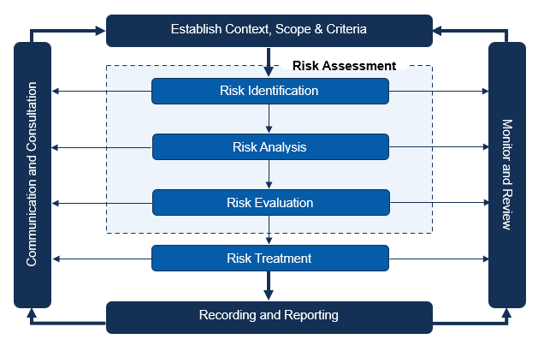

Figure 1 Risk Management process
3.1 Risk Assessment
The bushfire risk assessment approach within this plan aligns with and has been adapted from the Queensland Emergency Risk Management Framework (QERMF), as shown in Figure 2. QERMF provides a standardised and recognised method for hazard-based risk management

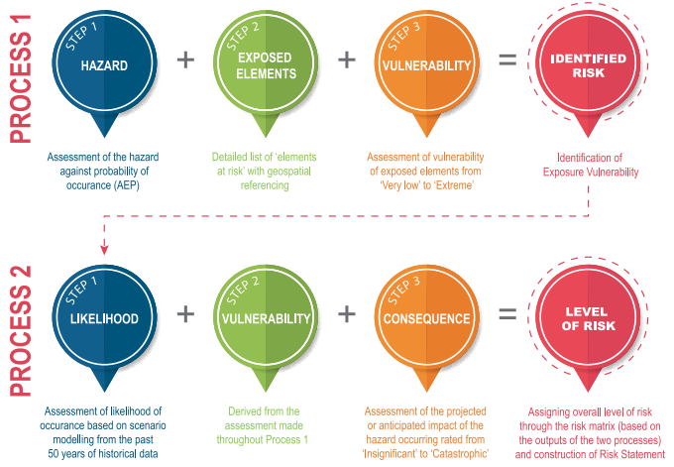

Figure 2 QERMF risk assessment approach

The bushfire risk assessments for this BRMP applies three key steps in line with the QERMF risk assessment approach:

Part 4: Bushfire Risk Treatment
Risk treatment is the process of determining and implementing the most effective actions to reduce bushfire risk. Treatments either remove or modify a risk source, strengthen existing controls, or improve the resilience of communities and assets so the overall level of risk is reduced.
This can be achieved by:
- Reducing the hazard (e.g., fuel management, ignition prevention)
- Modifying exposure and vulnerability (e.g., preparedness activities, infrastructure improvements, community education)
- Supporting more informed decision-making through planning and engagement
Risk treatments are recorded in the priority localities & planned activities table (ATTACHMENT B) provided in the BRMP template.

4.1 Treatment register
Every BRMP must include a Treatment Register listing agreed treatments for priority risks. The register must detail planned works for at least 12 months, with a three-year indicative schedule strongly encouraged. This enables:
- Sequencing treatments for greater effectiveness
- Time to secure approvals, permits, resourcing, and community support
- Tracking of risk reduction activities

4.2 Residual Risk
Residual risk is the level of risk remaining after agreed treatments and controls have been applied. While mitigation activities reduce risk, they rarely eliminate it entirely. Understanding and monitoring residual risk is essential to ensure treatments are effective and that risk owners and the ABMC maintain a realistic view of ongoing exposure.
Residual risk will be assessed once the Treatment Register has been finalised and endorsed by the ABMC. The outcomes of this assessment will inform ongoing monitoring and continuous improvement in the bushfire mitigation planning cycle.
Annual residual risk will be documented and submitted to the Local Disaster Management Group (LDMG) and District Bushfire Management Committee (DBMC) to support broader regional planning. It will also be incorporated into subsequent years of the mitigation planning cycle to ensure risk visibility is maintained over time.
Dashboard tools will be used to monitor progress against the Treatment Register and provide up-to-date reporting on the delivery of mitigation activities. As mitigation activities are completed and uploaded into the applicable technologies, systems will dynamically review and adjust the residual bushfire risk profile.
The information contained in residual risk reporting will inform pre-season bushfire readiness activities and regional residual risk assessments undertaken by RFSQ and other relevant agencies.

Part 5: Monitor and Review

5.1 Ongoing monitoring
ABMCs should monitor:
- The implementation of the BRMP and associated treatment register
- Emerging changes in bushfire risk (e.g., environmental, demographic, or land-use changes)
- The effectiveness of treatments, with lessons carried forward into future BRMP iterations


BRMP
Attachments

ATTACHMENT A

Membership of the ABMC <LGA>
Remove or add members as required in the below table.
Name of member | Role/Position | Organisation / Agency / Group
 | ABMC Chair | RFSQ

ATTACHMENT B

<LGA> Area Bushfire Management Committee priority localities & planned activities.
Locality Name | Locality Reference, Address or GPS Coordinate or Lot and Plan | Planned Mitigation Activity Type | Lead Agency | Detailed Information | Planned Mitigation Support agencies
e.g., Anstead | e.g., Hawkesbury Road & Mount Crosby Road | e.g., Hazard Reduction Burn | e.g., Queensland Parks and Wildlife Service | e.g., Hazard reduction burn in Queensland Parks and Wildlife managed estate and adjoining free hold properties to protect structures along Mount Crosby Road. Joint agency burn. | e.g., Rural Fire Service Queensland

Queensland Bushfire Plan Plans​ | Disasters | Queensland Government
State Disaster Management Plan Plans​ | Disasters | Queensland Government
Queensland Disaster Risk Management Risk | Disasters | Queensland Government

