**Airlie Beach Levy District**

The Queensland Fire Department helps protect persons, property and the environment through the continued delivery of emergency services, awareness programs, response capability and capacity, and incident response and recovery for a safer Queensland.

**Funding emergency services**

The Emergency Management Levy is the primary means of funding for the Queensland Fire Department.

The Emergency Management Levy is collected via council rates notices and enables the Queensland Fire Department to deliver emergency services to the community before, during and after emergency events.

The Emergency Management Levy applies to properties across the state with levy district boundaries reviewed and adjusted as required to ensure the levy charged matches the level of emergency services available.

When urban and industrial development expands, Emergency Management Levy boundaries or class changes may be required to ensure a fair levy contribution is made by all property owners receiving the benefit of those fire and emergency services.

**Fire and Rescue resources**

Due to the relocation and build of the newly constructed Airlie Beach Fire and Rescue Station on 13 September 2024, a review of the operational response areas for the permanently staffed fire and rescue stations located in the Whitsunday Regional Council area, was conducted and changes to the Queensland Fire Department levy districts are being made in accordance with the [*Fire Services Act 1990*](https://www.legislation.qld.gov.au/view/pdf/inforce/current/act-1990-010) and the [*Fire Services Regulation 2011*](https://www.legislation.qld.gov.au/view/pdf/inforce/current/sl-2011-0160).

Properties within the designated response area of a Fire and rescue station which is staffed by auxiliary firefighters and between five (5) and sixteen (16) permanent full time fire officers are required to pay a Class B levy.

Property owners adjacent to the Airlie Beach Levy District area currently pay a Class E levy and will be receiving the benefit of the Class B service. The correct Class B levy will commence from 1 July 2025.

Applying the correct levy class will ensure all residents continue to receive an appropriately funded and comprehensive fire and emergency service response and ensures that all similar properties contribute equally.

The existing rural fire brigades within these areas will continue to provide their vital and specialised services, with no change to their role. Through the Emergency Management Levy, the Queensland Fire Department in partnership with your local government will activate all necessary Queensland Fire Department resources when required.

**How much will my rates increase by?**

Properties included in the Airlie Beach Levy District are within the Whitsunday Regional Council area. The following table provides the increase of the Emergency Management Levy based on the 2024–25 financial year scheduled amounts.

|  |  |  |  |
| --- | --- | --- | --- |
| Category | Annual E Class Levy | Annual B Class Levy | Annual Increase |
| Residential Property | $ 119.00 | $ 193.00 | $74.00 |
| Vacant Land | $ 29.20 | $ 49.80 | $20.60 |

Commercial and industrial properties are charged varying amounts. A full list of the scheduled amounts is listed in the [*Fire Services Regulation 2011*](https://www.legislation.qld.gov.au/view/html/inforce/current/sl-2011-0160#sch.2).

A 20 per cent discount is available for a property that is the owner's principal place of residence and where the owner holds a [Commonwealth Pensioner Concession Card or a Repatriation Health Card](https://www.qld.gov.au/community/cost-of-living-support/concessions/property-concessions/emergency-management-levy) (Gold Card). If a property owner is currently receiving a pensioner discount on the Emergency Management Levy, the pensioner discount will automatically be applied to the Class B Emergency Management Levy. Eligible property owners should contact their Council to apply for property concessions which would include the Emergency Management Levy pensioner discount.

**How can I find out if my property is included?**

Please visit - [Queensland Fire Department - Emergency Management Levy District Mapping Tool](https://experience.arcgis.com/experience/96af23b49c7d4b8da860e78fa336994b/)  and search for your address.  Click on the symbol and enter your address. Properties effected are those in the yellow shaded area.

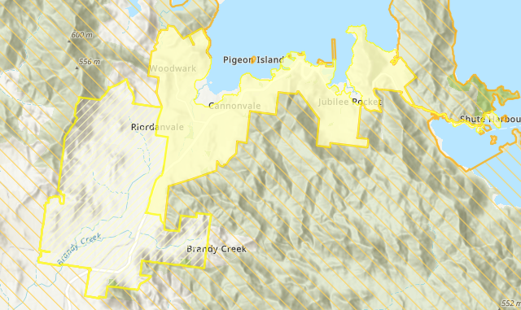

Figure 1 - Map of Airlie Beach Levy District including additional area

For further information about the Emergency Management Levy, please refer to [Frequently Asked Questions](https://www.qfes.qld.gov.au/planning-and-compliance/em-levy).