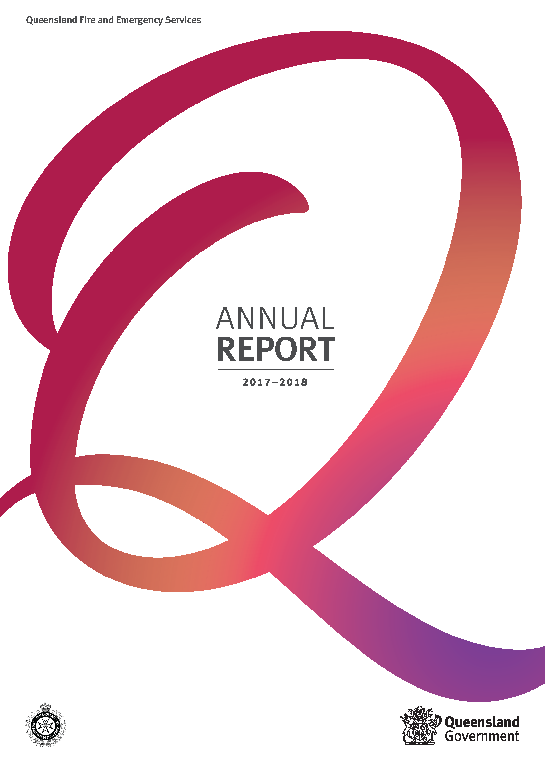

Acknowledgement of Country
Queensland Fire and Emergency Services acknowledges traditional owners of lands
across Queensland and pays respect to the Elders — past, present and emerging — for they
hold the memories, traditions, the culture and hopes of Aboriginal peoples and Torres Strait Islander peoples across the state.

This annual report provides information about Queensland Fire and Emergency Services’ financial and non-financial performance for 2017–18. It has been prepared in accordance with the Financial Accountability Act 2009, the Financial and Performance Management Standard 2009 and the Annual report requirements for Queensland Government agencies.
The annual report includes the significant achievements against the objectives, strategies and service area detailed in the Queensland Fire and Emergency Services’ 2017–2021 Strategic Plan and the 2017–18 Service Delivery Statement.
For more information:
Telephone: (07) 3635 3859
Visit: www.qfes.qld.gov.au
Email: Annual_Report@qfes.qld.gov.au
This annual report is available on the Queensland Fire and Emergency Services website at www.qfes.qld.gov.au/about/annualreport or a paper copy can be provided on request by calling (07) 3635 3859.
Open data
Information about consultancies, overseas travel and the Queensland Language Services Policy is available on the Queensland Government Open Data website (www.data.qld.gov.au)
Feedback
Feedback on the annual report can be provided through the Get Involved website:
www.qld.gov.au/annualreportfeedback
Other languages and formats
The Queensland Government is committed to providing accessible services to Queenslanders from all culturally and linguistically diverse backgrounds. If you have difficulty understanding this report, you can access the Translating and Interpreting Service (TIS National) via www.qld.gov.au/languages or by telephoning 13 14 50.


Copyright
© The State of Queensland (Queensland Fire and Emergency Services) 2018.
Published by the Queensland Government, September 2018. Cnr Park and Kedron Park Roads, Kedron Qld 4031.
Licence
This annual report is licensed by the State of Queensland (Queensland Fire and Emergency Services) under a Creative Commons Attribution (CC BY) 4.0 International licence.


CC by licence summary statement
In essence, you are free to copy, communicate and adapt this annual report, as long as you attribute the work to the State of Queensland (Queensland Fire and Emergency Services).
To view a copy of this licence, visit: www.creativecommons.org/licenses/by/4.0
Attribution
Content from this annual report should be attributed to:
The State of Queensland
(Queensland Fire and Emergency Services) Annual Report 2017–18.
ISSN
Online: 2204-0161
Print: 2206-1436

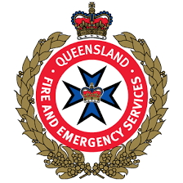 | www.qfes.qld.gov.au
 | www.facebook.com/QldFireandRescueService
 | www.twitter.com/@QldFES
 | www.youtube.com/user/FireRescueQld
 | www.instagram.com/qldfire

Letter of compliance
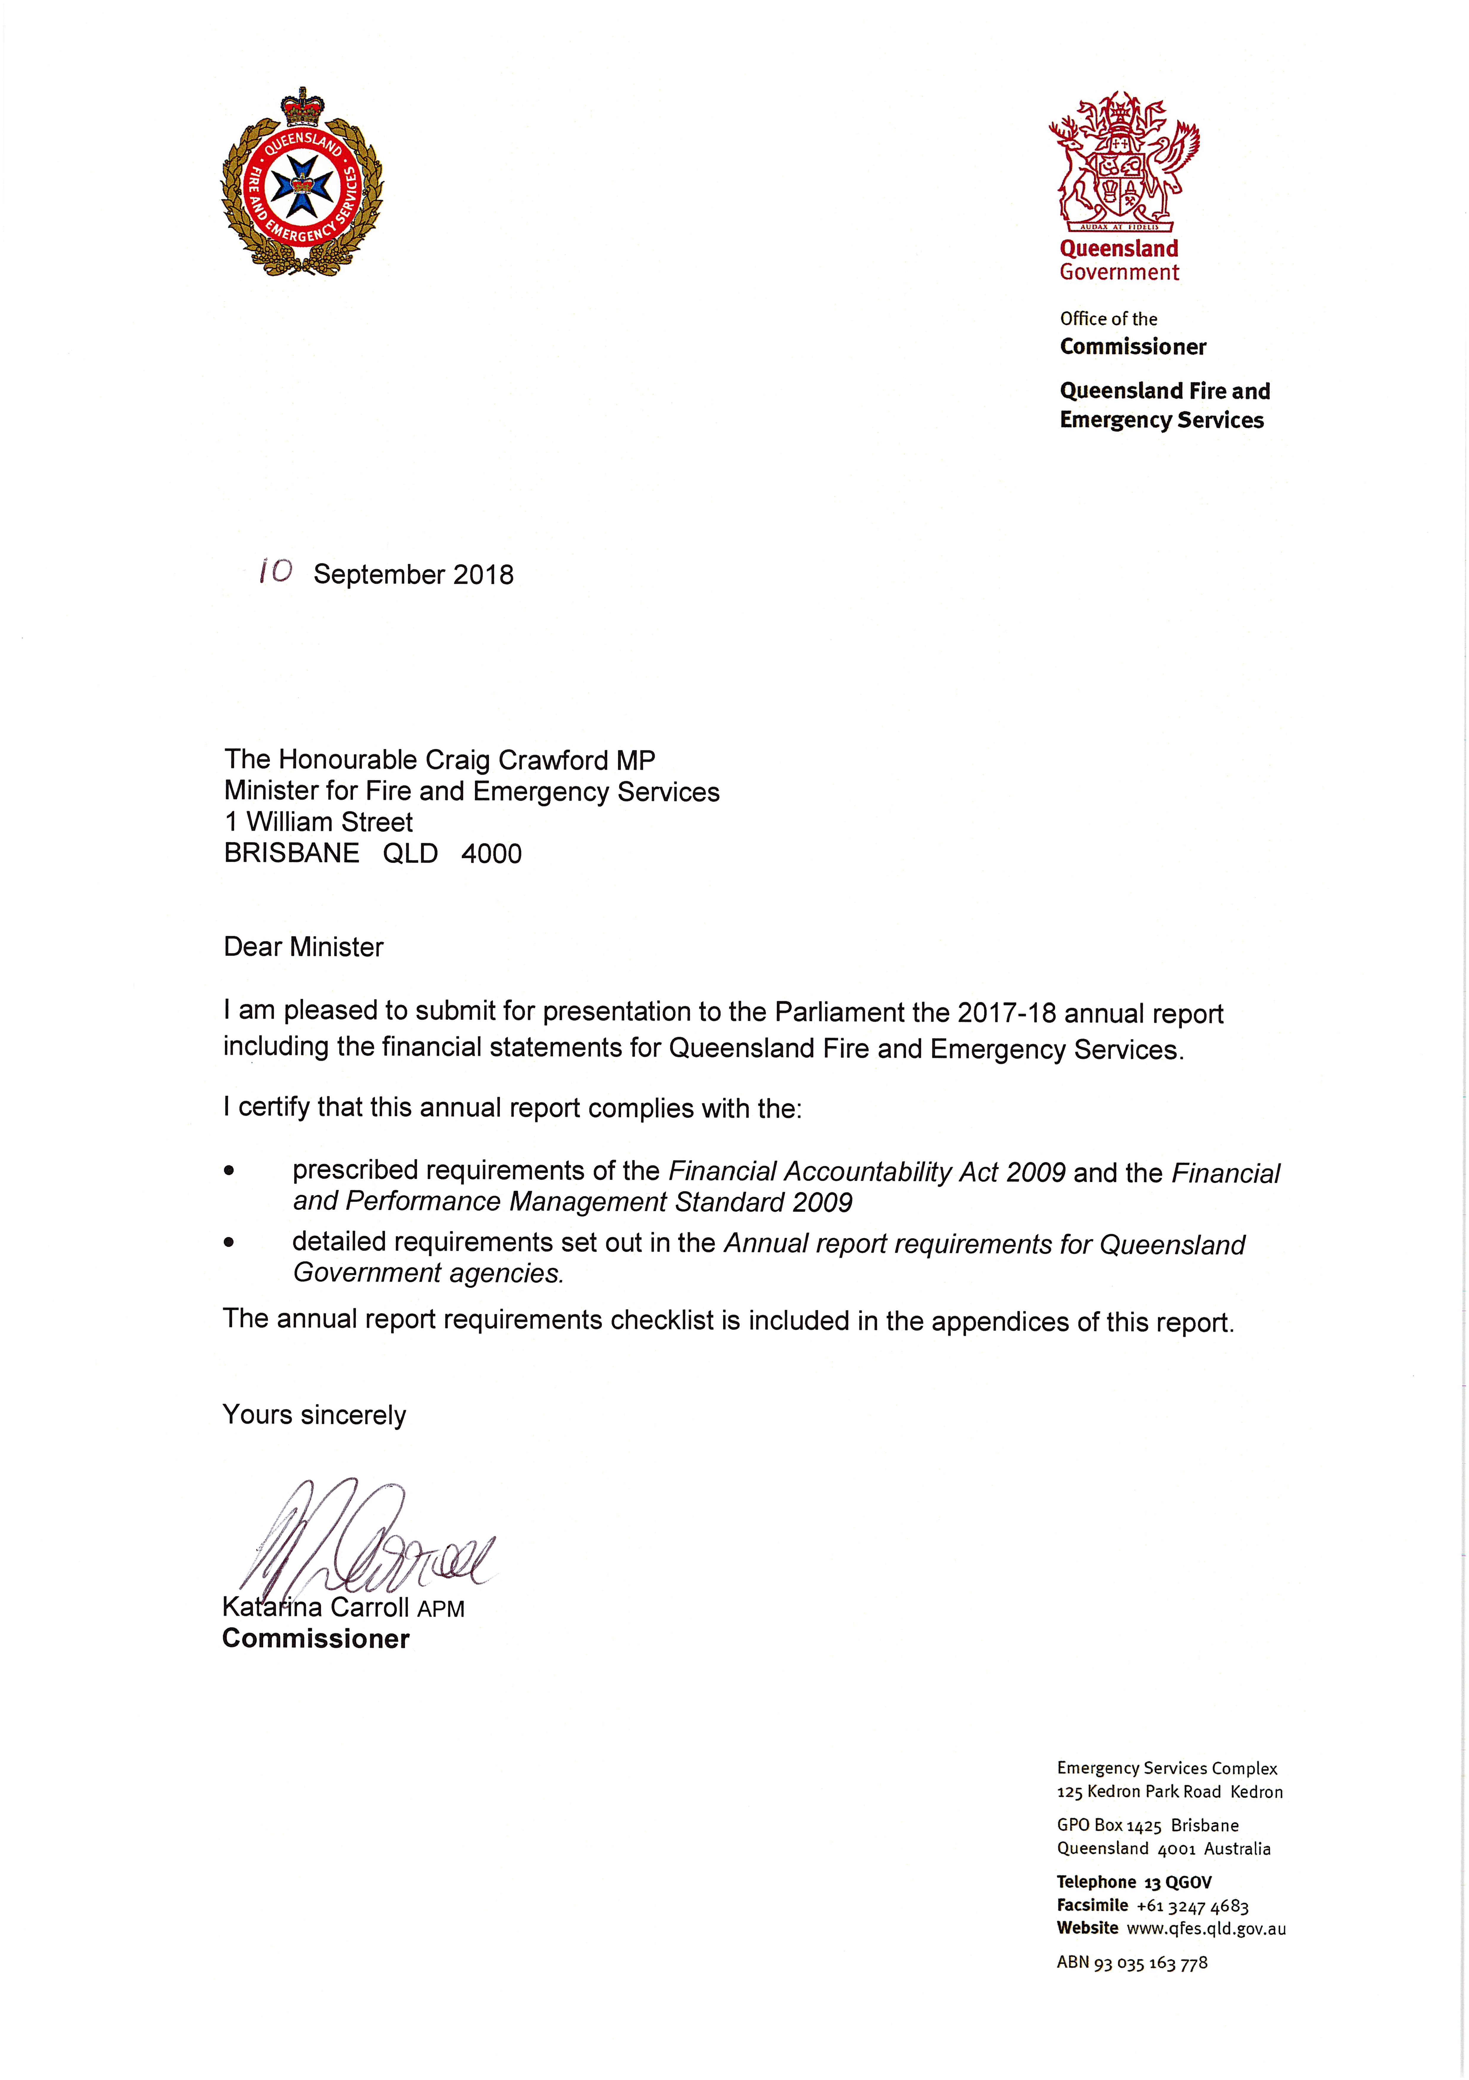

Contents
Letter of compliance iii
Commissioner’s message 2
Overview 4
About us 4
Structure 13
Organisational structure 14
Regions 15
Financial summary 16
Summary of financial performance 16
Summary of financial position 17
Performance 18
Key performance measures 18
2017–18 Highlights 25
Objective One 25
Objective Two 41
Objective Three 50
Objective Four 52
Objective Five 56
Governance 67
Executive management 67
Board and committees 69
Ethics and Code of Conduct 82
Risk management and accountability 84
Human resources 90
Financial statements 94
Statement of comprehensive income 95
Statement of financial position 96
Statement of changes in equity 97
Statement of cash flows 98
Notes to the statement of cash flows 99
Notes to and forming part of the financial statements 2017–18 100
Management Certificate 118
Independent Auditor’s report 119
Appendices 122
Acronyms 122
Compliance checklist 124
Contacts and key locations 126

Commissioner’s message
It is a pleasure to present Queensland Fire and Emergency Services (QFES) annual report for
2017–18. This report provides a review of our performance in delivering services to create safe and resilient communities for all Queenslanders.
QFES is a unique organisation where staff and volunteers work together to assist communities to recover in times of disaster and emergency. Above all, I truly appreciate the dedication and commitment of our staff and volunteers, and all they do to keep Queensland communities safe.
During 2017–18 much work has been done to further develop the QFES Volunteerism Strategy. QFES is supported by approximately 42,000 volunteers from the Rural Fire Service (RFS), State Emergency Service (SES), Research and Scientific Branch network and Technical Rescue Unit as well as Peer Support Officers. QFES’ paid and volunteer workforce provided input to the strategy’s development, which is expected to be finalised by 30 September 2018.
QFES has a strong focus in preparing for our future, and two further key strategies launched in 2018 will support us in continuing to deliver world-class fire and emergency services to all Queenslanders. Strategy 2030 will help us prepare our people and our organisation for whatever the future may bring. Scenario planning workshops, which included key partners and stakeholders, have helped to refine the way we think about QFES’ long-term view. Outcomes from the workshops, along with a community survey and research projects to understand community expectations of QFES, will inform the strategy’s development. The Digital Transformation Strategy also recognises QFES’ need to adapt to a rapidly changing and complex environment. Its focus is on creating a future where users, technology and information are better aligned, and where QFES is empowered and equipped to meet evolving demands and expectations. Both strategies are well underway, with consultation papers for each expected to be finalised by 30 September 2018.
A highlight this year was the Gold Coast 2018 Commonwealth Games. QFES deployed more than 800 personnel from each of its three services – Fire and Rescue Service (FRS), RFS and SES – along with the public service, to provide a range of support including response capabilities to fire, natural hazards, disasters and hazardous materials; support for counter terrorism activities; and support to Local Disaster Management Groups. The QFES planned response to the Games has left a fantastic legacy for future, planned major events within QFES.
Throughout 2017–18 QFES continued its commitment to a robust governance environment. Our clearly defined governance framework ensures well-informed decision-making and accountability across the department. A number of committees established under QFES’ new governance framework held their first meeting in 2017–18 including the Audit, Risk and Compliance Committee and People and Culture Committee. A follow-up review of the maturity and effectiveness of the governance arrangements was conducted in March 2018. The report highlighted significant progress has been made since 2016 and QFES is undertaking further work based on the report to further strengthen its governance maturity and effectiveness.
The 2017 Working for Queensland survey gave employees the opportunity to provide their views and opinions about a wide range of workplace factors. With 59 per cent of the workforce responding to the survey, up from 38 per cent from the 2016 survey, a much clearer insight into our workplace has been provided. This insight has enabled the development of actions that QFES can take in response to the survey findings.

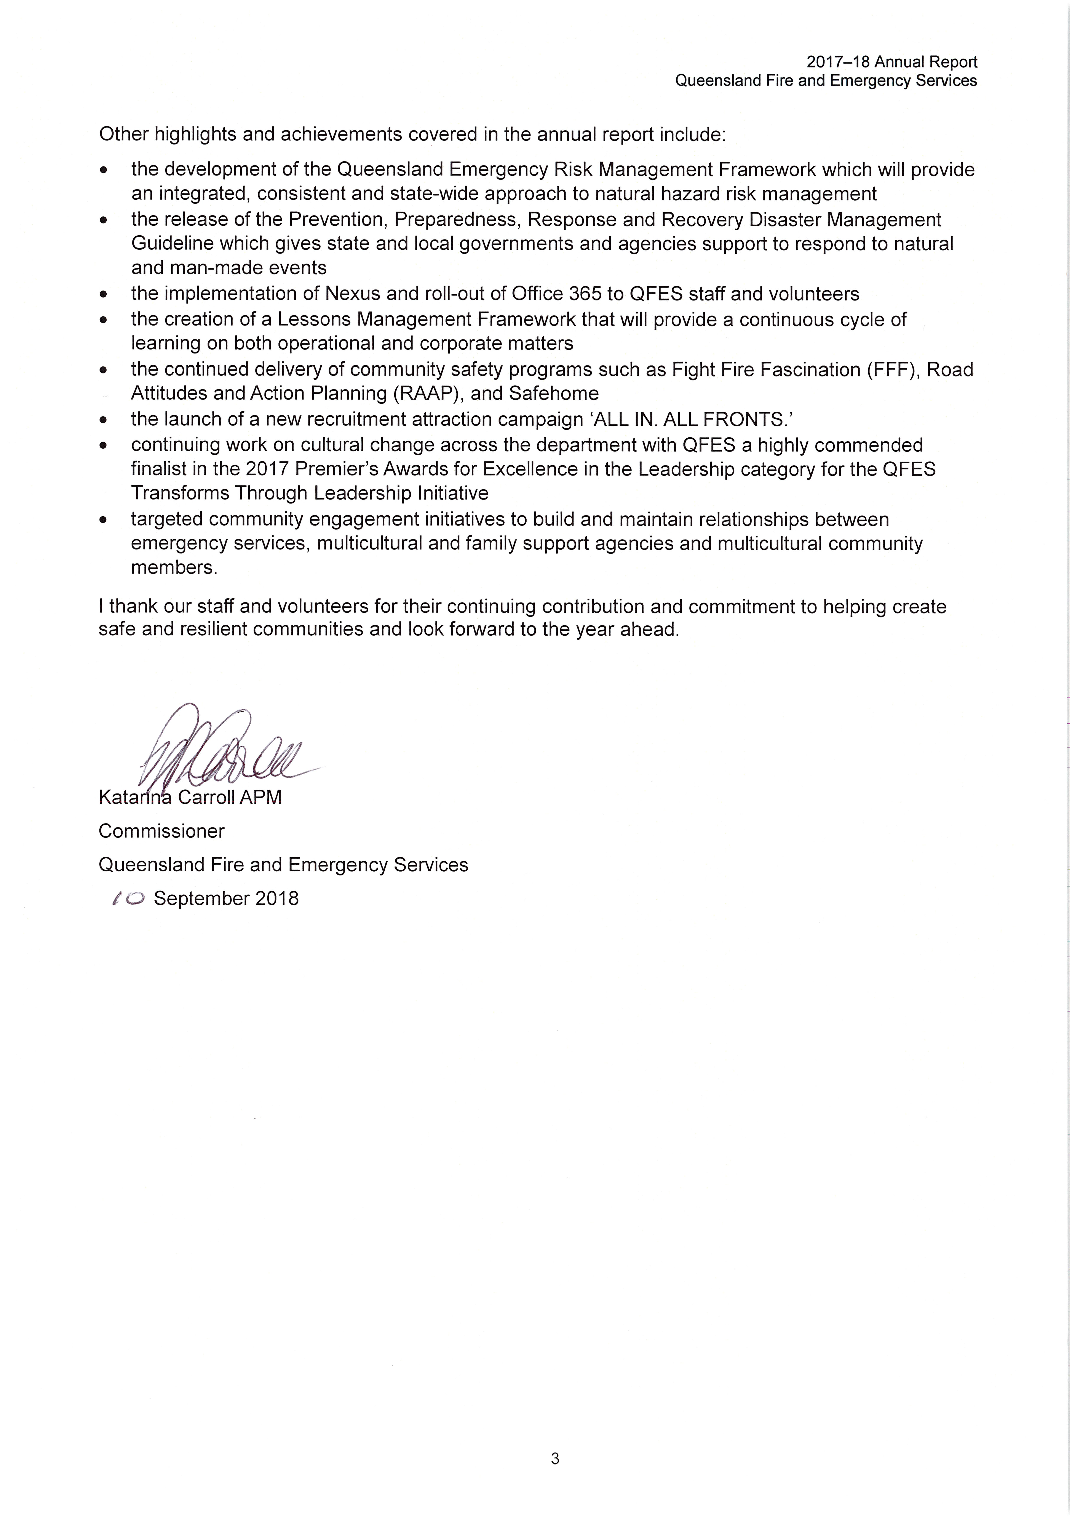

Overview

About us
Our vision:
One QFES creating safe and resilient communities.
Our purpose:
To help the community to prevent, prepare for, respond to and recover from the impact of fire and emergency events.

Queensland Fire and Emergency Services (QFES) was established as a department on 1 November 2013 under the Public Service Act 2008 (Public Service Departmental Arrangements Notice (No. 8) 2013).
QFES is the primary provider of fire and rescue and emergency management programs and services throughout Queensland. The department encompasses the Fire and Rescue Service (FRS), disaster management services, Rural Fire Service (RFS) and State Emergency Service (SES). QFES protects persons, property and the environment through the provision of effective prevention, preparedness, response and recovery (PPRR) activities across a range of fire and emergency events including natural and human induced disasters.
RFS and SES are the primary volunteer services of the department. The community-based RFS operates in rural, semi-rural and some urban fringe areas. SES is a community-based, not-for-profit, volunteer emergency service enabled by both state and local governments and sponsor partnerships.
Through service agreements, QFES also supports other volunteer groups that provide emergency response to Queenslanders, including:
- Australian Volunteer Coast Guard Association (AVCGA)
- Police-Citizens Youth Club (PCYC) Emergency Services Cadets
- Royal Life Saving Society Queensland (RLSSQ)
- Surf Life Saving Queensland (SLSQ)
- Volunteer Marine Rescue Association Queensland (VMRAQ).
Key outcomes for QFES include:
- communities are appropriately skilled and resourced to prevent incidents occurring and are adequately prepared for and able to mitigate the impacts of fire and emergency events.
- timely, coordinated and appropriate responses are provided to fire and emergency events to minimise their effects.
- appropriate relief and support is provided after responses to fire and emergency events until a managed transition occurs.
- the department is strategically capable and agile,
- the department’s business enabling services enhance, integrate and support its service delivery and are compliant, authorised and fit-for-purpose.

The Public Safety Business Agency (PSBA), established on 1 November 2013, provides professional information and communication technology (ICT), financial, procurement, asset management and human resource services to the public safety agencies including QFES, the Queensland Police Service (QPS) and Office of the Inspector-General Emergency Management (IGEM). PSBA also provides ICT services to the Queensland Ambulance Service (QAS) and Queensland Corrective Services. The provision of these services by PSBA allows frontline agencies to focus their efforts on delivering critical operational services to the community.
PSBA is governed by a Board of Management, which was formally established on 15 September 2016. The Board comprises the QFES Commissioner Katarina Carroll (Chair), QPS Commissioner Ian Stewart and an appointed external member, Geoff Waite, Executive General Manager, Risk and Intelligence, Queensland Treasury. The role of Chair rotates annually between the QFES Commissioner and QPS Commissioner.
The Board’s functions include providing leadership and oversight of PSBA and coordinating the provision of support services, and any programs provided by the PSBA to the public safety agencies. The Chief Operating Officer reports to the Board and must give effect to any direction of the Board.

Legislation administered
In accordance with Administrative Arrangements Order (No. 4) 2017, QFES administers the following legislation:
- Disaster Management Act 2003
- Fire and Emergency Services Act 1990.

Our accountabilities
The main functions of QFES under the Fire and Emergency Services Act 1990 are to:
- protect persons, property and the environment from fire and hazardous materials emergencies
- protect persons trapped in a vehicle or building or otherwise endangered, to the extent that QFES’ personnel and equipment can reasonably be deployed or used for the purpose
- provide an advisory service, and undertake other measures, to promote —
  - fire prevention and fire control
  - safety and other procedures if a fire or hazardous materials emergency happens
- cooperate with any entity that provides an emergency service
- perform other functions given to QFES under this Act or another Act
- perform functions incidental to its other functions
- identify and market products and services incidental to its functions.
In addition, the Act includes functions of the SES. These are to perform:
- rescue or similar operations in an emergency situation
- search operations in an emergency or similar situation
- other operations in an emergency situation to
  - help injured persons
  - protect persons or property from danger or potential danger associated with the situation
- other activities to help communities prepare for, respond to and recover from an event or a disaster
- activities to raise the profile of the SES or raise funds to support the SES in the performance of its other functions.

Under the Disaster Management Act 2003, the chief executive of QFES has the following functions for the administration of the Act:
- to establish and maintain arrangements between the state and the commonwealth about matters relating to effective disaster management
- to ensure that disaster management and disaster operations in the state are consistent with the:
  - state group’s strategic policy framework for disaster management for the state
  - state disaster management plan
  - disaster management standards
  - disaster management guidelines
- to ensure that persons performing functions under the Act in relation to disaster operations are appropriately trained
- to provide advice and support to the state group and local and district groups in relation to disaster management and disaster operations.

Queensland Government objectives
The Queensland Government works closely with all Queenslanders to deliver its objectives for the community. Integrity, accountability and consultation underpin everything the Queensland Government does.

Our objectives
QFES’ focus on creating safe and resilient communities supported the Queensland Government’s objectives for the community of delivering quality frontline services, and building safe, caring and connected communities. QFES delivered on the Queensland Government’s objectives through a range of strategies including:
- collaborating with communities to develop a shared understanding of their risks and empower them to have the capability to manage those risks
- providing timely and accurate information to inform and enable communities and responders to adequately prepare for, and respond to, fire and emergency events
- providing timely advice, reporting and support to other agencies to assist in the recovery process
- ensuring lessons learnt are taken into consideration during future fire and emergency PPRR programs
- strengthening community capability and partnerships.
QFES’ objectives and strategies, as outlined in its 2017-2021 strategic plan, are:
Objective |  | Strategies
1 | Build community capability to prevent incidents occurring and ensure that they are adequately prepared for and able to mitigate the impacts and consequences of fire and emergency events. | - Collaborate with communities to develop a shared understanding of their risks and empower them to have the capability to manage them.  - Enhance our peoples’ engagement and facilitation skills to work effectively with the community.  - Create a deeper understanding of diversity and ensure staff develop the skills to work with multicultural and Indigenous communities.

Objective (cont’d) |  |  | Strategies (cont’d)
2 |  | Contribute to the provision of a timely, coordinated and appropriate response to minimise the effects of fire and emergency events. | - Review the current service delivery model, levy arrangements and supporting legislation to ensure they meet contemporary needs.  - Continue to develop systems and strategies for a reduction of, and a more appropriate response to, unwanted alarms.  - Support interoperability through our equipment selection, practices and policies.  - Ensure that all services within QFES can operationally support each other and complement our ability to deliver services.  - Work with public safety partners to create, wherever practicable, interoperability in the delivery of services.  - Provide timely and accurate information to inform and enable communities and responders to adequately prepare for, and respond to, fire and emergency events.
3 |  | Provide appropriate relief and support during and after responses to fire and emergency events until a managed transition occurs. | - Provide timely advice, reporting and support to other agencies to assist in the recovery process.  - Conduct damage assessments to inform relief and recovery activities.  - Provide QFES transition planning that informs communities, government and non-government organisations.  - Deliver timely and accessible recovery information to the community.  - Contribute towards recovery operations by providing fit-for-purpose QFES capabilities including logistical and command and control.
4 |  | Enhance strategic capability and agility. | - Continue to create a transformational culture that promotes a shared understanding of how staff and volunteers work together professionally and respectfully.  - Progress the creation of a One QFES policy, doctrine, language and concepts of operation.  - Identify how existing QFES capabilities could be applied to emerging areas of need.  - Ensure that lessons learnt are taken into consideration during future fire and emergency PPRR programs.
5 | Provide business-enabling services that enhance, integrate and support the department’s service delivery and that are compliant, authorised and fit-for-purpose. |  | - Ensure that our organisational strategy and decisions respond to future need and that they are: timely; accurate; evidenced-based; accountable; and transparent.  - Strengthen community capability and partnerships.  - Support evidence-based service delivery through the use of business intelligence and data analysis.  - Deliver services within the state’s financial capability.  - Develop and implement a QFES Volunteerism Strategy to foster inclusivity and cohesion and remove duplication and barriers.  - Attract and retain a talented and diverse workforce.  - Provide safe, healthy and inclusive workplaces.  - Confirm that our business processes are aligned with contemporary practice and that they legislatively comply.  - Work with PSBA to ensure that it is aware of what it needs to deliver to meet the department’s business requirements and actively monitor its performance.

Our values
Our behaviour and the way we do business are guided by our values:
- Respect — we appreciate and value each other and our differences.
- Integrity — we are individually accountable for our performance and undertake our duties with diligence and transparency.
- Courage — we are brave when facing adversity, value ethical behaviour and challenge wrongdoing.
- Loyalty — we are committed to each other, have pride in our organisation and are dedicated to keeping Queensland communities safe.
- Trust — we are open, honest and dependable.
QFES’ values align with the Queensland Public Service values of:
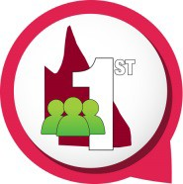 | Customers first  - Know your customers  - Deliver what matters  - Make decisions with empathy
 | Ideas into action  - Challenge the norm and suggest solutions  - Encourage and embrace new ideas  - Work across boundaries
 | Unleash potential  - Expect greatness  - Lead and set clear expectations  - Seek, provide and act on feedback
 | Be courageous  - Own your actions, successes and mistakes  - Take calculated risks  - Act with transparency
 | Empower people  - Lead, empower and trust  - Play to everyone’s strengths  - Develop yourself and those around you.

Our environment
The environment in which QFES operates is rapidly changing. Some of the strategic environmental factors QFES is working to address include:
- the continuing growth in Queensland’s population, combined with its diversity and geographic dispersal across the state
- a predicted increase in the severity and frequency of natural disasters
- changing community expectations around government services
- changes in the volunteer landscape
- crime and safety threats resulting from technological advancements, globalisation and violent extremism.

QFES responds to these environmental factors through the delivery of its strategic plan. Importantly, QFES works collaboratively with the public safety agencies, local governments and other non-government and community organisations such as Red Cross, Rotary Australia and
The Salvation Army, to enable it to respond to these factors whilst continuing to deliver frontline fire and rescue, and emergency services.
Further information about how QFES is responding to these environmental factors can be found in the 2017–18 Highlights (refer pages 25–66).

Strategic challenges
QFES identified the following key strategic challenges for 2017–18:
- increasing impact of climate change
- managing service capacity versus community expectations
- increasing demand for services as the population grows, ages and becomes more culturally diverse.
Information about how QFES is responding to these challenges can be found in the 2017–18 Highlights (refer pages 25–66).

Outlook
QFES will contribute to Our Future State: Advancing Queensland’s Priorities, the Queensland Government’s objectives for the community (launched 11 June 2018), to be a responsive government and keep communities safe through a range of initiatives, including:
- collaborating with communities to develop a shared understanding of their risks and empower them to have the capability to manage those risks
- providing timely and accurate information to inform and enable communities and responders to adequately prepare for, and respond to, fire and emergency events
- providing timely advice, reporting and support to other agencies to assist in the recovery process
- ensuring lessons learnt are taken into consideration during future fire and emergency PPRR programs
- ensuring that QFES’ organisational strategy and decisions respond to future need and that they are timely, accurate, evidence-based, accountable and transparent.
The future focus of QFES is reflected in its 2017–2021 strategic plan. The strategic plan provides a four year blueprint for the department and communicates QFES’ organisational priorities to staff, stakeholders and clients.
Key priorities for the department during 2018–19 include:
- continued focus on PPRR activities
- reviewing the current service delivery model, to ensure it meets contemporary needs
- ensuring the department continues to be an inclusive, respectful and diverse organisation for staff and volunteers
- continuing to enhance financial capability and embed a culture of fiscal sustainability
- creating a knowledge framework which fosters learning from experience, creates good governance, and supports the delivery of strategic capability.
During 2018–19, key strategic challenges for the department are:
- predicted climate change leading to more intense and frequent weather events with the department needing to plan to meet this increasing demand
- changing needs of an ageing and geographically dispersed population will result in the department having to adjust service delivery to better meet community needs.

Resources
QFES delivers its services from seven regional locations throughout the state — Far Northern, Northern, Central, North Coast, Brisbane, South Eastern and South Western. They include:
- 242 FRS stations
- 1,409 volunteer based rural fire brigades, including 486 with stations
- 301 SES groups
- seven communication centres (one located in each QFES region)
- Special Operations Centre located at Cannon Hill, Brisbane
- State Deployment Centre located at Morningside, Brisbane.
In addition, frontline staff and volunteers are trained throughout the state in various education and training facilities including the School of Fire and Emergency Services Training (SFEST) at Whyte Island.
The Emergency Services Complex in Brisbane’s northern suburbs houses emergency services including the QFES State Operations Centre (SOC), State Disaster Coordination Centre (SDCC) and the Brisbane Region Fire Communications Centre (FireCom).
A list of contacts and key locations for QFES is available in the appendices of this report (refer page 126).

Volunteers
Volunteers are critical to the successful delivery of frontline services and are essential in building community capacity and enhancing community resilience. QFES has approximately 42,000 dedicated volunteers across the state in the RFS, SES, Research and Scientific Branch network and Technical Rescue Unit.
- Rural Fire Service
Volunteer rural fire brigades provide fire management services for rural and semi-rural communities and some urban fringe areas across approximately 93 per cent of the state. In addition to responding to fires in their local area and in surrounding areas in support of other brigades and emergency services, volunteer brigades undertake a range of planning and preparation activities to ensure communities are well prepared for the bushfire season. This includes community education, hazard reduction and mitigation activities to reduce the risk from fire to people and property. The Permit to Light Fire system, which ensures the controlled use of fire across the state, is also largely implemented by volunteer fire wardens. Volunteer brigades are often called upon to assist other emergency service agencies during disasters such as floods and storms and may be deployed to assist other states during fire disasters.
As at 30 June 2018, there were approximately 36,000 RFS volunteers.
- State Emergency Service
The SES is a community-based, not-for-profit, volunteer emergency service enabled by both state and local governments and sponsor partnerships. It plays a vital part in Queensland’s emergency management approach and provides assistance to Queensland communities in times of disaster or emergency. The Queensland Government works in partnership with local governments through providing shared support and services that make a significant contribution to the ongoing effectiveness of the SES.
This important partnership assists SES volunteers to provide a valuable volunteer emergency service to their local communities. SES groups perform search and rescue, storm damage and floodboat operations, road crash rescue, emergency traffic management and vertical rescue, and protect persons and property from danger in disaster and emergency situations. They also perform incident management and agency support. The SES maintains a high level of cooperation and support to QPS for assistance in search activities.

The SES also provides valuable assistance to other emergency services and helps communities prepare for, respond to, and recover from an event or a disaster. Flood and storm responses form a significant part of Queensland SES activities.
As at 30 June 2018, there were approximately 5,600 active SES volunteers.
- Research and Scientific Branch volunteer (Scientific Advisor) network
The Research and Scientific Branch incorporates permanent staff and volunteers who respond to hazardous materials incidents across Queensland. This volunteer network is a critical component of the Branch’s expert advice service. The network includes chemists and chemical engineers who provide prompt, at-the-scene responses to emergency incidents involving chemical hazards. These specialists are from private industry, local governments and tertiary institutions across Queensland. During 2017–18, they attended a range of incidents including chemical reactions and spillages, and fires causing hazardous materials releases.
As at 30 June 2018, there were 53 scientific volunteers including 48 regional based Scientific Officers and five Queensland Health Brisbane-based Scientific Support Officers.
- Technical Rescue Unit – Urban Search and Rescue
The Disaster Assistance Response Team (DART) includes the Queensland Urban Search and Rescue (USAR) Team. This is a multi-jurisdictional, multi-disciplinary USAR Team made up of full-time and volunteer members, including firefighters, paramedics, doctors, engineers, Hazmat specialists, police and volunteer canine handlers, mechanics and communications operators who respond to natural and man-made disasters across Queensland. The volunteer network within this team is a critical component comprising doctors, engineers and canine specialists. These specialists come from private industry, local governments and tertiary institutions across Queensland. During 2017–18, these volunteers participated in the annual USAR 48 hour field deployment exercise (August 2017) and skills maintenance workshops and skills acquisition courses.
As at 30 June 2018, the AUS-1 DART has 14 volunteers including five doctors, five engineers and four canine handlers.

Partners
QFES works closely with the public safety agencies — the Office of the IGEM, PSBA and QPS. QFES also has strong relationships with its partners including local governments who provide shared services and support to SES, and those in the community through volunteer groups including the Rural Fire Brigades Association Queensland Inc. (RFBAQ), Queensland State Emergency Service Volunteer Association Inc. (QLDSESVA), Queensland Volunteer Marine Rescue Committee and the Queensland Police-Citizens Youth Welfare Association. These partnerships are vital for QFES to enhance community safety by minimising the impact of fire and emergency incidents on the people, environment and economy of Queensland.
- Local Government Association of Queensland
The Local Government Association of Queensland (LGAQ) is the peak body for local government in Queensland. QFES collaborates with LGAQ in relation to disaster management arrangements before, during and after a disaster event at all levels of the disaster management arrangements.
A Disaster Management Alliance Memorandum of Understanding (MoU) exists between QFES and LGAQ which establishes a strategic commitment and clear understanding of each agency’s roles and responsibilities. The MoU also enables collaboration opportunities for local government to contribute to the development of disaster management policies and service delivery strategies.
- Rural Fire Brigades Association Queensland
The RFBAQ is a representative body for rural fire brigades. It provides information and advice to volunteers and consults with QFES on matters of policy, training, equipment, finance and vehicle safety through the RFS Strategic Working Groups.

- Queensland State Emergency Service Volunteer Association
The QLDSESVA is a representative body for, and advocates on behalf of, its members. The association provides information and advice to volunteers and consults with QFES on matters of policy, training, equipment, finance and vehicle safety through the Communications Standards Committee. The QLDSESVA is a member of the national SES Volunteer Association.
- Queensland Volunteer Marine Rescue Committee
The role of the Queensland Volunteer Marine Rescue Committee is to provide advice to the Queensland Government and voluntary organisations involved in marine rescue activities and to investigate and make recommendations on matters referred to the committee. The committee also ensures suitable guidelines are available for the standardisation of an integrated Queensland statutory service/volunteer marine rescue capability.
The committee is chaired by the Assistant Commissioner, SES within QFES with membership from the following agencies:
- AVCGA
- Department of Transport and Main Roads (Maritime Safety Queensland)
- QPS
- RLSSQ
- SLSQ
- VMRAQ.
- Queensland Police-Citizens Youth Welfare Association
The Queensland Police-Citizens Youth Welfare Association, commonly known as PCYC, is a non-government, not-for-profit, charitable organisation that provides appropriate, affordable and accessible youth development programs and services to support young people in making positive life choices. The PCYC Emergency Services Cadets Program is delivered in partnership with PCYC and Queensland's emergency services including QFES and QPS.
For further information regarding the Emergency Services Cadets Program refer to page 34 or visit the PCYC website: www.pcyc.org.au/Youth-Programs/Emergency-Services-Cadets.aspx

Structure
QFES comprises:
- Emergency Management, Volunteerism and Community Resilience Division
- Readiness and Response Services Division
- Strategy and Corporate Services Division.
The Emergency Management, Volunteerism and Community Resilience Division is responsible for providing overall strategic leadership, direction and support to RFS and SES. It also provides support through service agreements to other volunteer groups involved in emergency response. The Division incorporates the Emergency Management and Community Capability Directorate, which is comprised of the Community Resilience and Risk Mitigation, and Community Capability and Volunteerism Branches. The Division is responsible for introducing innovative strategies to support the recruitment and retention of a sustainable skilled volunteer workforce and the application of technical expertise in disaster management capabilities and support that meet the increasing demand from more frequent and severe disasters and emergencies. It works in partnership with local governments to develop management and volunteer capability, and through the provision of high quality services, support and advice, ensures safer and more resilient communities across Queensland.
The Readiness and Response Services Division is responsible for ensuring the response capacity of QFES operational staff in emergent situations as legislated in the Fire and Emergency Services Act 1990 and Disaster Management Act 2003. The Division provides sustainable leadership and direction through the coordination of emergency management and fire and rescue operational activities. The Division is comprised of a skilled fire and emergency management workforce, working in partnership with state government departments, local governments and communities to improve resilience and enhance operational capacity during times of emergency. Regional operations as well as Fire Communications, Fire Safety, Fire Engineering, Investigation and Compliance, Technical Rescue, Breathing Apparatus (BA)/Hazmat, and Research and Scientific are integral elements of this Division.
The Strategy and Corporate Services Division is responsible for leading the department’s strategic framework and vision, and driving performance and integrated capability across QFES. The Division works closely with the public safety agencies to ensure the department’s planning and policy enhances the capability of its people, and services and equipment are contemporary, agile and able to meet the service delivery needs of Queensland communities.

Organisational structure
As at 30 June 2018
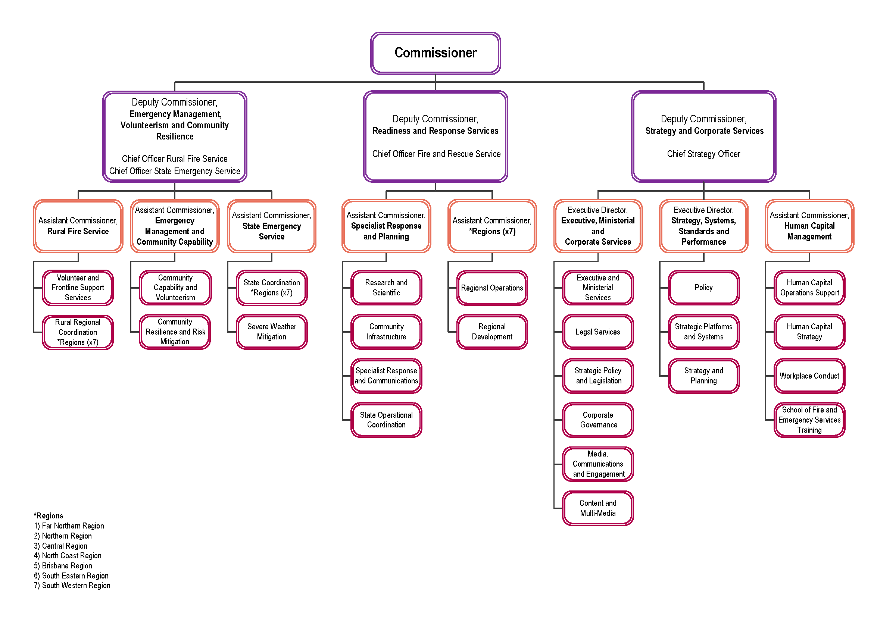
14
2017–18 Annual Report
Queensland Fire and Emergency Services

Regions
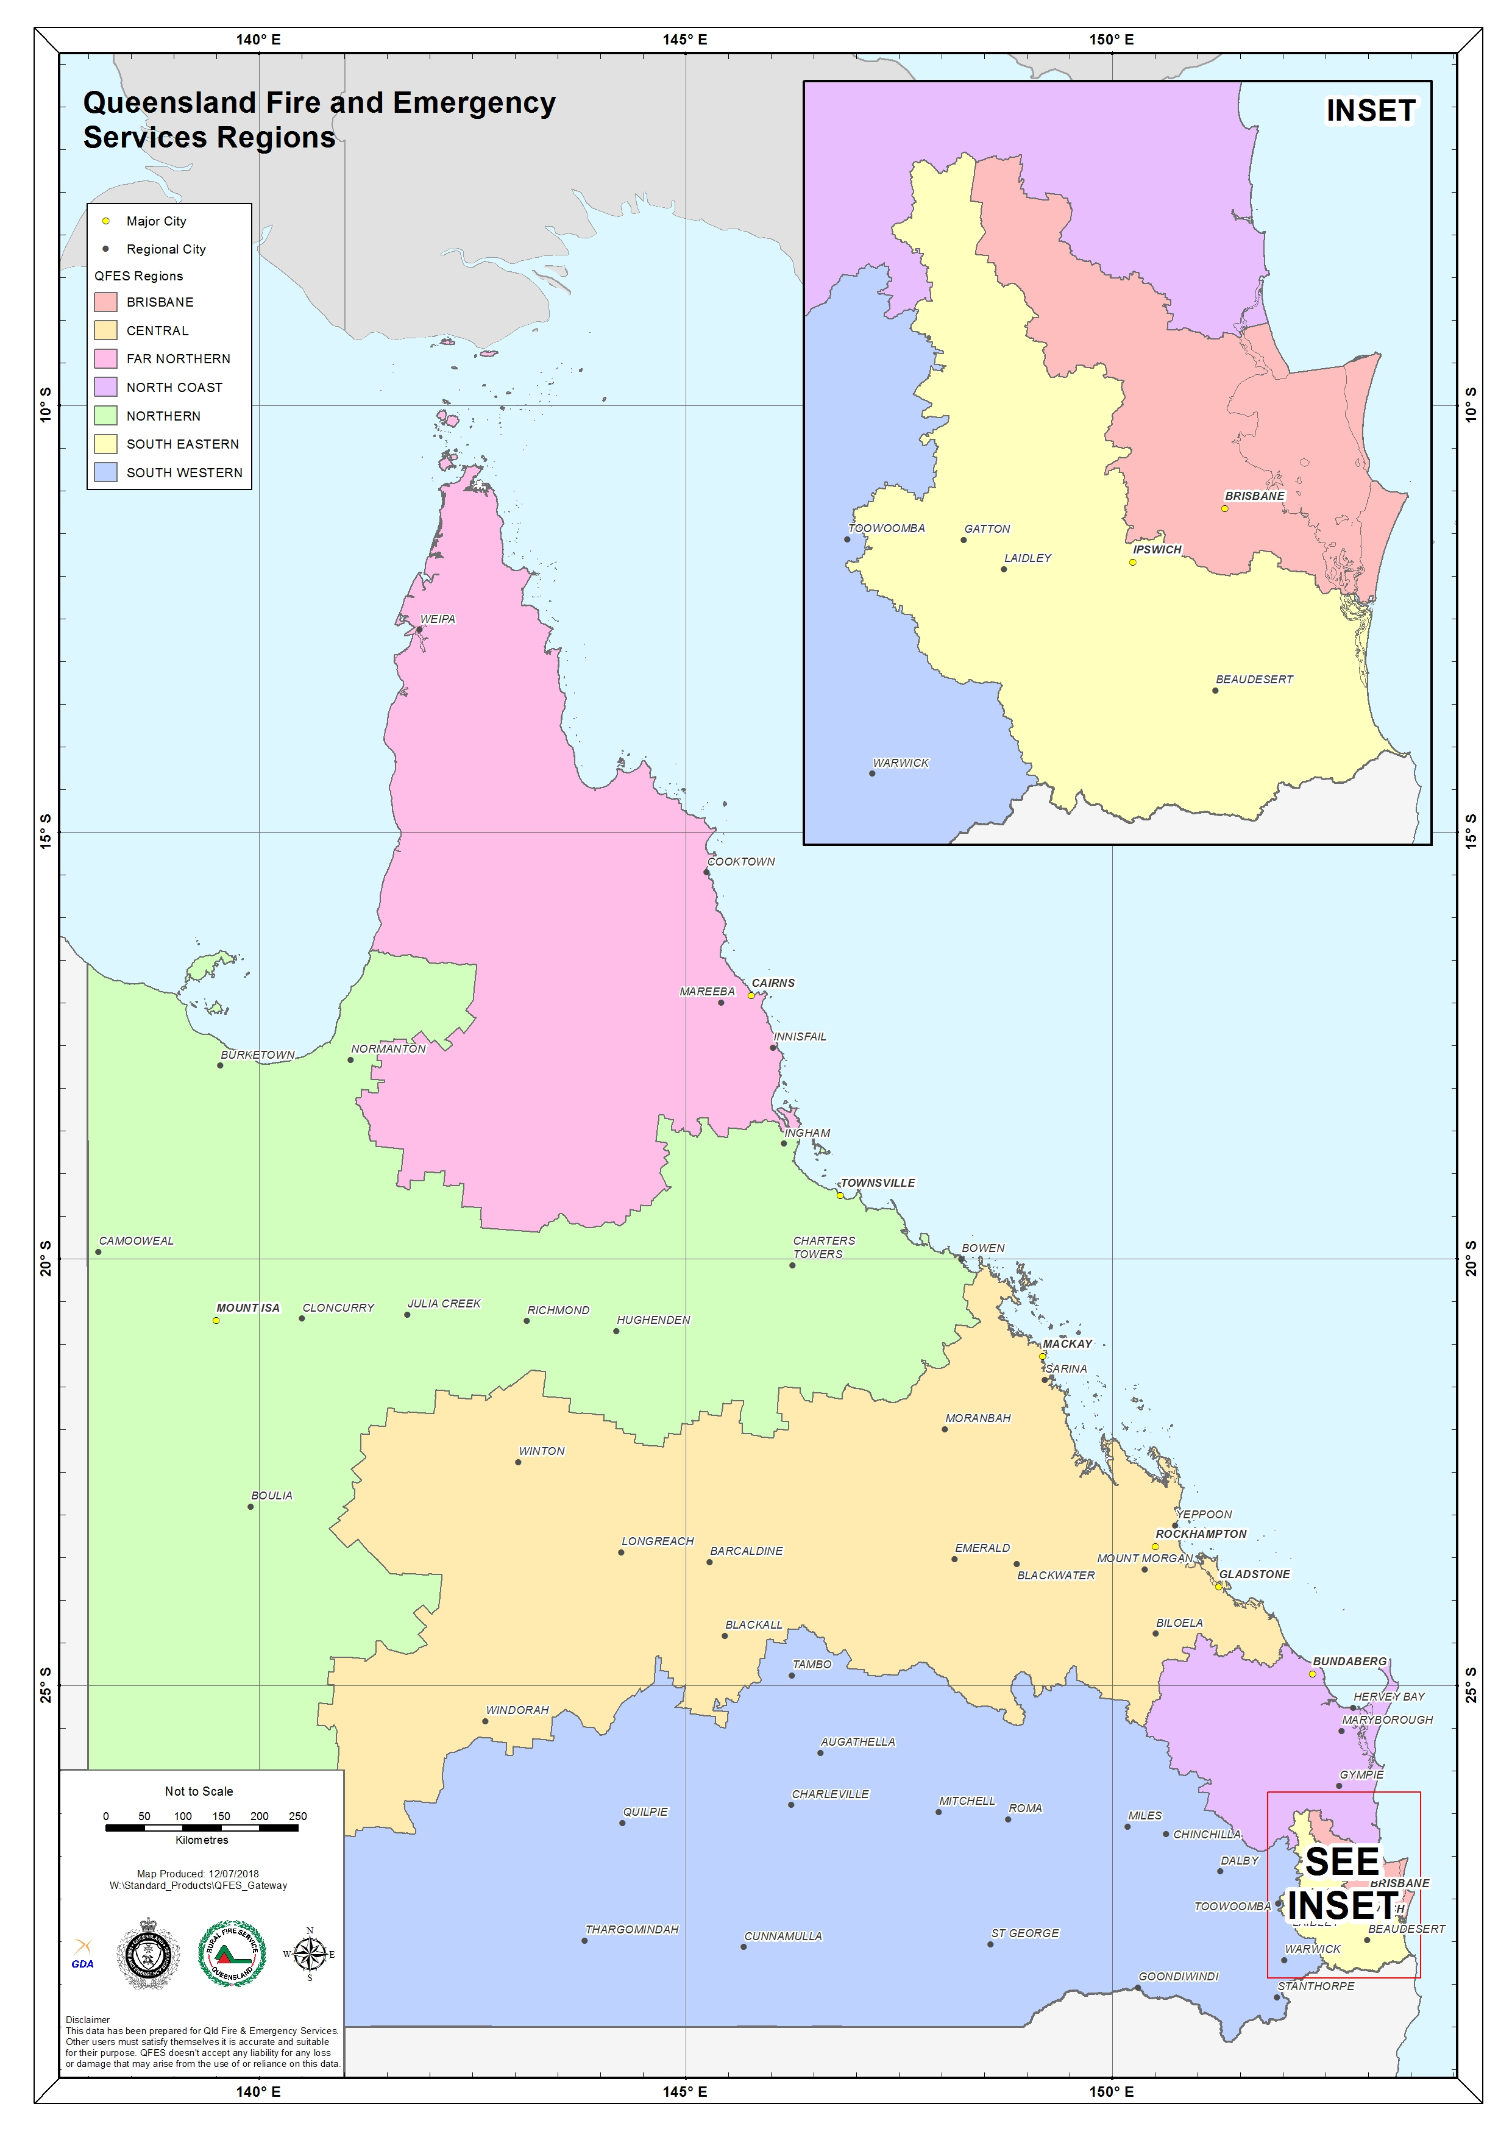

Financial summary

Summary of financial performance
The following table summarises the operating result and financial position for QFES 2017–18 and
2016–17.
Statement of comprehensive income | 2017–18  $’000 | 2016–17  $’000
Total income from continuing operations | 685,510 | 646,112
Total expenses from continuing operations | 682,237 | 637,280
Total comprehensive income | 3,273 | 8,832
Statement of financial position | 2017–18  $’000 | 2016–17  $’000
Total assets | 135,050 | 111,170
Total liabilities | 63,893 | 43,285
Net assets (equity) | 71,157 | 67,885
Income and expenses from continuing operations
QFES is funded to deliver a wide range of fire and emergency management and recovery services through emergency management levies paid by prescribed property owners across the state.
QFES also receives income from other revenue sources including user fees and charges from building and infrastructure fire safety and alarm monitoring services, training and contract services, charges for attendance at incidents, parliamentary appropriations and federal government grants and contributions.
QFES aims to protect persons, property and the environment through the delivery of emergency services, awareness programs, response capability and capacity and incident response and recovery for a safer Queensland. The expenses incurred in the delivery of these services are summarised further below.
For 2017–18, QFES received income from continuing operations totalling $685.510 million and incurred total expenditure from continuing operations of $682.237 million. This is comprised of:
Income
- appropriation revenue for services $87.6 million
- user charges and fees $53.7 million
- emergency management levies $511.9 million
- grants and other contributions $29.4 million
- other revenue $2.9 million.

Expenses
- employee expenses $381.6 million
- supplies and services $116.3 million
- grants and subsidies $162.6 million (including an operating grant to PSBA of $110.1 million and a capital grant of $35.7 million to fund corporate services and capital programs provided to QFES)
- depreciation and amortisation $5.0 million
- impairment losses $0.2 million
- other expenses $16.7 million.

Summary of financial position
QFES was in a positive financial position at the end of the financial year. The total equity (assets less liabilities) of QFES at the end of 2017–18 was $71.157 million. This comprised predominantly of:
Assets
- cash and cash equivalents $53.5 million
- trade and other receivables $50.5 million
- intangible assets $7.4 million
- property, plant and equipment $17.4 million
- inventory $5.2 million
- prepayments $1.0 million.
Liabilities
- trade payables and other payables $44.2 million
- accrued employee benefits $14.8 million
- other current liabilities $4.9 million.
Ownership of assets
The Public Safety Business Agency Act 2014 (section 7) requires the PSBA to hold and maintain infrastructure and fleet and communication technology assets for the public safety entities. As a result, the majority of these assets are recognised and reported in the financial statements of the PSBA. The net book value of these assets reported by PSBA but utilised by QFES are as follows:
- land $196.6 million
- buildings and infrastructure $327.7 million
- major plant and equipment $43.5 million
- plant and equipment $178.3 million
- software $5.9 million
- heritage and cultural assets $0.2 million.
There were no significant events after balance date that could be expected to impact the reported operating result for QFES for the year ended 30 June 2018.

Performance

Key performance measures
QFES delivers essential emergency, safety, mitigation and response services to Queensland to build safe, caring and connected communities.
QFES enhances community resilience, mitigates risk and contributes to safer and sustainable communities through disaster management, community assistance, responses to structure and landscape fires, and rescue across all hazards.
The Fire and Emergency Services service area objective is to enhance community safety by minimising the impact of fire, emergency incidents and disasters on the people, property, environment and economy of Queensland.
The table below provides an overview of the key performance measures for QFES for
2017–18. Data for 2016–17 is sourced from the Queensland Fire and Emergency Services 2016–17 Annual Report, 2018 Report on Government Services (RoGS) and Working for Queensland (WfQ) survey.
Service area: Fire and Emergency Services
Performance measures | Notes | Strategic plan | 2017–18  SDS | RoGS | 2016–17  Actual | 2017–18  Target/  Estimate | 2017–18  Actual
Rate of accidental residential structure fires reported (per 100,000 households) | 1, 2, 3 |  | ✓ | ✓ | 59.6 | <60 | 54.9
Response times to structure fires including call taking time: | 3, 4, 5 | ✓ | ✓ | ✓
- 50th percentile | 6 |  |  |  | 8.1 minutes | <7.8 minutes | 7.9 minutes
- 90th percentile | 7 |  |  |  | 12.5 minutes | <14.0 minutes | 12.3 minutes
Percentage of building and other structure fires confined to room/object of origin | 3, 4, 8 |  | ✓ |  | 82.4% | ≥80% | 83.6%
Estimated percentage of households with smoke alarm/detector installed | 9 |  | ✓ | ✓ | 97.9% | 95% | 97%
Percentage of building premises inspected and deemed compliant at first inspection | 10 | ✓ | ✓ |  | 51.7% | 50% | 56.2%
Rate of Unwanted Alarm Activations per Alarm Signalling Equipment | 11 |  | ✓ |  | 2.5 | <4 | 2.4

Service area: Fire and Emergency Services (cont’d)
Performance measures | Notes | Strategic plan | 2017–18  SDS | RoGS | 2016–17  Actual | 2017–18  Target/  Estimate | 2017–18  Actual
Percentage of volunteers satisfied with the experience of volunteering for the Rural Fire Service | 12 | ✓ | ✓ |  | 79% | - | -
Percentage of volunteers satisfied with the experience of volunteering for the State Emergency Service | 12 | ✓ | ✓ |  | 78% | - | -
Percentage of statewide State Emergency Service volunteers that meet minimal operational training requirements | 13 | ✓ | ✓ |  | 58% | 65% | 66%
Percentage of disaster management training participants with enhanced capability | 14 | ✓ | ✓ |  | - | 75% | 92%
Fire and emergency services expenditure per person | 15 |  | ✓ |  | $129.96 | $134 | $136.37
Level of household preparedness for emergencies and disaster events for which households perceive they are at risk of: | 16 | ✓
- Bushfire |  |  |  |  | - | - | 48%
- Storm |  |  |  |  | - | - | 51%
- Heatwave |  |  |  |  | - | - | 57%
- Cyclone |  |  |  |  | - | - | 51%
Percentage of the community that understand their local hazards | 17 | ✓ |  |  | - | - | -
Percentage of households with operational smoke alarms | 18 | ✓ |  |  | 84.6% | - | 80.2%
Percentage of high-risk localities with at least one bushfire mitigation activity completed | 19 | ✓ |  |  | - | - | 71%
Percentage of Area Fire Management Groups established and functioning | 20 | ✓ |  |  | - | 100% | 100%

Service area: Fire and Emergency Services (cont’d)
Performance measures | Notes | Strategic  plan | 2017–18  SDS | RoGS | 2016–17  Actual | 2017–18  Target/  Estimate | 2017–18  Actual
Response times to mobile property crashes | 4, 5, 21 | ✓
- 50th percentile |  |  |  |  | - | - | 8.5 minutes
- 90th percentile |  |  |  |  | - | - | 14.1 minutes
Response times to landscape fires | 4, 5, 22 | ✓
- 50th percentile |  |  |  |  | - | - | 11.0 minutes
- 90th percentile |  |  |  |  | - | - | 20.2 minutes
Number of landscape fires attended by the Rural Fire Service | 23 | ✓ |  |  | 3,272 | - | 3,037
Percentage of fire investigations completed within designated timeframes | 24 | ✓ |  |  | - | - | -
Percentage of staff that recognise that QFES has a one-team approach to service delivery | 25 | ✓ |  |  | 47% | - | 57%
Percentage of staff that understand the purpose of QFES | 26 | ✓ |  |  | 92% | - | 91%
Total expenditure as a percentage of the approved operating budget | 27 | ✓ |  |  | - | 100% | 103%
Actual income achieved is no less than one per cent below approved target | 28 | ✓ |  |  | $646.112 million | $663.8  million | $685.5  million
Level of satisfaction with QFES as a workplace as indicated by workforce survey results | 29 | ✓ |  |  | - | - | 83%
Agency engagement | 30 | ✓ |  |  | 74% | - | 74%
Completion rates for compulsory workplace training | 31 | ✓ |  |  | - | - | 95%
Percentage increase in the number of applications received from females for firefighter vacancies | 32 | ✓ |  |  | - | 2% | 1.6%

Service area: Fire and Emergency Services (cont’d)
Performance measures | Notes | Strategic  plan | 2017–18  SDS | RoGS | 2016–17  Actual | 2017–18  Target/  Estimate | 2017–18  Actual
Percentage increase in the number of applications received from Aboriginal people and Torres Strait Islander people for firefighter vacancies | 32 | ✓ |  |  | - | 4% | 5.4%
Level of satisfaction with services provided by PSBA as a service provider to QFES | 33 | ✓ |  |  | 20% | - | 69%
Key:
- Not available / not applicable
RoGS – 2018 Report on Government Services
SDS – Service Delivery Statement
Strategic plan – Queensland Fire and Emergency Services Strategic Plan 2017–2021
Notes:
- Accidental residential structure fires are those fires in a residential structure that are not deliberately lit and with effective educational programs can be reduced or prevented from occurring. Household data is sourced from the Australian Bureau of Statistics Household and Family Projections, Australia, catalogue no. 3236.0. In 2016–17, Queensland had the lowest rate of accidental residential structure fires reported per 100,000 households (59.6) of all Australian jurisdictions and was lower than the national average of 82.9 (2017 RoGS).
- A residential property is one in which sleeping accommodation is provided for normal living purposes, e.g. family dwelling, units, flats and apartments.
- Structure fires are fires in housing and other buildings.
- Only incidents occurring within the Levy District Boundaries (Class A–D) are included. Excluded are non-emergency calls and those where the department experienced delays due to extreme weather conditions or where the initial response was by another agency or brigade. Only primary exposure incidents are included. The location of incidents in relation to the levy district boundary is identified using the latitude and longitude of where the incident occurred or originated from.
- Response times are measured from either alarm time, or the point at which the incident is verified as requiring QFES attendance, to the time in which the first responding vehicle arrives at the scene. Response times can be affected by road congestion, driver behaviour (distraction and inattention to emergency responder) and high density urban residential designs.
- This measure reports the time within which 50 per cent of the first responding fire appliances arrive at the scene of a structure fire.
- This measure reports the time within which 90 per cent of the first responding fire appliances arrive at the scene of a structure fire. QFES has a long-established service delivery model for responding to 90 per cent of structure fires within 14 minutes.
- Only structure fires where the confinement has been determined are included in the calculations.

Notes (cont’d):
- On 31 August 2016, the Queensland Parliament passed new smoke alarm legislation requiring all domestic dwellings to install interconnected photoelectric smoke alarms in all bedrooms of the home, in hallways where bedrooms are connected, and on every level, over a staged period (refer pages 38–39 for further information). This measure provides an indication of the effectiveness of smoke alarm legislation and awareness raising campaigns represented by the percentage of households with smoke alarms installed. Results for 2017–18 are derived from the new annual QFES Community Insights Survey, which replaces the previous Household Survey. The 2018 survey was redeveloped to gain community insights in line with the future QFES strategic direction.
- This measure reports the percentage of building premises inspected and deemed compliant with building fire safety regulations (Fire and Emergency Services Act 1990, Building Act 1975 and Building Fire Safety Regulation 2008) and fire safety procedures on first inspection.
- This measure provides an indication of the effectiveness of QFES strategies to help reduce the number of unwanted alarm activations. This measure compares the number of system initiated false alarms responded to by departmental fire personnel with the number of connected Alarm Signalling Equipment devices per annum. ‘Unwanted Alarm Activations’ are defined as any activation of the fire alarm and detection system that could have been avoided. Unwanted alarms have a negative impact on firefighters and the wider community by increasing safety concerns for fire crews and the public, disrupting the community and industry, creating complacency and imposing unnecessary costs to attend these incidents. Reducing unwanted alarm activations ensures that the department can more effectively manage priority emergency responses and resources. The Fire and Emergency Services Act 1990 (section 104DA) provides a legislated target of no more than four unwanted alarm activations per Alarm Signalling Equipment per annum.
- This measure is sourced from the biennial QFES Volunteer Satisfaction Survey which commenced in 2014. It measures the percentage of volunteers who indicated they were either ‘very satisfied’ or ‘satisfied’ based on the question ‘how satisfied are you in general with the experience of volunteering with the RFS/SES?’. The survey also measures volunteer satisfaction across a range of areas including training and development, leadership, internal communication and culture. This is a biennial survey therefore no 2017–18 Target/Estimate or Actual is available. The next survey is scheduled for late 2018.
- This measure represents the percentage of active SES volunteers who have completed the most common minimum training competency of Storm Damage Operations. The 2017–18 Target/Estimate is set at 65 per cent in recognition of the dynamic nature of volunteering, including turnover and the varying risk profiles of localities.
- This new 2017–18 SDS measure is sourced from the annual Queensland Disaster Management Training Framework (QDMTF) Satisfaction and Capability Enhancement Survey. It assesses the efficacy of QDMTF training by measuring the percentage of participants who self-indicated that their capability to carry out their disaster management role was enhanced either ‘somewhat’ or ‘significantly’. The Disaster Management Act 2003 (section 16A(c)) provides the legislative requirement for those with a role in disaster operations to be appropriately trained. In accordance with this requirement, training for Queensland disaster management stakeholders is undertaken in accordance with the QDMTF. Participants undertaking QDMTF training include officers from local, state and Australian government agencies, non-government organisations and volunteer groups. Participant disaster management roles include, but are not limited to, Local Disaster Coordinators, Local Disaster Management Group Chairs, District Disaster Coordinators and District Disaster Management Group Executive Officers.
- This measure reports the fire and emergency services’ expenditure divided by the estimated population of Queensland. Population data is sourced from the Australian Bureau of Statistics catalogue no. 3101.0 Australian Demographic Statistics. This measure is reported in line with the RoGS methodology. The 2017–18 Target/Estimate is based on Queensland Treasury population estimates. For 2017–18, the Actual was above the Target/Estimate of $134. This was mainly due to an increase in the contribution to PSBA for agreed additional activities/services and capital projects. Expenditure includes QFES operating expenditure plus a calculated user cost of capital for property, plant and equipment assets excluding land assets.
- This is a new measure in the strategic plan. Level of household preparedness for emergencies and disaster events for which each household perceive they are at risk of is collated from the new annual QFES Community Insights Survey. Listed are the top four disaster events for which the households consider themselves prepared.

Notes (cont’d):
- This new strategic plan measure is designed to better understand Queensland communities’ perception and understanding of their local hazards compared with their actual risk. Accurate measuring requires a correlation of survey response data with geospatial disaster and hazard risk data. Due to the new design and methodology of the QFES Community Insights Survey, at the time of publication QFES was unable to link all the complex datasets necessary to provide an accurate result.
- This new strategic plan measure provides an indication of the effectiveness of smoke alarm legislation and awareness raising campaigns represented by the percentage of households with smoke alarms that have been tested and are operational. Results for 2017–18 are derived from the new annual QFES Community Insights Survey, which replaces the previous Household Survey. The 2018 survey was redeveloped to gain community insights in line with the future QFES strategic direction.
- During Operation Cool Burn priority locations for mitigation are identified by Area Fire Management Groups made up of key stakeholders such as land management agencies and local governments as well as QFES representatives. These locations are then treated with risk mitigation measures of targeted community education, fire line upgrades, hazard reduction burns or a combination of these activities. Some activities cannot be completed most commonly due to climatic conditions. Following Operation Cool Burn, QFES regions consider the risk areas that remain as part of their preparation and planning for the bushfire season itself. There are many activities carried out outside of the Operation Cool Burn period or in areas away from the Operation Cool Burn targets which also contribute to bushfire mitigation.
- Area Fire Management Groups provide a forum for key bushfire management partners to meet and coordinate fire management activities across the PPRR spectrum. The success of the groups has seen QFES expand the number of groups from one per QFES operations area (17) to a greater number as they link in closer with local governments. The target for 2017–18 was 30 groups functioning and operating.
- This new strategic plan measure has been amended from ‘Response times to road crashes’. Mobile property crashes encompass a broader range of incidents attended by QFES including road crashes. This measure reports the time within which 50 per cent and 90 per cent of the first responding QFES appliances arrive at the scene of a mobile property crash.
- This new strategic plan measure reports the time within which 50 per cent and 90 per cent of the first responding QFES appliances arrive at the scene of a landscape fire.
- This new strategic plan measure reports the number of landscape fires attended where the RFS was the primary responder.
- This is a new measure in the strategic plan. In 2017–18, QFES undertook 599 fire investigation inspections. Due to system constraints the percentage that were completed within required timeframes is unable to be reported.
- This is a new measure in the strategic plan. Data is sourced from the annual WfQ survey. The 2017–18 data was derived from an agency specific question to determine staff’s views as to whether ‘QFES has a ‘one QFES’ approach to service delivery’.
- This is a new measure in the strategic plan. Data is sourced from the annual WfQ survey. The 2017–18 data was derived from the survey factor ‘My job’ (question 21b: I understand how my work contributes to my organisation’s objectives).
- This is a new measure in the strategic plan. The additional expenditure was funded by additional income received in 2017–18.
- The actual annual income achieved in 2017–18 was three per cent above the approved budget of $663.8 million. The increased income is mainly due to higher than expected Emergency Management Levy revenues, building and infrastructure fire safety fees, unwanted alarm attendance and alarm monitoring.
- Data is sourced from the annual WfQ survey. The 2017–18 data was derived from the survey factor ‘My job’ (question 35: All things considered, how satisfied are you with your current job?). No survey was conducted in 2016–17.
- This new strategic plan measure has been amended from ‘Percentage improvement in agency engagement levels’. Data is sourced from the annual WfQ survey. Agency engagement is a driver of QFES’ strategic priorities and includes organisational leadership, learning and development and job empowerment.

Notes (cont’d):
- This is a new measure in the strategic plan. Compulsory workplace training refers to the QFES Workplace Behaviour Training (WBT) package. The WBT package contains modules that address the Code of Conduct for the Queensland Public Service and identifies what is acceptable workplace behaviour. The WBT package was implemented to satisfy recommendation 25 in the Allison Review (December 2014) that all paid staff complete Code of Conduct training. The WBT package is being replaced in August 2018 with a QFES workplace behaviour and code of conduct awareness training package called ‘Think, Say, Do’ which is expected to be rolled out across the organisation throughout 2018 and 2019. The ‘Think, Say, Do’ package will be mandatory for all paid and volunteer staff to complete.
- This is a new measure in the strategic plan. Measuring the percentage increase in the number of applications received from females and Aboriginal peoples and Torres Strait Islander peoples for firefighter vacancies reflects QFES’ focus on increasing its diversity profile. In February 2018, QFES launched a recruitment attraction campaign ‘ALL IN. ALL FRONTS.’ to attract new members to the workforce and promote QFES as an employer of choice. The campaign website contains detailed information on a variety of roles including firefighters and a tool to help members of the public find a role that suits their skills, abilities and experience. The campaign has been developed with a diversity focus to appeal to non-traditional cohorts.
- This measure has been amended from ‘Percentage of services provided by PSBA that are documented in a service level agreement and where performance is monitored’. At 30 June 2018, there are four Service Agreements that detail the services provided by PSBA as a service provider to QFES – Asset and Procurement Services; Finance Services; Frontline and Digital Services; and Human Resources. This measure assesses client satisfaction with the services provided by PSBA. Clients are defined as QFES staff who reported they had contact with PSBA in the previous 12 months. The 2017 PSBA Client Satisfaction Survey was conducted in September/October 2017 by Proof Research Pty Ltd. The 2017–18 Actual represents the percentage of QFES clients who were ‘extremely satisfied’, ‘very satisfied’ and ‘somewhat satisfied’ based on the question ‘Thinking about all of your dealings with the PSBA, overall, how satisfied are you with the service provider?’.

2017–18 Highlights
This section reports on the objectives of the QFES Strategic Plan 2017–2021. This is a sample of performance highlights from 2017–18 and is not representative of all work undertaken during the reporting period.

Objective One
Build community capability to prevent incidents occurring and ensure that they are adequately prepared for and able to mitigate the impacts and consequences of fire and emergency events.
Strategies
1.1 Collaborate with communities to develop a shared understanding of their risks and empower them to have the capability to manage them.
1.2 Enhance our peoples’ engagement and facilitation skills to work effectively with the community.
1.3 Create a deeper understanding of diversity and ensure staff develop the skills to work with multicultural and Indigenous communities.

Appliances for rural fire brigades
To support rural fire brigades, the Queensland Government fully funds essential firefighting equipment, reducing the financial burden on brigades, administration and red tape.
In 2017–18, QFES delivered 61 rural fire appliances (plus one prototype), 16 trailers and 79 slip-on units to rural fire brigades throughout Queensland. These appliances saw the introduction of improvements such as self-guiding electric hose reels and an exhaust driven venturi primer pump operated by an electric switch at the pump controls.
In 2018–19, 119 appliances will be replaced including 99 medium attack appliances and 20 light attack appliances. This will be one of the biggest appliance builds ever undertaken by QFES and will also see the installation of Automatic External Defibrillators (AEDs) on all new appliances. In addition, AEDs will be retrofitted to existing appliances (refer page 64).
These appliances, as well as other RFS asset registered vehicles, are supported by the Fuel and Vehicle Maintenance Funding Initiative, which includes the provision of vehicle servicing such as annual safety inspections, repairs and fuel requirements.
Building fire safety
QFES provides critical fire safety advice to building certifiers on both the technical and practical components of building fire safety. Building certifiers are required to seek QFES advice as part of the building approval process detailed in the Planning Act 2016 and Building Act 1975 for certain building fire safety matters.
Advice includes the assessment of building plans prior to construction for the suitability of fire safety installations. For example, fire hydrant and fire alarm systems, and onsite inspections to ensure compliance and correct installation to the agreed design upon completion of the building.

Community safety activities for the period 1 July 2017 to 30 June 2018 included:
- fire investigation inspections (599)
- Building Approval Officer assessments (1,899) and inspections (1,717)
- structure inspections by Safety Assessment Officers (825).
QFES officers continued to work with the Queensland Building and Construction Commission and the Department of Housing and Public Works regarding the fitting of combustible façade cladding to multi-level buildings. The Non-Conforming Building Products Audit Taskforce was established in July 2017 following the tragic Grenfell Tower fire in North Kensington on 14 June 2017 and comprises the Queensland Building and Construction Commission, Department of Housing and Public Works and QFES. QFES provides ongoing technical and operational support to the taskforce through the QFES Cladding Support Unit. The taskforce is identifying, investigating and coordinating risk mitigation strategies for owners and occupiers of buildings found to have non-conforming building products installed.
QFES officers also identified and inspected illegal Budget Accommodation Buildings (BABs). BABs are buildings including boarding houses, backpacker or other hostels, guesthouses, share-houses or similar, where six or more persons have shared access to a bathroom or sanitary facilities and do not form a common household. BABs are required to have fire safety mechanisms in place such as fire safety management plans, emergency lighting and early warning systems. QFES officers conduct joint inspections with local government to identify buildings operating as BABs.
The QFES Compliance and Prosecution Unit manages all enforcement and prosecution action against operators of BABs that do not meet the minimum fire safety standard requirements. During 2017–18, QFES conducted 340 inspections of 233 premises suspected of operating as illegal and unsafe BABs. These activities resulted in:
- 67 Requisitions by Commissioner issued to reduce the risk
- 20 Notices by Commissioner issued to improve fire safety within the premises
- 22 Infringement Notices issued for breaches of fire safety
- one successful prosecution case against one individual in relation to offences detected at one building resulted in $1,260 in fines imposed by the courts. At 30 June 2018, there are an additional seven prosecution matters progressing in relation to BAB activities conducted during 2017–18.
The QFES Compliance and Prosecution Unit continued to assist QFES regions with the provision of expert investigation capabilities including surveillance resources and is working with agencies at federal, state and local levels in ongoing investigations related to the unsafe accommodation of young international travellers engaged in the horticulture industry.
Bushfire hazard mitigation
QFES continues to strengthen Queensland’s bushfire capability by working towards enhanced coordination of activities and improved engagement with local communities ensuring they are prepared for the bushfire season.
Operation Cool Burn is the operational period, generally held from the beginning of April to the end of August each year, when QFES and its partners in land management and local government focus on fuel reduction and mitigation of bushfire risk across Queensland.
Whilst Operation Cool Burn is a focused operational period, risk mitigation activities occur at other appropriate times of the year with the responsibility for risk mitigation resting with the owner (landowner or occupier) of the hazard.

In preparation for the bushfire season the Office of Bushfire Mitigation coordinates targeted mitigation activities across the state. A network of Area Fire Management Groups established in all RFS areas in Queensland assist with local coordination of bushfire preparedness, prevention and mitigation activities. These groups also play a major role in identifying priority localities and community hotspots for mitigation activities including hazard reduction burning through Operation Cool Burn. Other key mitigation activities include fire break or fire trail works and targeted community engagement.
The Predictive Services Unit developed a decision support framework known as SABRE (Simulation Analysis-based Risk Evaluation) which, as a system, will transition to normal business as of 1 July 2018. SABRE was originally built to provide predictive, probabilistic fire spread products but has since expanded to include prevention and preparedness tools. The specific predictive decision support tools within SABRE continue to be integrated into business processes.
A new methodology for hazard reduction burn planning is being trialled in the North Coast Region during 2018 using the Phoenix bushfire simulation software program. This will provide an enhanced means for quantification of residual risk for prioritisation of planned burns and better identification of high risk areas leading into the bushfire season.
The Predictive Services Unit provides six day outlook products that use the latest science, tools and technologies to identify safe burning opportunities for mitigation operations and to identify areas of increased wildfire potential. The latter capability enables improved preparedness, preemptive planning and resource allocation decisions. Part of the work the unit undertakes nationally is the preseason outlooks. This is achieved by working closely with the Bushfire and Natural Hazards Cooperative Research Centre (BNHCRC) and AFAC, the National Council for Fire and Emergency Services Predictive Services Group.
QFES has also developed partnerships with local government and major land management agencies such as the Queensland Parks and Wildlife Service (QPWS), Department of Natural Resources, Mines and Energy, Department of Defence (Australian Government), Seqwater and HQPlantations Pty Ltd to mitigate the threat of bushfire to Queensland communities.
A key driver in developing these partnerships has been to provide key stakeholders and partners with access to a common set of information including a suite of data, mapping and analytical tools. Prior to 30 June 2018, this service was provided by the REDI-PORTAL (Risk Evaluation and Disaster Information) information system; however, all existing portal functionality, including Operation Cool Burn reporting and land use planning tools, are being migrated to the QFES enterprise system. This will provide significant cost savings and system operability improvements.
QFES also partnered with officers from the Department of State Development, Manufacturing, Infrastructure and Planning to develop bushfire resilient communities’ guidance material to support the State Planning Policy (July 2017). This work continues with the material expected to be released in the latter half of 2018.
During Operation Cool Burn, fortnightly video conferences are held with QFES executive, regional staff and the Bureau of Meteorology to provide updates on regional progress with the planning and implementation of Operation Cool Burn activities. These activities assist with mitigating the risk of bushfire in prone locations and contribute to better QFES and community preparedness for the bushfire season.
Operation Cool Burn 2017 commenced on 18 April 2017 and continued through to 31 August 2017. During this period QFES undertook priority mitigation activities including 131 hazard reduction burns, 50 fire trail or fire break upgrades and 125 targeted community education activities. These targeted mitigation activities were supported by significant media efforts including printed articles and radio and television items to heighten community awareness of bushfires and the need to prepare for the upcoming season.

Operation Cool Burn 2018 commenced on 1 April 2018 and will continue through to 31 August 2018, unless extended or discontinued earlier for climatic or operational reasons. Several new products and services are available to better support Operational Cool Burn activities throughout the state. This includes an online snap report which provides rapid and essential information to crews for fuel and hazard reduction burn planning and the grass fuel map which provides improved guidance with data underpinning fire behaviour models and tools for this vegetation type.
Commercial training partnerships
The QFES Training and Emergency Management (TEM) Branch manages the commercial activities of QFES by providing products and services to industry and the community. TEM has successful working relationships with a number of major commercial partners providing highly specialised fire-related services and consultancies including the Gold Coast City Council, Gladstone Ports Corporation, Redland City Council, Glencore, Toowoomba Regional Council and Norfolk Island Regional Council. TEM also provides unique commercial arrangements with APN Outdoor and Concept Safety Systems. These partnerships show an ongoing commitment to providing innovative business solutions that provide benefits to the community either directly from specialised training or indirectly by QFES’ continuous improvement philosophy.
Commercial training partnerships include:
- Hong Kong Fire Services Department
In October 2017, TEM conducted a specialised comprehensive road crash rescue training course in Hong Kong for 12 senior technicians.
- Norfolk Island Fire Service
A training agreement, solidified by a MoU, continues the relationship with the Norfolk Island Regional Council. TEM has supplied training to the Norfolk Island Fire Service since the agreement commenced in December 2017.
TEM has upgraded the Norfolk Island Fire Service fire officers to Certificate III in Public Safety (Firefighting and Emergency Operations) and is providing Respond to Aviation incidents training to 10 aviation firefighters. This ongoing relationship demonstrates interoperability across boundaries and the collaboration of like-minded industries.
Community Insights Survey
In 2018 QFES launched the new Community Insights Survey to better understand the state of Queensland’s preparedness. Replacing the annual Household Survey, the Community Insights Survey takes an all hazards approach and delves deeper into understanding community risk perception and awareness, preparedness levels and steps taken, and community understanding and expectations of QFES services.
The results are collated into a dashboard enabling the data for the whole state to be viewed or filtered by QFES region, respondent age, home age and ownership status. The interactive nature of the dashboard enables more specific analysis to identify areas that require targeted community education and campaign activities to build community preparedness and resilience into the future.
The 2018 Community Insights Survey results indicate that:
- 97 per cent of Queensland households have a smoke alarm installed, with 80 per cent of them confirmed to be operational by testing them in the past 12 months
- Queenslanders feel most at risk of severe storm (52 per cent), heatwave (52 per cent), transport accident (20 per cent), cyclones (19 per cent) and storm surge (18 per cent)

- 49 per cent of Queenslanders are aware of the new photoelectric interconnected smoke alarm legislation (commenced 1 January 2017), with 16 per cent of households having interconnected smoke alarms already
- customer satisfaction with QFES is very strong with 33 per cent satisfied and 51 per cent very satisfied.
Community safety education campaigns
Community safety education campaigns aim to improve community safety and resilience. Several campaigns were conducted in 2017–18 including:
- Home Fire Safety: this campaign is timed around winter when there is typically a peak in the number of house fires. It encourages residents to prepare their home for a quick escape and to discuss their plan at home and practise it so they are ready to escape quickly during a fire. The campaign runs from early June to late August each year with advertising on radio, web banners, online search and social media. For more information refer www.qfes.qld.gov.au/fireescape
- Smoke alarm legislation: the public safety campaign, which ran from July to December 2017, focused on the new smoke alarm legislation which commenced on 1 January 2017, with specific messaging to introduce and build awareness of the legislative changes. The campaign encompassed television, search engine marketing and social media advertising statewide. For more information refer www.qfes.qld.gov.au/community-safety/smokealarms
- If it’s flooded, forget it: this campaign tracks storm and flood season. The campaign commenced in November 2017 reminding Queenslanders of the dangers of driving through floodwater and asking people to prepare for their decision to affect others. The campaign asked people to make alternative plans to avoid being on the road during storms or flooding. It included a television commercial, web banners, online search and social media advertising. For more information refer www.floodwatersafety.initiatives.qld.gov.au
- Bushfire Safety: the campaign focused on Queenslanders acknowledging the risk of bushfire with the message ‘Bushfire could be closer than you think’. The campaign ran from mid-July to 31 October 2017. The campaign directed people to the QFES Bushfire Safety website to learn more about how to prepare and tailor a household bushfire survival plan using the online interactive tool. Radio, search marketing and music streaming services targeted all of Queensland with general bushfire safety awareness messaging, while social media and digital advertising targeted audiences living in bushfire prone areas. For more information refer www.ruralfire.qld.gov.au/bushfires
Education campaigns can be beneficial in keeping Queenslanders safe. For example, attitudes about driving through floodwater have improved significantly since the If it’s flooded, forget it campaign was first launched in November 2015.
Quantitative research undertaken by Footprints Market Research with a group of 1,015 Queensland drivers conducted in July 2017 showed:
- 75 per cent said it is not socially acceptable to drive through floodwater
- 84 per cent said they make other arrangements for work or home if it looks like local roads might flood
- 65 per cent said they make sure they have a back-up plan if it looks like local roads might flood
- 73 per cent said they would be comfortable staying in the car for a long time rather than driving through floodwater.

Cultural capability
QFES is committed to respectful, inclusive engagement with Aboriginal peoples and Torres Strait Islander peoples. QFES’ engagement principles are outlined in its Aboriginal and Torres Strait Islander Engagement Strategy 2015–2019.
The QFES Aboriginal and Torres Strait Islander Cultural Capability Action Plan 2017–2020 was developed to ensure that Aboriginal perspectives and Torres Strait Islander perspectives are an inherent part of core business and directly relate to the Queensland Government Aboriginal and Torres Strait Islander Cultural Capability Framework. It also demonstrates QFES’ commitment to growing cultural capability via the principles of:
- valuing culture
- leadership and accountability
- building cultural capability to improve economic participation
- Aboriginal and Torres Strait Islander engagement and stronger partnerships
- culturally responsive systems and services.
Highlights for the reporting period include:
- supporting local governments prior to and during severe weather events including Tropical Cyclone Nora (March 2018) with planning, response and recovery activities.
- engagement with Aboriginal and Torres Strait Islander communities regarding land management practices and planning and preparation for the bushfire season and storm and cyclone season.
- the engagement of two university students on the CareerTrackers Indigenous Internship Program. The 12 week internship provided an opportunity for the department to contribute to improving career pathways for Aboriginal and Torres Strait Islander university students as well as helping the interns prepare for leadership in the workplace and community. The interns helped QFES reach a deeper understanding of the many diverse Aboriginal and Torres Strait Islander peoples’ cultures across Queensland.
- the Cherbourg Fire and Rescue Station was revitalised with the official opening held during NAIDOC week (July 2017). The station operated with only two auxiliary firefighters in 2012 and was supported by auxiliary crews from Murgon FRS. As at 30 June 2018, the station has a full complement of 11 auxiliary firefighters trained through a partnership between QFES and the Cherbourg Aboriginal Shire Council. The fully resourced station provides a significant boost to Cherbourg’s FRS capability.
- participation by QFES staff from across the state in the Jigija Indigenous Fire Training program (at the remote north-west Queensland area of Hells Gate) to learn about traditional fire ecology and land management practices from local Aboriginal peoples’ and Torres Strait Islander peoples’ rangers. This is the second year QFES has joined with the Carpentaria Land Council Aboriginal Corporation to facilitate the program. The program is a wholly Indigenous owned business that provides wild fire management and mitigation training on the traditional country of the Gangalidda People in the Gulf of Carpentaria. The program consists of controlled burns and demonstrated planning for fire management across different landscapes. QFES was recognised as a finalist in the partnership category of the Queensland Reconciliation Awards for this program.
- the unveiling of a Native Garden and Indigenous Rock Art at the Emergency Services Complex at Kedron in Brisbane as part of the celebrations of NAIDOC week. The Native Garden honours the history, culture and achievements of Aboriginal peoples and Torres Strait Islander peoples. The garden is a tribute to the contributions Aboriginal peoples and Torres Strait Islander peoples make within QFES and in the community. Themed ‘Meeting Place’, the garden is outside the café where staff, volunteers and visitors come together to meet, talk and have a meal. Traditionally, a meeting place is a culturally significant site for Aboriginal men and women to gather. The garden was inspired by Indigenous languages, the colours and patterns of the desert and Australia’s native plants.
- Aboriginal and Torres Strait Islander staff and volunteers representing all QFES regions came together for the QFES Indigenous Leaders Forum held at Kedron during NAIDOC week. The forum was an opportunity for the group to provide their ideas, input and feedback into the development of QFES plans and activities including how to respect Aboriginal cultures and Torres Strait Islander cultures and how to best create and maintain relationships within the community. Representatives also focused on strategies to attract and recruit Aboriginal peoples and Torres Strait Islander peoples to all roles within QFES and how the department can develop and support existing staff and volunteers.
QFES is represented on the following whole-of-government Cultural Capability committees:
- Cultural Capability Community of Practice Committee
- Cultural Agency Leaders Committee.
Detecting and preventing wildfires
Partnerships within QFES and with external companies play a vital role in detecting and preventing wildfires in Queensland. Before technology became what it is today, fire spotters were used to detect fires by sitting high above the tree tops in fire towers, watching for the first wisp of smoke from a potential wildfire. Since the late 1990s, the use of staffed fire towers in Queensland has dwindled due to changing forestry practices and emerging technology such as satellites, remote sensing and spotter planes.
The RFS works closely with various partners for wildfire prevention and response, such as QPWS and QFES Air Operations.
In February 2018, QPWS installed seven remotely-operated cameras in wildfire-prone forests with high-value cypress pine west of Toowoomba to improve fire detection and response times. QPWS can share the vision from the cameras, if required, which have a combined coverage of 1.2 million hectares. QPWS will be notified if a hot spot turns up on satellite signal and will then check the camera to validate if there is a fire and determine what direction it is moving and if smoke is rising. Crews will then be sent to investigate and advise QFES if assistance is required.
QFES also liaises with aircraft suppliers to request vision from air observers or for water bombing responses.
Work continues with AFAC, the BNHCRC and other fire and land management bodies to improve methods of early fire detection.
Disability service plan
The Disability Services Act 2006 provides a foundation for promoting the rights of Queenslanders with a disability, increasing their wellbeing and encouraging their participation in community life. The legislation requires all Queensland Government departments to develop and implement a disability service plan that includes actions to deliver the State disability plan 2017–2020 ALL ABILITIES QUEENSLAND: OPPORTUNITIES FOR ALL. The state disability plan has five priorities for action to support the achievement of the vision of ‘opportunities for all Queenslanders’ – Communities for all; Lifelong learning; Employment; Everyday services; and Leadership and participation.
The Queensland Fire and Emergency Services Disability Service Plan 2017–2020 supports the state disability plan and includes actions for the development and improvement of services that are responsive to the needs of clients and members with a disability and their families and carers. The plan has been developed through internal and external consultation and identifies QFES’ continued commitment to providing a high standard of services for the Queensland community.

During the reporting period QFES continued to work with Queenslanders with a disability and support agencies to build resilient communities and ensure community preparedness for disaster events by:
- assisting members of the deaf community or people who have hearing impairment to install specialised smoke alarms through the Smoke Alarm Subsidy Scheme managed by Deaf Services Queensland. In 2017–18, 433 deaf and hard of hearing smoke alarms were provided. A total of 1,959 have been provided (as at June 2018) since the commencement of the scheme in June 2013
- providing Auslan interpreters when broadcasting severe weather safety information
- engaging with Deaf Services Queensland to implement incident interpreter support if required by crews attending incidents in the QFES Far Northern Region.
In addition, QFES released its Fairness, Equity and Inclusion Framework, which defines QFES’ strategic direction and commitment to inclusion and diversity and helps shape the department’s culture of inclusion, and the new QFES recruitment website which includes a tool to help members of the public find a role that suits their skills, abilities and experience.
Disaster Management Guideline
In January 2018, QFES released the PPRR Disaster Management Guideline which came into effect on 1 May 2018. The guideline gives state and local governments and agencies support to respond to natural and man-made events by detailing the roles and responsibilities of all parties involved in disaster management. Following extensive consultation, the guideline provides end-to-end steps and procedures to be carried out in the event of a disaster including prevention strategies, planning and preparation, and response and recovery arrangements.
This substantial body of work consolidates more than 10 separate guidelines, removing duplication and highlighting the dependencies and interrelationships between functions. The development of the guideline involved contribution from local, district and state agencies to address the needs of disaster management groups and ensure greater interoperability during a large-scale event.
The guideline is enhanced by a suite of toolkit items including manuals, reference guides, handbooks, templates, forms and other resources, giving disaster management stakeholders the necessary tools to undertake disaster management planning across PPRR.
The new guideline will be reviewed and updated regularly to maintain best practice and meet the evolving needs of Queensland’s disaster response requirements.
To coincide with the release of the guideline, the Disaster Management website was refreshed, providing an interactive platform with enhanced navigation and a feedback link to enable continuous improvement.
The PPRR Disaster Management Guideline can be accessed via the Disaster Management website at www.disaster.qld.gov.au
Diversity
The Queensland Multicultural Policy Our story, our future delivers on the requirements of the Multicultural Recognition Act 2016 and is the Queensland Government’s framework for promoting an inclusive, harmonious and united Queensland.
The policy focuses Queensland Government action on three policy priorities for culturally diverse communities and Queensland as a whole: achieving a culturally responsive government; supporting inclusive, harmonious and united communities; and improving economic opportunities. This policy is being implemented through the Queensland Multicultural Action Plan 2016–17 to
2018–19.

QFES supports the legislation and policy which requires government departments to develop an agency culturally and linguistically diverse customer information implementation plan. The QFES implementation plan outlines the process of implementing the collection and analysis of statistical information about the diversity of people who use its services to inform future planning for the delivery of services and programs that meet customer needs.
In 2017–18, QFES investigated options for collecting culturally and linguistically diverse data on its customers of the Fight Fire Fascination (FFF), Safehome and Road Attitudes and Action Planning (RAAP) programs. Changes to customer application forms, systems and processes will continue in 2018–19 to enable the collection of the minimum mandatory indicators.
QFES continues to work with its partners to ensure new human capital systems will improve the collection and response rates of workforce diversity data. The QFES Human Capital Strategy Branch identifies and provides attraction and recruitment, and development and leadership pathways and activities to retain under-represented areas including people from non-English speaking backgrounds and culturally and linguistically diverse people.
Highlights during the reporting period include:
- the RFS, through the Office of Bushfire Mitigation, worked in collaboration with QFES’ Community Engagement Unit and the Queensland University of Technology (QUT) in a culturally and linguistically diverse partnership. The partnership project aims to transform existing bushfire safety information and messages into key cultures and languages to make it more accessible to Queensland’s diverse communities and international visitors. The first presentation by students in the project was held at the Gardens Point Campus in Brisbane in May 2018.
- sponsorship of a Local Club or Community Group Award at the Queensland Multicultural Awards held in August 2017. The Dalby Welcoming Community Inc received the award. The group was created in 2008 to promote Dalby as a more welcoming community particularly to people from different cultures working on construction and resource sector projects.
- sponsorship of a Tri-agency Diversity Symposium held in Rockhampton in October 2017. The symposium was aimed at advancing diversity strategies for emerging leaders in the emergency services. Approximately 150 people from across various emergency services including QFES, QAS, Australian Federal Police, Melbourne Metropolitan Fire Brigade and QPS attended the symposium which featured speakers and panels discussing topics including Embedding a diversity culture, and Opportunities and challenges.
The main outcomes from the event were making connections and building trust and respect with people from other agencies. An agency mix at every table and a networking event provided opportunities to learn more about each other, especially the daily issues individuals and agencies manage.
In addition, QFES, QPS, Multicultural Development Australia Ltd (MDA) and volunteers from Toowoomba Refugee and Migrant Support have been working together in Toowoomba, which is home to a large number of refugees from around the world including Afghanistan, Syria, Iraq, Rwanda and Sudan, to develop a multi-agency approach to welcoming the city’s newest arrivals.
The community engagement initiatives in Toowoomba are a targeted approach to build and maintain relationships between emergency services, multicultural and family support agencies, and multicultural community members. QFES initiatives include:
- Safehome visits specifically tailored for when migrants and refugees first settle into the area. Safehome aims to reduce the occurrence of death, injury and property loss in and around the home due to fires and accidents. Safehome is a free QFES program offering personalised fire and general safety information and advice by operational firefighting staff to householders in their homes.

- the development of a MoU between QFES Toowoomba Command and MDA to formalise and commit to ongoing relationships and activities such as the education of MDA clients on Australia’s emergency services systems including Triple Zero (000), roles and responsibilities of QFES staff and volunteers, and home fire safety.
E-contact
Building community resilience is key for QFES and the partnerships made and input received via its Facebook page helps to achieve this. Social media enhances interaction between QFES and Queensland communities enabling QFES to provide the community with safety messages and warnings.
The QFES Facebook page had more than 250,000 fans at 30 June 2018 compared to approximately 235,000 fans at 30 June 2017. In addition, the QFES Twitter account had more than 53,000 followers at 30 June 2018 compared to more than 47,300 followers at 30 June 2017. The QFES Instagram page had more than 6,900 followers at 30 June 2018 compared to more than 4,280 followers at 30 June 2017.
Emergency Services Cadets Program
The Emergency Services Cadets Program is a unique and innovative program that endeavours to build community resilience through the fostering of the next generation of emergency services personnel. Launched in 2014, the program is aimed at people aged between 12 to 17 years who want to volunteer, help their community and learn emergency response and leadership skills. The program is delivered in partnership with the PCYC. Participating emergency services include QFES, QAS, QPS, Red Cross, AVCGA, SLSQ and VMRAQ.
The program supports the delivery of the Queensland Youth Strategy Building young Queenslanders for a global future which aims to create opportunities for young people to participate in decision-making that will affect their lives now and in the future.
At 30 June 2018, there were 496 young Queenslanders actively involved in the program supported by more than 100 adult leaders and active emergency services members. There are 14 cadet units in operation at Biggenden; Bowen; Childers; Cooroora; Hervey Bay; Hughenden; Mackay; QPS Academy, Oxley; Redland City; Tara; Toowoomba (Highfields); Torres Shire (Thursday Island); Wolffdene; and St Laurence’s College, a school-based group in South Brisbane. Discussions are underway in several communities to assess the feasibility of opening new cadet units in various locations.
Highlights for 2017–18 include:
- more than 200 cadets competed in the Cadet Games 2018 held in Brisbane and Townsville and delivered by PCYC and QFES. The games are a friendly competition that commands excellence in skill, teamwork, leadership and camaraderie. The games were supported by judges who are emergency services or defence personnel and are the ultimate gathering of all cadet disciplines throughout Queensland
- two new units opened in the Torres Shire and Toowoomba with both units establishing waiting lists to join
- two cadets completed the Certificate II in Public Safety (SES).
A new three year Service Agreement from 1 July 2018 to 30 June 2021 for the provision of the program will see expansion of the PCYC Emergency Services Cadets’ units from 14 to 25 by 2021. An increase in funding will support the expansion and will see the Queensland Government commit approximately $1.8 million over the next three years.

Exercises
QFES staff and volunteers participate in exercises to increase their competency levels in major, joint agency and small routine incidents through hands-on training. Exercises enable testing of factors including:
- interoperability across QFES services
- ability to liaise with external agencies
- appropriate response and operational procedures
- communications plans
- response times
- suitability and effectiveness of equipment and personal protective equipment
- operational preparedness.
Examples of exercises conducted include:
- Urban search and rescue
A team of 75 highly skilled people and four canines from the Australian Taskforce 1 (AUS-1), Queensland’s DART, participated in a four day exercise at Fort Lytton in Brisbane in August 2017. The exercise provided the opportunity for the newly developed USAR Coordination Cell (UCC) component to be used for the first time. The UCC concept was developed by the International Search and Rescue Advisory Group (INSARAG) to maximise the coordination of search and rescue operations during and after large-scale international disaster response incidents. The UCC concept builds on the INSARAG structured approach to rescue operations. All information from the multi-national teams in the field is reported to the UCC as the single point of truth increasing the efficiency of operations enabling a better coordinated response.
- Earthquake simulation
In September 2017, teams from Moggill and Western SES groups, Pullenvale FRS D Shift and St John Ambulance, St Lucia took part in Exercise MogWest Quake, an earthquake simulation held at the Moggill SES depot. During the exercise, a search and recovery effort for people unaccounted for was initiated by five SES field teams led by the Incident Management Team. After safety assessments and locating and triaging the casualties, the St John Ambulance team provided advanced care to the injured and unconscious. The FRS team also assisted with a difficult extrication when a casualty was located trapped underneath a vehicle.
- Cross border relationships
South Eastern Region Bilinga FRS D Shift and Fire and Rescue New South Wales (FRNSW) enhanced their Cross Border MoU in July 2017 with a joint management exercise. Senior firefighters from each state described the features of their appliances, including FRNSW Hazardous Materials Unit, with a focus on vehicle capabilities, rescue and communications equipment and how they could best work together on scene when required. The crews gained a better understanding of each service’s capabilities and enhanced their future working relationships.
- Multi-agency exercise
The exercise, held in January 2018 at Cameron Hill, Reid River, involved approximately 50 personnel and was designed to test interagency operations. The scenario required QPS to instigate a land search using RFS and SES volunteers to search for a missing hiker who was eventually located on a cliff face which required a FRS vertical response activation. Another nearby medical emergency kept the search teams occupied while the FRS extracted the injured hiker to QAS staff waiting at the cliff top. The exercise reinforced how important it is to understand other agencies’ practices and procedures and the need to work collaboratively.

- Multi-agency exercise
In April 2018, QFES participated in the largest multi-agency exercise ahead of the Gold Coast 2018 Commonwealth Games (GC2018), Exercise Final Lap Delta 002. QFES worked alongside other emergency service agencies and key Games partners to test whole-of-government crisis management arrangements and to practise the integration of command, control, coordination, communication and decision-making arrangements if a counter terrorism incident was to occur during the Games.
Valuable lessons were learnt from the exercise which provided an opportunity to test preparedness, plans and processes, as well as build relationships with Games partners.
Fight Fire Fascination program
The FFF program is a free, confidential and voluntary educational program designed to teach children and young people to respect fire and develop fire safety skills. The program supports the Queensland Youth Strategy Building young Queenslanders for a global future and is based on a belief that children and young people can learn skills to remain safe from fire. This is achieved through a series of visits to the home by specially trained firefighters.
The program is available to children and young people aged between three and 17 who have been involved in at least one concerning fire incident. It works in partnership with schools, mental health services and other community agencies to ensure children and families are supported and receive assistance to develop fire safety skills. Research shows that more than 90 per cent of children who go through the program do not continue with unsafe fire behaviour.
As at 30 June 2018, there are 46 trained practitioners across the state who participated in 115 cases during the reporting period.
Queensland: an age-friendly community
The Queensland: an age-friendly community Action plan outlines the Queensland Government’s priorities, initiatives and services that contribute to building age-friendly communities. QFES supports the action plan by building the capacity of older people to deal with emergency situations through volunteer roles, resources and programs on preparing for emergencies and disasters, and the Safehome community education program.
QFES supports the ability for RFS and SES volunteers to transition from operational roles to support roles off the frontline, allowing older people to remain active in their community and help their community prepare for emergencies and disasters. For example, the Volunteer Community Educator (VCE) role enables Queenslanders to become volunteers with the RFS and SES in a highly beneficial role. VCEs are local people delivering community education messages with the benefit of local knowledge and existing rapport with community members.
QFES also continued to deliver the Safehome program where firefighters visit households to assist in recognising and eliminating fire and safety hazards in and around the home and provide information for people, including seniors, to support them in increasing fire and general safety measures. The Safehome program is actively promoted within QFES regions and to older persons at key engagement events. Fire and home safety presentations are also delivered to seniors groups including retirement villages, Probus Clubs and service clubs.
The department’s seniors community is promoted using local radio and television outlets, external and internal communications, and social media platforms such as Facebook and Instagram. For example, during RFS Week, volunteers who give up their time to serve and protect the community were promoted. For some members, 2018 marked 40 or 50 years of volunteering. As a ‘thank you’ for their tireless dedication to the department and the community, a poem and a series of short videos and posts were made on official social media platforms.
Queensland Emergency Risk Management Framework
The Queensland Emergency Risk Management Framework (QERMF), endorsed by the Queensland Disaster Management Committee in August 2017, is designed to align local, district and state disaster risk assessments and planning. The QERMF assessment method supports all disaster management groups working together to identify exposures, analyse vulnerabilities and develop collaborative mitigation and treatment strategies.
Workshops continue to be facilitated at local and district levels around the state to support the use of the QERMF in developing local and district disaster risk assessments and disaster management plans. Training was also provided to QFES Emergency Management Coordinators, QPS Executive Officers and local government Disaster Management Officers in the QERMF method.
Following the development of the QERMF, a comprehensive 2017 State Natural Hazard Risk Assessment was finalised and approved by the Queensland Disaster Management Committee in August 2017. The assessment was undertaken using the scientific methodology laid out in the framework, alongside the expertise and knowledge of agencies including the Bureau of Meteorology, Geoscience Australia and the then Department of Science, Information Technology and Innovation.
The seven most prominent natural hazards identified and analysed were tropical cyclones, riverine flooding, bushfires, severe weather, earthquakes, heatwaves and coastal inundation. Tropical cyclones and riverine flooding remain the hazards whose impacts pose the greatest risk to Queensland.
The QERMF and the 2017 State Natural Hazard Risk Assessment are available at www.disaster.qld.gov.au
A number of district and local government disaster risk assessments underpinned by the QERMF methodology, ranging from the Gold Coast to the Gulf of Carpentaria, were completed during the reporting period. Key results include:
- a clearer understanding of local and district risks informing fit-for-purpose planning considerations
- an increase in local government confidence in QFES developing evidenced-based and authoritative risk methodology
- increased confidence to share data across agencies via the PSBA Geographic Information System (GIS) capability
- closer working relationships with local governments and state and national partners across the risk space.
As part of the ongoing maturation of the QERMF, QFES developed a State Earthquake Assessment in collaboration with Geoscience Australia. A State Heatwave Assessment is also being developed in partnership with Queensland Health along with a suite of tools to up-skill relevant QFES personnel regarding the scope of land use planning matters affecting QFES.
Queensland Strategy for Disaster Resilience
The Queensland Strategy for Disaster Resilience 2017 supports the Disaster Management Act 2003 to drive the incorporation of disaster preparedness and risk reduction into daily government, business and community activities in Queensland.
QFES is working in collaboration with the Queensland Reconstruction Authority (QRA) to assist in defining a suite of pilot programs aimed at improving opportunities for local communities to increase resilience to disaster risk. This body of work will be a complementary program to the QERMF risk assessment workshops being led by QFES.

Regional integrated planning
To embed the concepts of collaboration in planning, preparedness and capability building across QFES’ three services (FRS, RFS and SES) and with its partners, Regional Integrated Planning Executive (RIPE) meetings were held across the QFES’ seven regions during 2017–18.
The RIPE approach was introduced to improve how QFES’ regional leadership teams work together to deliver the best possible outcomes for the three services and their staff, volunteers and local communities. Under the approach, regional staff share information and planning, learn more about the whole business and work together building QFES’ capability in each region.
The RIPE in each region includes the Assistant Commissioner and FRS, RFS, SES and functional regional representatives. RIPE is providing the opportunity for staff and volunteers to better understand what each service can do and enables discussion around how each service can better work together to meet the changing needs of local communities.
Road Attitudes and Action Planning program
The RAAP program, facilitated by operational firefighters, provides an in-school road safety presentation designed to enable young drivers (predominantly in year 11) to make informed decisions and follow safe driving habits, ensuring their own safety and the safety of the extended community when using roads. The program supports the Queensland Youth Strategy Building young Queenslanders for a global future.
As at 30 June 2018, there were 135 program presenters located throughout Queensland including additional presenters trained during 2017–18 within the Northern Region to support delivery.
During 2017–18, 280 presentations were delivered to approximately 65,000 students with numerous regional presentations enabling many schools to have access to the RAAP presentation for the first time. Regional presentations included schools in Charleville, Cunnamulla, Dysart, Hughenden, Longreach and Winton.
Improvements were made to program governance processes and the presentation based on client and RAAP presenter feedback.
Significant relationships were established with other government and non-government agencies including the Department of Transport and Main Roads, QPS, Spinal Life Australia and University of the Sunshine Coast (Adolescent Risk Research Unit), on the delivery and development of the program. Information about the program was also shared with the Australian Capital Territory Fire and Rescue, Fire and Emergency New Zealand and Tasmania Fire Service to ensure contemporary practices continue to be implemented.
Smoke alarm legislation
Smoke alarms play a critical role in alerting dwelling occupants to the presence of a fire with a working smoke alarm significantly increasing the chance of escape.
On 31 August 2016, the Queensland Parliament passed new smoke alarm legislation requiring all domestic dwellings to install interconnected photoelectric smoke alarms in all bedrooms of the home, in hallways where bedrooms are connected and on every level, over a staged period. Further, the photoelectric smoke alarms must comply with Australian Standard AS3786-2014 and be either hard wired or powered by a 10 year battery. Interconnected means if one smoke alarm sounds all other smoke alarms in the premises will sound. Queensland households are the safest in the country since the new smoke alarm legislation was introduced.
The legislation was developed in response to the Coroner’s recommendations handed down after the tragic 2011 Slacks Creek fatal house fire which claimed 11 lives.

Commencing from 1 January 2017, there is a 10 year phased roll-out of interconnected photoelectric smoke alarms in Queensland that will happen over three specific periods:
- from 1 January 2017: in all new dwellings and substantially renovated dwellings (this applies to building applications submitted from 1 January 2017)
- from 1 January 2022: in all domestic dwellings leased and sold
- from 1 January 2027: in all other domestic dwellings.
The smoke alarm legislation public safety campaign was launched in July 2017 with specific messaging to introduce and build awareness of the need for change.
For further information refer to www.qfes.qld.gov.au/community-safety/smokealarms
Specialist rescue training
In April 2018 QFES conducted a new USAR Coordination Course in Brisbane. The course included nine personnel from QFES along with 19 representatives from FRNSW, the Department of Foreign Affairs and Trade, Singapore, New Zealand, Thailand and the Philippines. The experience and knowledge of instructors from QFES (three), FRNSW (one), New Zealand (one) and Singapore (one) were shared with participants.
The effective coordination of international USAR teams during disasters is crucial to improving the chances of reducing human suffering and saving lives. USAR operations must be coordinated and use established methodologies delivered under the structure and leadership of the relevant authorities.
The four day course focused on key aspects of USAR coordination and provided an understanding of the general humanitarian coordination processes and systems within a broader disaster response for participants. The training will enable a coordinated response to major earthquakes and similar incidents using globally accepted standards so that local, national and international response and recovery crews can do their best for communities impacted by man-made or natural disasters.
Sponsorships
Sponsorship programs provide opportunities to make contact with a specific target audience, deliver community initiatives and campaigns, develop important stakeholder relationships that deliver valued and sustainable benefit to QFES and foster community resilience.
QFES receives and administers sponsorships to expand its resource base in order to add value to appropriate government and community services, events and initiatives. Examples include:
- Energy Queensland, through its branches of Energex and Ergon, partners with Powerlink to provide funding for a valuable, statewide equipment program. Since 2015, the Energy Queensland partnership has provided a wide range of equipment to SES groups including inverter generators, lighting, chainsaws, pole saws, stretchers, vehicle accessories and resuscitation equipment.
- Energy Queensland, through Energex, supported the RFS with the provision of funding for solar power installations at a number of isolated brigades.
- NRMA Insurance, part of the Insurance Australia Group, provides funding and in-kind support including highly-valuable equipment for SES volunteers such as hydration packs and shade shelters, and important storm preparedness education campaigns and resources.
In addition, NRMA Insurance worked with the SES to create more prepared and resilient communities with the launch of the 2017–18 NRMA Insurance Storm Season Preparedness Campaign in October 2017. The campaign commenced with a program of community awareness in preparation for the storm season. NRMA Insurance also shared claims data which can assist in identifying high risk areas and enables targeting of community preparedness messaging.
In outgoing partnerships, the Children’s Hospital Foundation received funds raised by QFES in a presentation at the Foundation Telethon in November 2017 and is the recipient of other fundraising programs undertaken by QFES personnel including the Bike for Burns program. In addition, as host organisation for International Women’s Day activities in March 2018 for the public safety network, QFES coordinated events and activities that supported the event partners Zephyr Education Inc. This support resulted in donations and gifts from public safety network personnel that assisted the charity with its work supporting families arriving in shelters as a result of domestic and family violence.
Informal partnerships also support volunteer services with opportunities throughout the year with organisations including Bunnings and Specsavers supporting services directly.
Working in collaboration with local governments in support of the SES
QFES works with local governments across the state to ensure and enable SES unit and group capability. MoUs are being established to ensure a collaborative approach between QFES and local governments for the management and support of local SES groups. The MoUs set out roles and responsibilities for both parties to ensure the ongoing delivery of an effective emergency service response. A number of MoUs have been finalised with QFES and local governments working together to finalise those that are yet to be established.

Objective Two
Strategies
2.1 Review the current service delivery model, levy arrangements and supporting legislation to ensure they meet contemporary needs.
2.2 Continue to develop systems and strategies for a reduction of, and a more appropriate response to, unwanted alarms.
2.3 Support interoperability through our equipment selection, practices and policies.
2.4 Ensure that all services within QFES can operationally support each other and complement our ability to deliver services.
2.5 Work with public safety partners to create, wherever practicable, interoperability in the delivery of services.
2.6 Provide timely and accurate information to inform and enable communities and responders to adequately prepare for, and respond to, fire and emergency events.
Contribute to the provision of a timely, coordinated and appropriate response to minimise the effects of fire and emergency events.

Auxiliary Firefighter Charter
The Auxiliary Firefighter Charter provides the framework for the relationship between the Queensland Government, QFES and the Queensland Auxiliary Firefighters Association. It outlines the principles for decision-making, procedures and consultation between QFES management, auxiliary firefighters and their representatives.
Auxiliary firefighters are located in regional communities across Queensland and at a small number of stations in the outer suburbs of the south-east corner. Auxiliary firefighters attend structural and environmental fires, road crashes, chemical spills and many other rescue scenarios. They also conduct building compliance inspections and community education activities. As at 30 June 2018, there were 2,010 auxiliary firefighters who respond from 186 auxiliary and composite (permanent and auxiliary) FRS stations to protect the Queensland community.
QFES and the Queensland Auxiliary Firefighters Association meet regularly to discuss and review all relevant matters.
Bushfire season
The 2017 bushfire season, known as Operation Thum nhoom 2017 (pronounced ‘Toom Noom’), officially commenced on 1 August 2017 and concluded on 31 December 2017. QFES thanks the Ngan Aak-Kunch Aboriginal Corporation for granting permission to use the Wik-Mungkan people’s term.
Operation Thum nhoom 2017 ran parallel with Operation Guardiare 2017–18 (severe weather season) until the bushfire season ceased.
Queensland had an early and significant start to its bushfire season with very high fire dangers across the state. QFES heightened its awareness and preparedness in response, introducing fire permit restrictions and local fire bans in many areas at key times.
There had been significant fuel build-up through vegetation growth as a result of Tropical Cyclone Debbie (March 2017) and subsequent rain events in early winter 2017, particularly in coastal and near coastal areas. Following this period, Queensland experienced unseasonably hot and dry conditions. The combination of these factors led to a very high bushfire risk for large sections of the state during 2017–18.
QFES conducted extensive, proactive media activity to inform the public of the need to be prepared, to have a bushfire survival plan, and to report any fires to Triple Zero (000) immediately. Critical community messaging information was also disseminated through Bushfire Safety Officers, VCEs, rural fire brigades and Area Fire Management Groups in partnership with other land management agencies through face-to-face meetings and local door-knocking.
The combination of heightened community vigilance with a rapid and strong response from QFES staff and volunteers minimised property loss and prevented any loss of life.
Capital program
Most new and ongoing capital initiatives to support QFES’ operational capability are delivered by PSBA. This includes fire and emergency services facilities, fire appliances and communications equipment, and the continued implementation of the Accelerated RFS Fleet Program.
QFES continues to be responsible for delivering operational equipment and information systems development.
Significant capital works initiatives progressed or delivered during 2017–18 include:
- completion of the:
- replacement Bundaberg permanent station, rural fire and SES facility
- replacement Bundamba permanent station
- replacement Mackay permanent station and BA Hazmat facility
- replacement Smithfield permanent station
- replacement Roma auxiliary station, rural fire and SES facility
- replacement Charleville, Goombungee, Gordonvale, Herberton, Oakey and Proserpine auxiliary stations
- North Rockhampton specialist response and training facility upgrade
- Toowoomba State Air Operations Facility hangar fit-out.
- continuing the:
- infrastructure works for the south western regional headquarters at Charlton
- replacement Childers, Rathdowney and Richmond auxiliary stations
- upgrade of the Horn Island collocated rural fire and SES facility
- replacement of the Howard rural fire station and SES facility, collocated with the police station
- upgrade of the Rockhampton permanent station and Communications Centre
- upgrade of the Loganlea, Mount Ommaney and West Logan permanent stations and Dirranbandi auxiliary station.
- commencing work on the:
- replacement Kilkivan auxiliary station
- replacement Mount Isa combined area office
- upgrade of the Mount Isa rural fire and SES facility
- refurbishment of the Charleville area office
- replacement of the Maryborough station and BA Hazmat and North Coast region headquarters.
Fleet projects progressed or delivered during 2017–18 include delivery of 33 urban appliances and 61 rural fire appliances and one prototype.

Compressed Air Foam System
QFES received its first Compressed Air Foam (CAF) System Type 2 proto type appliance in April 2016 followed by a production run of 30 appliances entering service from August 2017 through to April 2018. As at 30 June 2018, there are 31 appliances across the state, with a further 30 expected to be rolled out by the end of 2019. Across Queensland, each region has at least one new CAF system appliance.
The new appliance has a more efficient foam injection system coupled with the CAF technology. With the implementation of the new post-pump non-toxic foam injection system, a more accurate mix of foam coupled with the CAF aid mixing chamber, allows the production of the compressed air foam. This results in a far better projection allowing safer application. The foam structure is more uniform allowing it to have a much better drain time and is more resistant to the heat breaking it down. Additionally, it uses less foam concentrate due to its efficiency. The foam used is a non-toxic foam that is different from the Aqueous Film Forming Foam (AFFF).
The CAF system can be up to four times more efficient than just water as it has a quicker knock down rate. As the water and foam system has air injected into it, hose lines become much lighter and easier to manoeuvre. The system also attacks all three sides of the fire triangle and simultaneously blankets the fuel reducing the fuel’s capacity to seek out the oxygen.
The new CAF system can be used on a variety of situations including bushfires, deep seated fires, structure external attack, transitional attack and industrial and vehicle fires, and can be pumped into aerial apparatus appliances. It can also be used on bunted fuel fires until enough B class foam can be sourced.
The durable bubble structure allows the foam to be used on vertical structures, meaning it can be used for creating fire breaks and exposure protection.
Deployments
Due to protracted or complex operations, QFES may be requested to deploy officers to participate in intrastate, interstate or international deployments as a member of a QFES Strike Team or taskforce for the purpose of an emergency response. Deployments can be an opportunity to gain personal and professional development including learnings around fire management and resourcing systems, as they often involve an integration of QFES permanent, auxiliary, civilian and volunteer staff and resources. International deployments provide an opportunity to share knowledge with fire service professionals across the globe. Depending on the nature of the emergency, an inter-agency response may also be required.
During the reporting period, QFES supported several operations including:
- the 2017 fire season in British Columbia, Canada. Eight QFES personnel were deployed to Canada in the period July 2017 to September 2017, to help fight more than 1,000 wildfires that burnt one million hectares of land and destroyed more than 300 buildings. QFES personnel shared their skills and expertise in fire behavior analysis, operational support and aerial operations. Lessons learnt from the deployment were presented to the QFES Executive Leadership Team (ELT) to improve QFES operational response
- the deployment of more than 100 QFES personnel across the state to provide support and assistance to areas impacted by severe weather events (refer pages 47–48).

Emergency Vehicle Priority
QFES’ response times continue to be strengthened by the statewide roll-out of the Emergency Vehicle Priority (EVP) system. The EVP system, launched in 2012 on the Gold Coast, detects emergency vehicles with lights and sirens approaching enabled intersections and changes the traffic light to green before the vehicle arrives, if safe to do so. The system halts traffic coming from different directions in more natural patterns, improving safety for road users and ultimately cutting minutes off emergency response times. EVP-equipped vehicles on the Gold Coast show travel time reductions by up to 26 per cent.
The system is fitted out across intersections in Bundaberg, Cairns, Mackay, South East Queensland, Toowoomba and Townsville. The technology is expected to be rolled out to Gladstone, Hervey Bay, Maryborough and Rockhampton by 31 December 2018.
At 30 June 2018 there are more than 2,300 intersections and 136 fire appliances across Queensland fitted with the technology.
The system has attracted a number of awards at a state, national and international level.
Fire alarms
QFES worked extensively with the building industry and building owners and occupiers to reduce the number of false/unwanted automatic fire alarms. This ongoing work with the building industry has resulted in a continued reduction in the number of false/unwanted automatic fire alarms per Alarm Signalling Equipment connection from 3.67 in 2005–06 to 2.4 in 2017–18.
Strategies being implemented to further reduce the number of false/unwanted automatic fire alarms per signaling unit include:
- improved recording, analysis and reporting of data through proposed enhancement to the Community Safety Operations System
- enhancement of the role of the Regional Fire Alarm Management Teams to improve the engagement of building occupiers to identify problems at the earliest opportunity
- a review of the current legislative provisions to ensure the regulatory framework is relevant to contemporary issues within the building industry.
Gold Coast 2018 Commonwealth Games
The GC2018 were held across Queensland from 4 to 15 April 2018 with more than 6,600 athletes and team officials from 71 nations and territories, 15,500 volunteers and over 1.5 million ticketed spectators.
QFES’ service delivery included response capabilities to fire, natural hazards, disaster response, hazardous materials, support for counter terrorism activities and support to Local Disaster Management Groups.
The QFES deployment included 817 personnel from FRS, RFS, SES and the public service, working alongside key government and partner agencies to achieve the Games’ mission of a ‘safe and friendly games’. A total of 3,421 shifts were worked across 18 Games venues on the Gold Coast, Brisbane, Cairns and Townsville.
FRS personnel attended to 34 incidents impacting Games venues and conducted 859 building fire safety checks at Games venues during the event.
More than 420 RFS and SES volunteers supported 13 different areas of operations including the cycling time trial and road race, mountain bikes, marathon and support roles at mobilisation and coordination centres.

The QFES planned response to GC2018 will leave a legacy for future, planned major events within QFES. Specialist equipment procured for the Games included all-terrain vehicles and command and decontamination trailers which will continue to support regions and special operations. The QFES Commonwealth Games Office developed innovative systems and apps to further support QFES operations at the Games. These included the Beacon Dashboard which highlighted venue readiness across venues and showed any issues in real-time to command centres across QFES operations. The QFES Deploy app was also developed to assist deployed personnel providing essential information such as individual rosters, accommodation and travel and transport plans on personal mobile devices. QFES is investigating the legacy of these applications for use in normal operations.
The upskilling of staff in major event project planning and the development of the Planned Event Management Doctrine will assist QFES in providing consistent service delivery when responding to planned major events in the future and aligns QFES to other agencies in major events planning.
In addition, a state-of-the-art, multi-agency emergency coordination facility primarily built for GC2018, will remain as a permanent multi-agency facility to manage major events like the Gold Coast 600, smaller scale planned operations and critical incidents on the Gold Coast.
Informing Queenslanders
QFES is committed to keeping Queenslanders informed of its operations, initiatives and events. To support this a new Release of Information Policy along with supporting documents (delegations matrix, standards, procedures and guides) were released during the reporting period. The policy supports a standardised approach for all QFES personnel whether they are conducting a media interview, administrating a social media page on behalf of QFES, speaking to a member of the public face-to-face or communicating in any other way.
These documents, available on the staff intranet (known as the QFES Gateway), provide guidance on the appropriate release of information using a variety of channels and platforms; reinforce the importance of continual engagement with Queenslanders; and clearly outline the obligations of QFES personnel in line with QFES expectations. QFES provides an ongoing training program to staff and volunteers to increase their level of understanding on matters associated with the policy.
In addition, a two day course for the Public Information Officer sub role was rolled out across Queensland with volunteers learning about communication and engaging with the community during an emergency response. The course focus was on the sub roles of media, information and community liaison.
Public Information Officers are appointed by the Incident Controller and are responsible for managing the dissemination of relevant and critical information to the public. They receive regular briefings about the current, predicted and projected situations, communities that might be threatened and ongoing media issues and inquiries.
Public Information Officers are also required to work with QFES media to manage media relationships including briefings, press conferences, media releases, media inquiries, arranging interviews and community liaison including public meeting arrangements.
Participants put their training into action with practical and hands-on sessions that test their skills and understanding of the Public Information Officer sub role.
QFES also reviewed its bushfire community warnings and implemented a series of enhancements to ensure Queensland communities are better informed during fire incidents. QFES worked closely with QUT to apply research and workshop outcomes in the development of a new suite of community messaging.

The new warnings which officially came into effect on 21 August 2017 provide clear, action-based information and instructions which ask people to stay informed, prepare to leave, leave or seek shelter:
- Advice – stay informed
- Watch and Act – prepare to leave; leave now; leave immediately
- Emergency Warning – leave immediately; seek shelter; seek shelter immediately.
With each level of messaging there is a corresponding information template which outlines courses of preparedness that communities should follow, including what to expect if the bushfire intensifies, likely locations to be impacted, and warnings about the effects of smoke, reduced visibility and air quality. This data will keep communities fully informed about risk levels of the developing bushfire event, how to prepare their households, declared evacuations and alternative shelter.
The warnings will be instrumental in helping people make informed decisions to ensure their safety and the safety of loved ones.
National Fire Danger Rating System
QFES is part of the National Fire Danger Rating System (NFDRS) project involving representatives from all Australian jurisdictions. The intent of the NFDRS project is to build a more contemporary science-based fire danger rating model which takes into consideration a broader range of vegetation types across the country, thereby providing a more accurate fire danger rating to communities.
QFES participated in the live trial of the NFDRS research prototype from October 2017 to March 2018 which involved representatives from all jurisdictions. The purpose of the research prototype trial was to demonstrate that it is feasible to develop a fire danger rating system that is national, modular and open to continuous improvement. QFES provided data from fires that compared the calculated prototype fire danger ratings to the existing fire danger ratings to inform the development of the NFDRS.
In May 2014, the Australia-New Zealand Emergency Management Committee (ANZEMC) agreed that development of a new NFDRS was a national priority. In April 2016, ANZEMC agreed to a phased approach that included the trial. A revised program management plan is under development for the next phase that will detail funding requirements and proposed works through to 2020–21 to finalise the NFDRS development. The revised program management plan is expected to be presented to the ANZEMC in October 2018.
OneCAD project
QFES continued working with PSBA, QPS and QAS in 2017–18 to further define the capabilities, operational outcomes and proposed delivery model options to transform the Computer Aided Dispatch (CAD) environment to support QFES’ end-to-end interoperable service requirements.
The CAD represents a critical element of the public safety service chain. Its role in a transformed environment will enable QFES to better process, prioritise and initiate responses to requests for emergency assistance.
In future years it is expected that QFES will continue to collaborate with PSBA, QPS and QAS to undertake the transformation of its CAD and broader communications environment to further enhance public safety service capabilities.

Remotely Piloted Aerial Systems
During the reporting period, QFES continued to develop the use of Remotely Piloted Aerial Systems (RPAS) (drones). RPAS are being trialled to assess their possible use supporting firefighting and search and rescue operations. RPAS can be equipped with high resolution video cameras and infrared equipment useful in search and rescue. In some circumstances, RPAS may provide a low-cost, low-risk alternative to traditional air and land searches.
Brisbane and Far Northern Regions are conducting trials into the benefits of RPAS within QFES with both trials expected to be completed in December 2018. Brisbane Region FRS is testing the use of RPAS as to the benefits of greater accessibility when conducting fire investigations, building inspections, hazardous material identification and situational awareness during structural fires. In Far Northern Region, SES members are utilising different drones to test the feasibility of QFES operating drones in support of emergency operations.
Both Brisbane and Far Northern Regions groups have gained their Civil Aviation Safety Authority remote pilot licence and are developing skills in piloting the drones including producing mapping imagery, supporting searches with QPS and safely delivering payloads such as radios, first aid and haul lines across flooded rivers or roads.
On completion of the regional trials a report will be developed as to the feasibility of RPAS within QFES.
In September 2017, Exercise Flight was held on the Brisbane River using RPAS technology in a simulated boat incident. Urban and rural firefighters, SES volunteers and QPS participated in the exercise. The exercise successfully demonstrated the benefit and enhancement to field operations in using RPAS. The aircraft provided a non-intrusive overview of the search area that allowed both the search coordinator and the searcher to quickly gain situational awareness and locate objects in the water. The exercise also demonstrated a successful joint emergency services operation and highlighted systems compatibility between QFES and QPS.
Review of supporting legislation
In 2017–18 amendments were made to the Fire and Emergency Services Regulation 2011 and the Building Fire Safety Regulation 2008 to increase fees in accordance with government approved policy and make associated updates. Additionally, the Disaster Management Regulation 2014 was amended to extend the trial amalgamation of the Cairns and Mareeba Disaster Districts into the Far Northern Disaster District.
Severe weather events
QFES staff and volunteers work tirelessly, often alongside other agencies, to support people and communities prior to, during and after an emergency event. This support ranges from providing warnings, alerts and information to affected stakeholders and communities; undertaking damage assessments; clearing of debris; tarping of damaged roofs; conducting swiftwater rescues; and the provision of relevant advice to disaster management groups at both local and district levels.
In addition, the SDCC Watchdesk develops and distributes information about incidents to key stakeholders including government and non-government agencies, and not-for-profit organisations to assist in situational awareness.
During 2017–18 major incidents QFES responded to included:
- Central Coast Queensland Severe Weather (16 – 19 October 2017)
- Cape York Queensland Trough (19 January – 2 February 2018)
- Central and South West Queensland Trough and Associated Storms (20 – 21 February 2018)
- North and North West Queensland Low and Associated Rainfall and Flooding (24 February – 8 March 2018)

- North Queensland Flooding (6 – 10 March 2018)
- Severe Tropical Cyclone Nora and Associated Flooding (24 – 29 March 2018).
As an example of the extent of QFES’ response to these incidents, QFES crews responded to more than 80 weather-related incidents, completing 553 SES tasks, 626 damage assessments and 35 water related incidents in February and March 2018.
Siren trial
QFES is trialling new sirens to help save precious seconds during emergency callouts and potentially help save lives in the process. Modern technology such as better sound systems and sound-proofed vehicles are making it increasingly difficult for firefighters to alert motorists to their presence and allow fire appliances to weave in and out of high-traffic areas to get to an emergency.
Low frequency sirens have been fitted to eight fire and rescue appliances across the state to alert distracted drivers, cyclists and pedestrians. The sirens emit low frequency soundwaves through large subwoofer speakers attached to the front of the vehicle creating a vibration which can be felt up to 60 metres away.
High-traffic inner-city areas are being targeted during the long-term trial including Acacia Ridge, Brisbane’s Central Business District, Bundamba, Caboolture, Durack, Surfers Paradise and Townsville.
Due to the positive feedback received from fire crews including that vehicles and pedestrians, especially those wearing headphones, are better alerted, the low frequency sirens are being considered for potential installation on all appliances across the state.
Storm and cyclone season
Queensland’s 2017–18 severe weather season, known as Operation Guardiare 2017–18, officially commenced on 1 November 2017 and ended on 30 April 2018. ‘Guardiare’ is a Latin word meaning to guard or protect. The operation’s objectives were the protection of life; timely public information and warning; preservation of assets and property; and to support the recovery of the community.
During October and November 2017, QFES, in partnership with local governments, conducted multi-agency exercises and briefings on pre-season preparedness across the state, supported by the Queensland Tropical Cyclone Consultative Committee, to improve resilience and enhance operational capacity during times of emergency.
QFES senior management conducted fortnightly teleconferences during Operation Guardiare to monitor regional activities and receive briefings on weather predictions and patterns by a Senior Forecaster from the Bureau of Meteorology.
The SDCC is responsible for coordinating state level whole-of-government operational capability during disaster response operations ensuring information about an event and associated disaster response operations is disseminated to all levels of government. The SDCC is maintained in a state of operational readiness in preparation for activation in response to events. Training in the systems and processes used in the SDCC was conducted during the reporting period for QFES, PSBA, QPS and whole-of-government staff who work in the SDCC during activation.
The QFES SOC is responsible for delivering whole-of-QFES emergency management capability through effective operations. The SOC manages and coordinates QFES response to large scale incidents, events or disasters in Queensland, interstate and internationally, with the deployment of QFES personnel and resources. The SOC maintains situational awareness of potential impacts on communities and QFES capacity and capability to respond.

QFES also manages the Emergency Alert national telephone warning system for Queensland which sends voice messages about potential or actual emergencies to landlines, and text messages to mobile telephones within a defined area, providing information on the emergency, what action to take and where to find further information. As at 30 June 2018, there have been 339 Emergency Alert campaigns issued in Queensland since the national launch of the system in December 2009. Fourteen campaigns were released during 2017–18 resulting in approximately 220,000 members of the community receiving information. These include events and incidents such as floods, flash flooding, cyclones, storm tides, tsunamis and community health alerts.
The SDCC received 2,858 weather advices from the Bureau of Meteorology from 1 July 2017 to 30 June 2018. During this period, the SDCC Watch Desk received more than 6,500 requests for assistance through the SES 132 500 call centre and mobile application, and more than 900 agency support requests from agencies including QFES, QAS and QPS.

Objective Three
Provide appropriate relief and support during and after responses to fire and emergency events until a managed transition occurs.
Strategies
3.1 Provide timely advice, reporting and support to other agencies to assist in the recovery process.
3.2 Conduct damage assessments to inform relief and recovery activities.
3.3 Provide QFES transition planning that informs communities, government and non-government organisations.
3.4 Deliver timely and accessible recovery information to the community.
3.5 Contribute towards recovery operations by providing fit-for-purpose QFES capabilities including logistical and command and control.

Damage assessments
During 2017–18, QFES continued to develop the Damage Assessment capability to assist communities at risk during and after severe weather events. The Damage Assessment tool has been re-developed to operate on Apple iOS devices, allowing the data to be uploaded to the QFES mapping systems at the time of the data collection, where previous data collection relied on the ‘return to base’ process to upload the collected information. The new collection platform has been provided to regions for use on iOS devices, and has been shared with the QRA to maintain the existing collaborative working relationship for the collection of quality damage assessment data from severe weather events. Both QFES and QRA have the capability to collect the damage assessment data in iOS devices with competency training provided to QRA staff by QFES trainers. The data collected is provided to QRA and is used in post incident recovery to track reconstruction and recovery progress.
Damage assessments were conducted on 1,971 premises following severe weather events in Queensland from 1 November 2017 to 30 March 2018 with a total of 2,017 damage assessments conducted in Queensland in the period 1 July 2017 to 30 June 2018.
Disaster Assistance Response Team
QFES maintains a DART comprising over 350 trained staff. The DART is a multi-skilled, multi-jurisdictional team consisting of staff from QFES, QAS, QPS (canine unit) and PSBA. The team also includes volunteer doctors, canine handlers and engineers.
The DART is internationally deployable as a 75 person team for earthquake and disaster incidents and is flexible and agile enough to provide response and recovery, and command and control capability in a vast array of severe weather and flood events. The team can deploy as small swiftwater response or damage assessment teams of two to four personnel, through to the full-scale deployment of a 75 person taskforce as needed.

Flexible habitat
QFES maintains a deployable flexible habitat tentage system that is available for deployment to emergency and disaster events. The flexible habitat is deployment ready on a semi-trailer at the QFES State Deployment Centre with the capacity to house 70 people on stretchers. This capability is supplemented by two additional tentage systems in the QFES USAR cache. The flexible habitat is used in response and recovery activities during and after severe weather events in Queensland and interstate as necessary, providing QFES with a base of operations for community response or alternately providing emergency shelter for effected communities.
State Disaster Coordination Centre
QFES has established a whole-of-government agency network to support the SDCC during a natural disaster or emergency. This is undertaken with the establishment of agency coordinators who meet throughout the year and act as a conduit to each agency, providing advice on agency capability to perform roles in response to a natural disaster or emergency. The provision of timely advice, reporting and support to other agencies to assist in the recovery process is coordinated through the SDCC with all government and non-government agencies participating in SDCC training and exercises throughout the year.
QFES has developed a working partnership with QPS in the running and operations of the SDCC.

Strategies
4.1 Continue to create a transformational culture that promotes a shared understanding of how staff and volunteers work together professionally and respectfully.
4.2 Progress the creation of a One QFES policy, doctrine, language and concepts of operation.
4.3 Identify how existing QFES capabilities could be applied to emerging areas of need.
4.4 Ensure that lessons learnt are taken into consideration during future fire and emergency PPRR programs.

Objective Four
Enhance strategic capability and agility.

2030 and beyond
Strategy 2030 will refine thinking on the long-term view of QFES with the participation of QFES staff, volunteers and external stakeholders. QFES’ core business is about keeping Queensland communities safe so ensuring QFES stays abreast of changing community and stakeholder expectations of emergency services delivery is critical.
By thinking about the possible futures, identifying the gaps, risks and opportunities, QFES can better adapt to providing services where they are needed most.
Considering the potential for shifting geographic and socio-demographic demand, accounting for climate change adaption scenarios and other megatrends are just some examples that will inform QFES’ future needs. Adapting to the changing operating environment will position QFES as a trusted leader in emergency management into the future.
Discussions commenced with a workshop in March 2018 with approximately 70 QFES staff and volunteers representing the diversity of QFES’ services. This was followed by a scenario planning workshop in May 2018 with QFES staff, volunteers, key partners and stakeholders to consider how the future may look.
In addition, QFES developed a community survey and undertook two research projects to better understand community expectations of QFES into the future. A range of data is being reviewed to better understand the strategies, challenges and preferred futures of QFES’ partners and potential changes in demand for QFES services.
QFES will consider all the information obtained through these activities to determine how QFES can best deliver public value over the next 12 years.
The Strategy 2030 consultation paper is expected to be finalised by 30 September 2018.
Cultural transformation
QFES’ transformation to a culturally diverse and inclusive department commenced in 2014 in response to the findings of the Independent review of an incident involving Queensland Fire and Emergency Services employees (Allison Review, December 2014). Lieutenant General Mark Evans (retired) was appointed chair of an Independent Committee formed to oversee the implementation of the review recommendations and his evaluation report was presented to the then Minister in April 2017. The evaluation report highlighted significant positive cultural change across QFES from 2014 to 2017 as well as areas where QFES needs to continue to work.
In April 2018, QFES commissioned an independent review to identify how QFES is tracking against the recommendations implemented as part of the Allison Review. The cultural review report will include the next steps to continue the department’s organisational cultural transformation.
QFES continued to work on cultural change across the department throughout the reporting period. The QFES Transforms Through Leadership initiative, which commenced in May 2015, has equipped hundreds of QFES leaders with the skills to empower the workplace into a modern and inclusive organisation. In November 2017, QFES was a highly commended finalist in the 2017 Premier’s Awards for Excellence in the Leadership category for this initiative.
QFES also commenced formally assessing its culture with an initial cultural assessment conducted with ELT. This, along with the Working for Queensland (WfQ) survey results (refer pages 65–66), staff feedback and other people data, is being used to determine current priorities for QFES to move towards its preferred culture. This information will form part of the forthcoming People and Culture Strategy, a component of Strategy 2030.
Damage assessment data collection
The damage assessment capability is being supplemented by the introduction of an additional data collection program called Impact Note. This program has been developed for use by staff and volunteers in the early aftermath of a severe weather event to provide early indications of damage in their local areas. The early collection of damage data allows the appropriate and strategic deployment of damage assessment teams to areas of greatest need, resulting in the best use of resources for the community.
Impact Note will provide an early damage ‘heat map’ and will be available for use by any staff or volunteer without the need for specific training. The integration of damage assessment and Impact Note provides an operational link between permanent and volunteer personnel, working as one in support of the community.
Knowledge Generation
QFES has commenced building the Knowledge Generation. This project is an enhancement of the current documentation environment which encompasses policy and doctrine. The current framework has served QFES well; however, there is ongoing need to ensure QFES is a modern organisation operating with contemporary practices.
The Knowledge Generation takes QFES into a common operating environment where concepts, language and culture are aligned with the department’s obligations and support the capability to deliver to the community of Queensland.
The Knowledge Generation project is building improved capability development and planning, knowledge management and a learning environment for the whole of QFES.
Lessons Management Framework
QFES is establishing a Lessons Management Framework that will provide a continuous cycle of learning on both operational and corporate matters. It includes the maturing of a culture which supports sharing insights and capturing data which may be analysed for risks of significance or ongoing trends. The QFES Lessons Management Framework will support decision-makers with an environment of active problem-solving and evidence-based decision-making.
Considered review of the current QFES approach and research on contemporary practice across other jurisdictions and private industry was undertaken prior to workshopping the initial concept. The concept has been consulted with a team of strategic leaders and tested with a broad range of QFES staff prior to approval by the QFES Board of Management (BoM).

Following a review of the effectiveness of the disaster management system in response to Tropical Cyclone Debbie (March 2017) and associated weather events undertaken by IGEM and the release of The Cyclone Debbie Review in October 2017, the Queensland Government endorsed the implementation of the review recommendations including the implementation and maintenance of a system-wide lessons management framework to be led by IGEM. Engagement with other Australian jurisdictions that are developing comprehensive lessons management and after-action review programs confirmed the proposed approach for QFES is cohesive and will align with the outcomes of the work produced by IGEM.
The next phase of the program is to build each process stage and to test each of the stages incrementally with stakeholders including staff and volunteers. It is anticipated that a lessons management pilot will be conducted in September 2018 prior to full implementation which is expected to be completed mid 2019.
QFES capabilities
QFES capabilities are the collective elements (people, organisation, information, systems, training, equipment and doctrine) that define what QFES delivers to protect people, property and the environment. QFES capabilities are used in partnership with communities before, during and after an emergency incident or disaster.
During 2017–18, QFES continued to analyse, refine and develop its capability model to align with communities’ changing risks to ensure the appropriate capability is located appropriately to mitigate or manage identified risks. The model addresses capabilities across PPRR.
QFES continues to undertake risk assessments at state, regional and local levels and to conduct horizon scanning to identify emerging risks. Where an emerging risk is identified, appropriate capability to address that risk is effectively applied.
Further work will be undertaken in the following areas to ensure QFES capability is responsive to community needs:
- review and confirm baseline capability
- enhance practices to develop and plan appropriately for current and future capability
- align capability with other QFES strategic initiatives
- establish a capability blueprint for ongoing capability refinement.
White Ribbon accreditation
In April 2018 QFES embarked on the White Ribbon Australia Workplace Accreditation Program, strengthening support for staff and volunteers affected by domestic and family violence. White Ribbon accredited workplaces promote respectful relationships, gender equality and a zero tolerance towards violence. The program recognises workplaces that are taking active steps to stop violence against women, accrediting them as a White Ribbon Workplace.
Throughout the accreditation process staff and volunteers will be invited to participate in a range of events and activities to increase awareness of violence against women and domestic and family violence. Staff and volunteers will also have access to training opportunities to equip them with skills to help them respond to disclosures of violence.
The White Ribbon Australia Workplace Accreditation Program will support QFES to respond to and prevent domestic and family violence, whether it occurs inside or outside the department, through supporting people experiencing violence, holding people who use violence to account, supporting all employees to challenge inappropriate behaviour and strengthening gender equality within the broader community.

As part of the accreditation process, QFES is improving the support available to staff, volunteers and their families who are impacted by domestic and family violence and workplace harassment. Work is underway to increase awareness of the issues surrounding violence against women and domestic and family violence and to provide easier access to support services for men and women affected by violence.
The accreditation program is a priority for QFES that builds on existing gender equality and diversity initiatives and directly ties to the QFES values of Respect, Integrity, Courage, Loyalty and Trust.
The White Ribbon Australia Workplace Accreditation Program will take place over 18 months and create a safer and more respectful workplace for everyone. White Ribbon Australia workplace accreditation announcements will take place in May 2019.

Objective Five
Strategies
5.1 Ensure that our organisational strategy and decisions respond to future need and that they are: timely; accurate; evidenced-based; accountable; and transparent.
5.2 Strengthen community capability and partnerships.
5.3 Support evidence-based service delivery through the use of business intelligence and data analysis.
5.4 Deliver services within the state’s financial capability.
5.5 Develop and implement a QFES Volunteerism Strategy to foster inclusivity and cohesion and remove duplication and barriers.
5.6 Attract and retain a talented and diverse workforce.
5.7 Provide safe, healthy and inclusive workplaces.
5.8 Confirm that our business processes are aligned with contemporary practice and that they legislatively comply.
5.9 Work with the Public Safety Business Agency to ensure that it is aware of what it needs to deliver to meet the department’s business requirements and actively monitor its performance.
Provide business-enabling services that enhance, integrate and support the department’s service delivery and that are compliant, authorised and fit-for-purpose.

Aqueous Film Forming Foam
AFFF is a foam concentrate product which when sprayed on a flammable liquid fire forms a thin aqueous film at the fuel/air interface suppressing the combustion reaction. Prior to 2003, QFES purchased AFFF along with other types of foam such as protein-based foams. QFES has not purchased AFFF containing fluorine since 2003. Since the emergence in 2016 of health concerns around the historic use of foam containing per- and poly- fluoroalkyl substances (PFAS), QFES has worked closely with national and state authorities to ensure its workplaces containing residual PFAS are safely managed.
QFES is proactively managing concerns about AFFF by disposing of identified legacy foam stocks, decommissioning all in-ground water tanks and providing a health testing program for its workforce.
During the reporting period, QFES continued filling in-ground water tanks with gravel and capping them with concrete as part of a statewide program; with 29 in-ground water tanks emptied, filled and capped. In addition, a voluntary health program was launched in July 2017 for current and former members of the QFES workforce, both paid and volunteer, who may have come in contact with AFFF during their service with QFES.

Celebrating our RFS and SES volunteers
Within Queensland there are approximately 36,000 RFS volunteers operating from 1,409 volunteer based rural fire brigades and approximately 5,600 active SES volunteers operating out of 301 SES groups who dedicate thousands of hours to providing invaluable support to their communities.
RFS and SES weeks are an opportunity to recognise and praise the selflessness, hard work and commitment of volunteers and staff around the state who support them, so they can undertake and deliver their critical work in Queensland communities.
RFS volunteers are involved in a variety of activities including hazard mitigation, community education and engagement, managing the Permit to Light Fire system, fighting fires and helping during other disasters such as floods and storms.
SES volunteers are trained and equipped to help their communities across a range of functions including storm damage operations, incident management, special rescue and vertical rescue, and their primary purpose is to assist the most vulnerable members of the community.
SES Week was held 7 to 15 October 2017, and RFS Week was celebrated from 3 to 9 June 2018 with the theme of ‘Give a little. Change a lot.’ Events and open days were held in the regions across the state to highlight the dedication and commitment of the men and women who volunteer to help keep Queensland communities safe.
Conflict of interest register
In accordance with the Integrity Act 2009 QFES is committed to ensuring conflicts of interest that could now or in the future be seen as influencing the performance of duties and outcomes of processes are identified, disclosed and managed in a transparent and accountable manner.
In performing their roles all QFES staff and volunteers are expected to make decisions that are not affected by self-interest or personal gain and are individually responsible for arranging their private affairs as far ahead as reasonably possible to prevent conflicts of interest arising.
In March 2018, QFES implemented a new Conflict of Interest Register and updated the department’s Conflict of Interest Policy, Procedure and Notification Form. These documents are available to all staff on the QFES Gateway.
Cross-border partnership
In April 2018 the New South Wales Rural Fire Service signed a MoU with QFES to ensure strategic cooperation between the agencies and the provision of timely assistance. The MoU outlines the operational understandings and protocols between the agencies, while recognising the unique operational capabilities of each agency, and elaborates on the broad principles contained within relevant legislation and supporting arrangements.
Digital transformation
QFES is undertaking strategic planning through Strategy 2030 activities to help QFES position itself to keep pace with rapid change. It is also important that consideration be given to the role of ICT in enabling future QFES service delivery to Queensland communities.
The department is undertaking planning and consultation to create a better ICT future for QFES including enabling of appropriate ‘command and control’ practices in times of emergency and disaster.

QFES digital transformation aims to move QFES past existing ICT challenges and into a current and future-ready ‘digital’ stage where users, technology and information are better aligned and where QFES is empowered and equipped to do new things, in new ways, to meet evolving demands and expectations.
The QFES Digital Transformation Strategy (consultation draft) is expected to be completed by 30 September 2018. The strategy will outline activities and projects planned for the next one to three years.
Emergency Volunteers Advisory Forum
The Emergency Volunteers Advisory Forum was established in May 2017 with the aim of strengthening and supporting Queensland’s emergency services volunteer network. The forum will advise the Queensland Government on how best to support and strengthen the emergency services volunteer sector, while overseeing a broader program of volunteer recognition, providing a collaborative approach to enable effective policy decision-making.
The membership of the forum includes a broad range of emergency services volunteer organisations and associations such as volunteers and representatives from the RFS, SES and SLSQ. The Chief Executive Officer of Volunteering Queensland is the forum chair.
The forum met in May 2018 and discussed several key priorities for 2018–19 including the valuing volunteers initiatives, training, community resilience and volunteer sustainability. A further meeting is scheduled for September 2018.
Evidence drives investment
QFES continues to mature its use of data and technology to drive evidence-based decision-making. In line with Strategy 2030, QFES is partnering with data insights teams across government to develop a forecasting tool to better understand future trends and community needs so it can take a long-term investment approach to service delivery.
Understanding expected service demand 10 years into the future and beyond means QFES can progressively adapt and change its services and resources based on long-term insights to ensure it is best placed to deliver the right services, to the right people, in the right way. These improved insights will also allow for the creation of new performance measures so QFES can continually track and monitor how and where it is creating public value.
Fiscal sustainability review
The QFES Fiscal Sustainability Review (the review) was completed in March 2016. The review produced 12 recommendations and an implementation roadmap through to 30 June 2021.
In response to the review, QFES implemented a five year strategic budget initiative which holds supplies and services budgets at a set level over the period. Redirected funds are being utilised to meet funding pressures and resource strategic priorities.
QFES has also undertaken a range of other fiscal sustainability initiatives including:
- commissioning an external review of the QFES Governance Framework to ensure it remains focused on strategy, risk and sound fiscal principles
- commencing a complex body of work to develop a strategic investment decision support tool
- developing and implementing a new Capital Works Management Framework aimed at improving planning and examining innovation in builds to achieve best value for public investment
- implementing a long-term Fleet Management Strategy to clarify the current and future fleet profile and drive sustainable investment decisions.

Governance framework
In addressing the recommendations identified within the QFES Fiscal Sustainability Review, QFES implemented the Governance Framework through a phased approach; this incorporated a definition, principles and a six key elements approach to accelerate an immediate maturity across the department.
As at 30 June 2018, the committee structure has been mobilised and meetings are being held for all defined committees with a range of supporting sub-committees.
A follow-up review of the maturity and effectiveness of the QFES governance arrangements was conducted by an independent consultant in March 2018. The report highlighted significant progress from the baseline of 2016 with the mobilisation of the committee structure, improved interaction between committees, the development of a committee threshold matrix and improved support and guidance provided to committee secretariats by the Corporate Governance Branch. A number of findings and recommendations were also made in the report and QFES is currently developing an implementation plan to further strengthen the governance maturity and effectiveness across QFES.
Further information regarding the QFES governance structure is available in Board and Committees (refer pages 69–81).
Internal audits
In accordance with the Financial Accountability Act 2009 the department’s internal audit function provides independent, objective assurance and advisory services designed to improve QFES’ operations and control environment.
Internal audit is managed by the PSBA and it functions independently from the core activities of QFES. Internal audit is a key component of the department’s corporate governance and it operates in accordance with an approved charter and annual internal audit plan. The Director, Internal Audit, PSBA is accountable to the Commissioner for the efficient, effective and economical operation of the internal audit program.
In accordance with the annual internal audit plans for 2016–17 and 2017–18 several internal audits were completed by an independent provider during the reporting period:
- Auxiliary Skills Assessment Review
The Auxiliary Skills Assessment Review assessed the adequacy of the auxiliary training framework and the effectiveness of its application at the regional levels. Additionally, the framework was benchmarked against other models that exist such as the Retained Firefighters model that exists in FRNSW. The review considered the required skills of auxiliary firefighters versus their actual capability, as well as the resources and mechanisms that exist to support the capability and skills development of auxiliary firefighters.
- Assurance Review - Human Resource Information Solution (HRIS) Project
The objective of this audit was to assess the level of preparedness of the department and the appropriateness and completeness of the transition strategy for the QFES HRIS project.
- Operational Fleet Management Review
The Operational Fleet Management Review assessed the effectiveness and adequacy of the asset management and procurement systems and the requirements for developing and implementing a new asset management system.
The focus of the review was on FRS appliance assets with the outcomes informing the management of the wider QFES fleet.

- QFES Procurement Assessment
The review assessed the efficiency and effectiveness of procurement controls within QFES.
- RFS Volunteers Membership Review
The review assessed the design and effectiveness of the processes in place to identify RFS volunteers and to manage their records.
- Service Delivery Model Review
The Service Delivery Model Review assessed the:
- efficiency and effectiveness of services being provided to various regions and the associated funding arrangements
- approach taken by the predecessor agencies on establishing service delivery models and the subsequent evolution to QFES’ Service Delivery Model arrangements
- maturity and sustainability of the existing Service Delivery Model and its fit-for-purpose considering the requirements of the Financial Accountability Act 2009 and the commitments documented in the Service Delivery Statement.
- SES Support Group Review
The review assessed the responsibilities, practices, policies and procedures in respect of SES’s interaction with SES Support Groups and assessed whether these provide adequate governance and risk mitigation. SES Support Groups are independent of the SES and QFES hierarchy and governance structure and, as such, manage and control their activities independently.
The abovementioned audit reports provided recommendations or actions requiring implementation by QFES to improve the effectiveness of risk management, control and governance processes.
The QFES Audit, Risk and Compliance Committee (ARCC) oversees the implementation of recommendations and actions that have been accepted by management.
Legal status of rural fire brigades
The Fire and Emergency Services Act 1990 provides delegated powers to rural fire brigades for the purpose of conducting their operations. However, the legal status of brigades is far more complex. A review is underway to gain a better understanding of the impact the current legal status has on brigades and develop solutions and strategies that will support a modern rural fire service into the future.
In February 2018 the RFS in conjunction with RFBAQ established a Rural Fire Brigade Legal Status Review Project Working Group and commenced discussions with brigades across the state generating conversation and gathering feedback on the legal status of brigades. The working group is not a decision-making body; its purpose is to gather information and provide its findings to RFS.
Findings are being collated and will inform RFS future planning and considerations.
Nexus
HRIS is a program of work to provide Human Capital Management (HCM) and payroll solutions to QFES, Office of the IGEM, QAS and Queensland Corrective Services. The program is being facilitated by the Department of Housing and Public Works. Nexus is the name of the QFES HCM product being delivered as part of the HRIS program by Datacom.
Nexus went live on 7 December 2017 with the roll-out of the new system to QFES staff and volunteers bringing together into one platform information and records from many business areas and giving volunteers and staff improved access to information.

During the first stage, all QFES members can access their home page, profile and learning modules. Once fully rolled out, Nexus will become a ‘one-stop-shop’ for recruitment, onboarding, learning, workplace health and safety, workforce reporting, case management, performance and goals, succession and development.
The system will also enable QFES to conduct analysis for future planning and workforce modelling, improving the department’s ability to deliver on its priorities.
Nexus will transform the way QFES HCM data is collected and handled, enabling the department to better manage staff and volunteer information through one system.
Nexus will also deliver new capabilities for QFES’ workforce through integrated modules, allowing for a seamless flow of information to improve data accuracy and currency, reducing double handling.
Key features of Nexus include:
- a customisable Nexus home page providing a central location to easily navigate between Nexus modules
- recruitment and onboarding modules delivering an integrated and streamlined approach to these processes. Contact with candidates will be through an end-to-end online process and online onboarding will enable QFES to engage with and welcome new staff and volunteers
- a learning module where users can access their learning history, print certificates, view in-progress activities and scheduled training events. Online browsing for courses in the learning catalogue and online enrolments will also be available
- a health and safety module introducing a new way of planning, auditing, recording, tracking and reporting health and safety matters.
Office 365
With the successful roll-out of Office 365 in 2017–18 to paid and volunteer staff, QFES joins a 250 million person strong global trend. Office 365 products promote collaboration between paid staff and volunteers and between QFES and other government departments. With Office 365 being rolled out across many educational institutions, a generation of new employees will also be familiar with the tools when they join the department.
Further updates to improve the way QFES connects and works together are underway. The department is making progress towards achieving the goal of having a centralised online platform for staff and volunteers.
Organisational realignment
A review of QFES capabilities undertaken in 2017–18 identified strengths and areas for improvement in QFES’ capability and considered the people, processes and system requirements for the future. The review identified capabilities that required further development at a more in-depth level in order to be a mature department; flexible enough to respond to changing environments and expectations.
As such, based on the results of the review, QFES undertook a realignment of its organisational structure as a key priority. The department is now operating with a realigned organisational structure that provides the required capabilities with the authorising and enabling environment QFES needs to ensure it is well positioned to deliver services that meet the needs and expectations of Queensland communities into the future.

Policy environment
QFES has a proactive role in assessing and meeting the requirements of delivering fire and emergency services to Queensland communities. As part of its strategic capability to administer these services, QFES has a responsibility to manage strategic policy and legislation.
During the reporting period, the department reviewed the effectiveness of the QFES Policy Framework which takes a whole-of-QFES approach to providing the governance and management context for the department’s policies, procedures and subsidiary documentation. QFES is aligning the Policy Framework within a holistic approach to knowledge and information management to be known as the Knowledge Generation.
The review of the policy environment found opportunities to rationalise, improve and build the department’s policies to align more effectively with its services, capabilities and the legislation which guides QFES.
The Knowledge Generation of the future will continue to:
- strengthen the structure and direction for all departmental activities
- ensure accountability and consistency is applied across the department
- provide the authorising environment for QFES to operate
- ensure the department continues to meet government and community expectations
- support emerging capabilities in the future.
The Knowledge Generation has been designed to ensure the department continues to understand its capability to supply services to the community based on risk and demand. It will also ensure the department has the most appropriate standards which govern and monitor the effectiveness of QFES to execute its capabilities.
Important to the policy environment will be the alignment of the Lessons Management Framework to ensure QFES knowledge is continually improved based on learnings from operational and non-operational activities.
Recruitment of firefighters
QFES monitors staffing levels, profiles of operational staff and current and projected attrition rates to identify accurate recruitment targets.
Marketing techniques and activities for all positions, including recruit firefighters, are focused on increasing diversity, attracting and engaging the best candidates possible and positioning QFES as a preferred employer of choice.
The firefighter recruitment process is campaign based. Applicants must successfully complete a range of assessments, reflective of industry best standards and the occupational requirements of the role of a firefighter, before consideration for employment.
Recruit firefighters undertake a rigorous 16 week training course covering theoretical, practical and attitudinal aspects. Training and assessment of recruit firefighters is conducted by current operational firefighters, working to national vocational education standards.
In February 2018, QFES launched a recruitment attraction campaign ‘ALL IN. ALL FRONTS.’ to attract new members to the workforce and promote QFES as an employer of choice. The campaign website contains detailed information on a variety of roles including firefighters, a tool to help members of the public find a role that suits their skills, abilities and experience, and a range of videos featuring QFES members. The website can be accessed at www.qfes.qld.gov.au/employment

In 2017–18, three recruit courses graduated at the SFEST with 69 recruit firefighters successfully completing recruitment training (including recruits from the 2017 recruitment campaign fulfilling requirements for 2017–18).
A 2017 Government Commitment provides an additional 100 firefighters and 12 fire communications officers over the four year period 2018–19 to 2021–22.
RFS Volunteer Summit 2018
The 2018 RFS Volunteer Summit was held on the Sunshine Coast from 25 May to 27 May 2018. The summit’s focus was on stakeholder engagement and offered the 160 participants the opportunity to hear from a number of key stakeholders and reflect on who our stakeholders are, learn about the importance of building local and statewide relationships and how QFES works in partnership to better support Queensland communities. Sessions were conducted to build the skills and understanding of participants around a range of topics such as disaster management arrangements.
Service agreements with PSBA
The Review of the Public Safety Business Agency (November 2015) identified the need to support the effective operation of the PSBA partner agencies by mandating the development of service level agreements. As at 30 June 2018, the following service agreements have been signed by the relevant parties:
- Asset and Procurement Services
- Finance Services
- Frontline and Digital Services
- Human Resources.
QFES is currently undertaking an annual review of the service agreements and catalogues to assess if the department’s needs are being effectively supported.
Supporting our volunteers
During the reporting period, QFES progressed initiatives to support its volunteers including:
- QFES Volunteerism Strategy
The QFES Volunteerism Strategy will help shape QFES and allow it to better meet the challenges of the present and future, and the needs and expectations of the community. The strategy will look at a range of issues including recruitment and retention initiatives, and training and volunteering opportunities. To develop the strategy, there were:
- 29 workshops held throughout the state including two workshops specifically for ‘under 30’s’
- 20 locations across Queensland visited
- nearly 600 workshop participants across the paid and volunteer workforce
- more than 4,000 items of information gathered.
The QFES Volunteerism Strategy is expected to be finalised by 30 September 2018.
- Accelerated RFS Fleet Program
During 2017–18, the Accelerated RFS Fleet Program provided for the replacement of 61 rural fire appliances (and one prototype) across Queensland. These appliances have a range of improvements such as self-guiding electric hose reels and an exhaust driven venturi primer pump operated by an electric switch at the pump controls.
A further $15.3 million has been allocated in 2018–19 for the program. This program will be one of the biggest appliance builds ever undertaken by QFES with 119 appliances replaced; 99 medium attack appliances and 20 light attack appliances. These appliances will have AEDs installed.
- Automatic External Defibrillators
Commencing August 2018, AEDs will be installed on all new RFS vehicles with training provided on first-aid and maintenance of the equipment as part of the QFES capital funding program. Previously AEDs have been installed in various brigades’ RFS appliances through grants, additional funding and community group funding including the Red Cross and Rotary Australia. In addition, AEDs will be retrofitted to existing appliances. The AEDs are a vital piece of first-aid equipment for brigades, who are often the first responders to incidents in rural and regional areas.
The device will greatly enhance the safety of QFES staff, volunteers and members of the public.
- Volunteer Emergency Services Grants Program
The Volunteer Emergency Services Grants Program has been approved for implementation and will provide a coordinated opportunity for funding distribution to enable all emergency service volunteer groups access to grants for operational equipment, vehicles, appliances, watercraft, trailers and facilities.
- Emergency Service Volunteers Register
QFES has continued to liaise closely with Volunteering Queensland on the QFES Volunteerism Strategy and how a future volunteer register will align with the strategy and QFES’ Strategy 2030. This will include continuing to scope how a volunteer register can assist in developing short-term, episodic and online/virtual volunteering opportunities for people who are time poor and cannot commit to frontline volunteer requirements.
- Leadership Development Centre
A Leadership Development Centre will be established to provide a structured approach for developing future staff and volunteer leaders within QFES and support volunteers into the future through training, experience and development opportunities. This will include the targeting of current volunteer leaders and will support the development of emerging leaders as well as providing special opportunities to RFS and SES volunteers who are under the age of 25 years and Emergency Services Cadets.
- Emergency Services Volunteer Pin
An Emergency Services Volunteer Pin for issuing to all emergency services volunteers in recognition of the extraordinary contribution volunteers provide to their local community during emergency and disaster events has been developed following extensive consultation with volunteers including two surveys. The distribution of the pin is scheduled for late 2018.
- Volunteer ‘Grant Champions’ Network
The concept of a ‘Grant Champions’ network is being developed and is aimed to be implemented by June 2019. The network of ‘Grant Champions’ is to assist volunteers throughout the state to apply for grants.
Support to other rescue services in Queensland – Volunteer Marine Rescue
The Queensland Government supports approximately 35,000 Volunteer Marine Rescue volunteers through service agreements with various marine rescue organisations. QFES, on behalf of the Queensland Government, administers the service agreements. Volunteer Marine Rescue encompasses the AVCGA, RLSSQ, SLSQ and VMRAQ.
The Queensland Volunteer Marine Rescue Committee comprised of representatives from all Volunteer Marine Rescue organisations is chaired by the Assistant Commissioner, SES within QFES.
In 2017–18 under the Volunteer Marine Recue Support Package, $8.87 million (excluding GST) was provided to AVCGA, RLSSQ, SLSQ and VMRAQ. This financial support assisted in providing water safety programs, white water rescue and helicopter support, and blue water search and rescue.

Swiftwater rescue/Motorised Swiftwater Rescue Craft
QFES has introduced an Australian first capability with new Motorised Swiftwater Rescue Craft (MSRC). This new capability has been developed from recommendations of the Queensland Floods Commission of Inquiry (Final Report March 2012), with the product and training development being carried out by QFES’ Specialist Response and Planning Directorate.
In April 2018, six MSRC were added to the 11 craft already within QFES. These six new MSRC are made up of a 3.8 metre Zodiac boat and a 30HP Evinrude motor that can be inflated in two minutes. These craft are specifically designed to deal with rescues in hostile river or swiftwater conditions and are an invaluable tool for trained technicians in swiftwater situations. The MSRC reduces the need for rescuers to paddle long distances to reach people and help in situations where fast-flowing flood water hampers non-powered rescue operations.
Following the completion of training activities to occur in July 2018, each region will have two MSRC with an additional three at the State Deployment Centre for training and deployment.
Training consists of a nine day course provided in two parts. The first five days address boat handling, maneuvering and drills in tidal waters, followed by a further four days with rescue technicians conducting rescue scenarios in challenging swiftwater environments to hone their skills and provide real life training scenarios. As at 30 June 2018, there are 58 personnel trained to use the craft inclusive of 11 senior instructors.
Uniforms
The QFES Uniforms and Logistics Unit, established in March 2018, will deliver a consolidated approach to uniforms, personal protective clothing and operational equipment within QFES. Work is underway with stakeholders to redesign the processes and systems supporting these functions to ensure efficient and effective service delivery into the future.
Staff satisfaction has improved with the introduction of online uniform ordering.
Members of the Uniform and Personal Protective Clothing Sub-Committee conducted more than 25 feedback forums on a draft QFES uniform policy at 17 locations across the state. Based on the feedback provided the policy will be circulated for a final round of consultation.
Working for Queensland
The WfQ survey is an annual survey which measures Queensland public service employees’ perceptions of their work, manager, team and organisation. The survey is conducted by an independent provider and facilitated by the Public Service Commission.
The 2017 survey, undertaken in July/August 2017, provided an opportunity for QFES staff to have their say and make a difference, and provide insight into the QFES workforce and the issues that matter to them.
The survey was completed by 59 per cent of staff, an increase from 38 per cent from the previous survey in 2016.
Following the finalisation of the survey results, staff from the Human Capital Management and Strategy, Systems, Standards and Performance Directorates, visited regions and Divisions to present the localised survey results and host staff forums and informal discussions providing the opportunity for staff to expand on their responses. This additional information, along with the survey results, has been used to develop the people and culture components of local business plans that outline the actions that QFES will take in response to the survey findings.

A state summary report has been presented to the ELT documenting the findings with proposed actions to address identified issues. The main benefit of these actions is their focus on solutions provided by the workforce. It is through their ownership and internalisation of the problems and solutions that QFES will see higher workforce engagement and cultural transformation realised. The summary report, along with other information including the independent cultural review report, is being used to assess the current state of workplaces to develop priorities for creating positive, healthy and inclusive workplaces. A focus for 2017–18 was to ensure staff were kept informed about progress of initiatives as a result of their feedback. To support this there has been more effort to ensure planning, reporting and communication of progress across the regions, directorates and services occurs.

Governance

Executive management

Board of Management profiles
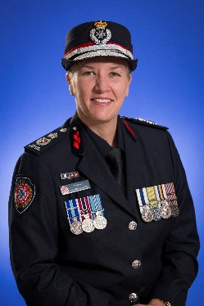 | Katarina Carroll APM  Commissioner  The Commissioner is responsible for leading and managing the efficient functioning of FRS, RFS and SES, and emergency management and disaster mitigation programs and services throughout Queensland. The Commissioner is the Chair of the PSBA Board of Management and represents QFES at local, community, state, national and international forums.
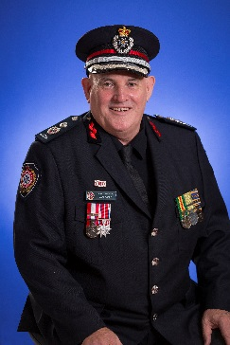 | Mark Roche AFSM GradCertAppMgmt GAICD  Deputy Commissioner, Readiness and Response Services  Chief Officer, Fire and Rescue Service  The Deputy Commissioner, Readiness and Response Services and Chief Officer, FRS is responsible for the leadership and management of FRS operations for the seven QFES Regions. This Service primarily provides the response to emergencies and includes Specialist Response and Planning.  The Deputy Commissioner is also the President of the Australasian Road Rescue Organisation which is the peak body in Australasia for the development and exchange of information, knowledge and skills in road rescue.
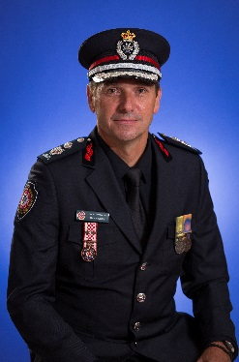 | Mike Wassing BAppSc (EnvMgt and LandUsePolicy) GradDipBusiness (StratMgt) GAICD  Deputy Commissioner, Emergency Management, Volunteerism and Community Resilience  Chief Officer, Rural Fire Service  Chief Officer, State Emergency Service  The Deputy Commissioner, Emergency Management, Volunteerism and Community Resilience, Chief Officer, RFS and Chief Officer, SES is responsible for leading and managing the prevention and community preparedness, and recovery functions for QFES. The role has oversight of the QERMF, emergency management planning for before and after disasters, volunteerism, and strengthening community partnerships to build safe, healthy, confident and connected communities across Queensland.  The Deputy Commissioner is a member on the National Aerial Firefighting Centre Board of Directors and represents QFES on a number of state and national bodies.
 | Doug Smith APM MPubAdmin BA GradCert(HRM) FAIM GAICD  Deputy Commissioner, Strategy and Corporate Services  Chief Strategy Officer  The Deputy Commissioner, Strategy and Corporate Services and Chief Strategy Officer is responsible for leading the department’s strategic framework and vision, driving performance and integrated capability across QFES. The Division includes Strategy, Systems, Standards and Performance; Executive, Ministerial and Corporate Services; and Human Capital Management Directorates and works closely with the public safety agencies.  The Deputy Commissioner and Chief Strategy Officer represents QFES on a number of major committees and boards including the BNHCRC, the Government Wireless Network Governance Board and the Public Safety Portfolio Audit and Risk Committee.
 | Peter Griffin BBus(Comm) GradDipAppFin F Fin GAICD  Chief Operating Officer, PSBA  The Chief Operating Officer reports to PSBA’s governing Board of Management. The Chief Operating Officer supports the Board to perform its functions and give effect to any direction of the Board. The Chief Operating Officer is responsible for the day-to-day operations of PSBA.  The Chief Operating Officer is responsible for leading PSBA in the provision of high quality, sustainable services in alignment with the priorities and policies of the government to deliver the best public safety outcomes for Queenslanders.  The Chief Operating Officer represents the public safety agencies on a number of major committees and boards including the Directors-General ICT Council and the Government Shared Services Customer Board as well as being a member of the Public Safety Portfolio Audit and Risk Committee.

Board and committees
The QFES governance structure comprises the:
- Board of Management (BoM)
- Executive Leadership Team (ELT)
- Audit, Risk and Compliance Committee (ARCC)
- Health and Safety Committee
- Finance and Budget Committee
- Information and Communication Technology (ICT) Committee
- People and Culture Committee
- Workplace Representatives Committee
- Operations Management Committee
- Strategic Projects Committee.
The QFES governance structure and the line of reporting with other bodies is as follows:
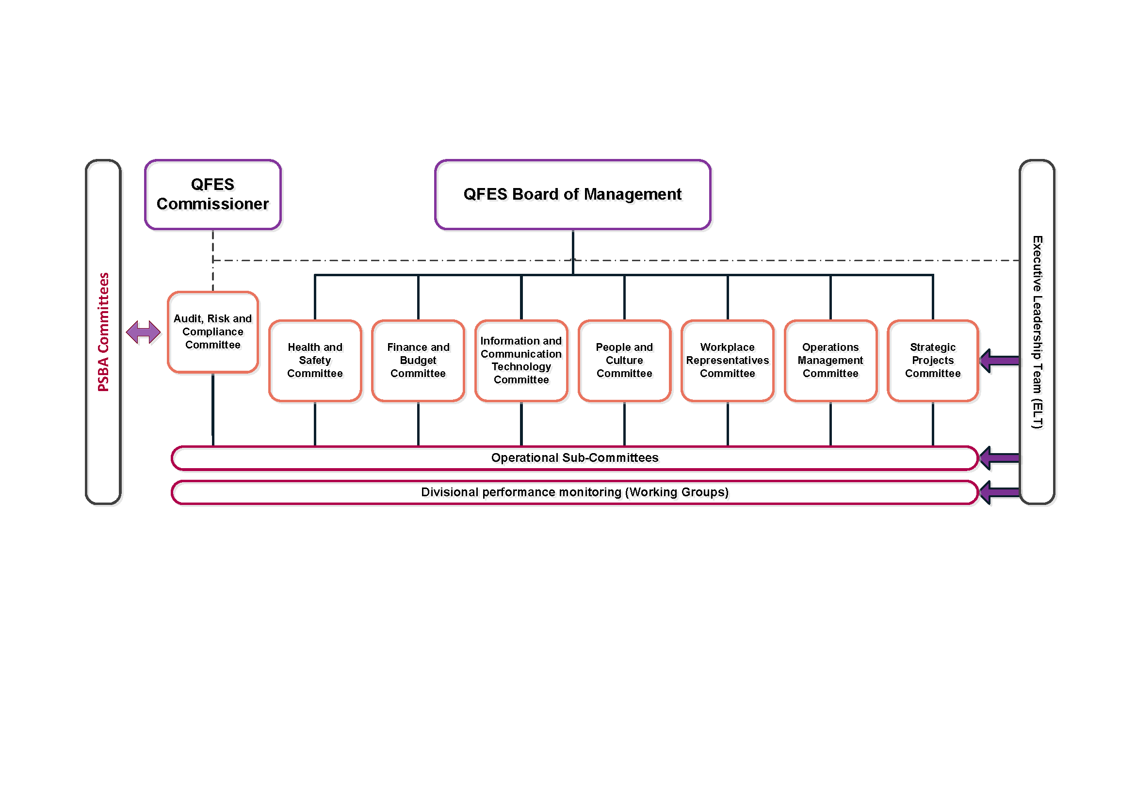
QFES committees support the Commissioner in decision-making and play an assurance role. Each committee has a clear purpose that aligns with achievement of the strategic plan and is charged with monitoring performance of QFES in designated areas.
The governance committees are reviewed annually by the BoM to ensure their structure, membership and purpose continue to support the governance needs of QFES.
In addition to the QFES committees:
- the Public Safety Portfolio Audit and Risk Committee has primary responsibility for audit and risk matters as they relate to PSBA and the Office of the IGEM. It provides relevant information to the standalone Audit and Risk Committees established by QFES and QPS when required (refer pages 80–81).
- PSBA is governed by a Board of Management chaired by the Commissioner, QFES (rotated annually with the QPS Commissioner). The Board’s functions include providing leadership and oversight of PSBA and coordinating the provision of support services, and any programs provided by PSBA to the public safety agencies (refer page 5).

QFES Board of Management
The BoM provides stewardship of QFES by providing information and advice to the Commissioner as the accountable officer of the department. The BoM assists the Commissioner with strategic leadership to meet the objectives of QFES including the vision and purpose, and direction setting to ensure compliance and to improve performance. It provides direction and guidance along with oversight of all governance committees within QFES. The objectives of the BoM include:
- approving the strategic narrative, directions and priorities of QFES, enabling coherent messaging with the Minister and QFES staff
- adopting a long-term perspective and anticipating and responding to changes in the external environment to ensure responsiveness to change in community needs and expectation
- carrying out collective discussion and providing constructive challenge, leadership and input on significant strategic and operational challenges to inform and shape key decisions of the Commissioner and the Minister
- being accountable for the delivery and achievement of QFES’ objectives and outcomes
- considering and communicating to QFES, via the ELT, the strategic direction and imperatives of QFES, along with the QFES risk appetite
- reviewing and approving initiatives referred by the Strategic Projects Committee
- reviewing and approving expenditure as referred by the Finance and Budget Committee.
The BoM meets bi-monthly with emergency or special meetings convened as required. During
2017–18 the BoM met on eight occasions.
Board members
- Katarina Carroll APM, Commissioner (Chair)
- Mark Roche AFSM, Deputy Commissioner, Readiness and Response Services
- Mike Wassing, Deputy Commissioner, Emergency Management, Volunteerism and Community Resilience
- Doug Smith APM, Deputy Commissioner, Strategy and Corporate Services
- Peter Griffin, Chief Operating Officer, PSBA
Achievements
In 2017–18, BoM’s achievements include approving the:
- Fraud and Corruption Control policy and Fraud and Corruption Control plan
- Procurement Plan 2017–2021
- Conflict of Interest policy
- Capital Works Management Framework
- Queensland Fire and Emergency Services Annual Report 2016–17
- Queensland Fire and Emergency Services 2018–2022 Strategic Plan
- Strategic Risk Register
- Volunteerism Strategy strategic priorities and guiding principles
- Overtime and firefighter review
- Five-year strategic budget
- Long-term Fleet Management Strategy
- Uniform Strategy.

Executive Leadership Team
The ELT provides stewardship of QFES by providing information, advice and support to the BoM and working to translate the BoM’s strategic vision for QFES into operations, while having regard to the BoM’s appetite for risk. The ELT provides the BoM with accurate, timely and clear information, and advice and support to enable the BoM to perform its responsibilities. The objectives of the ELT include:
- disseminating the vision and strategy set by the BoM to the wider QFES, embodying and driving the direction of QFES
- developing and communicating the strategic plan for QFES
- developing a shared organisational culture and values to enable achievement of the strategic imperatives of QFES
- directing work to sub-committees, approving the annual work plans and monitoring progress to ensure results are aligned to strategic outcomes
- identifying demand requirements, constraints and allocation of resources
- monitoring the performance of QFES
- overseeing risk management, compliance and assurance mechanisms.
The ELT meets bi-monthly, face-to-face and runs for a period of no more than three days. Monthly interim ELT meetings are held via telephone and emergency or special meetings are convened as required. In 2017–18 the ELT met on six occasions.
ELT members
- Commissioner (Chair)
- Deputy Commissioner, Readiness and Response Services
- Deputy Commissioner, Emergency Management, Volunteerism and Community Resilience
- Deputy Commissioner, Strategy and Corporate Services
- Executive Director, Strategy, Systems, Standards and Performance
- Executive Director, Executive, Ministerial and Corporate Services
- Assistant Commissioner, Emergency Management and Community Capability
- Assistant Commissioner, HCM
- Assistant Commissioner, RFS
- Assistant Commissioner, SES
- Assistant Commissioner, Specialist Response and Planning
- Assistant Commissioner, Far Northern Region
- Assistant Commissioner, Northern Region
- Assistant Commissioner, Central Region
- Assistant Commissioner, North Coast Region
- Assistant Commissioner, Brisbane Region
- Assistant Commissioner, South Eastern Region
- Assistant Commissioner, South Western Region

Achievements
ELT’s achievements for 2017–18 include:
- endorsing the Strategic Risk Register
- endorsing Queensland Fire and Emergency Services 2018–2022 Strategic Plan
- endorsing the Commissioner’s Priorities 2018
- commitment to the strategic alignment of projects
- endorsing the Ethical Decision-Making workshops.

Audit, Risk and Compliance Committee
The ARCC provides independent assurance and assistance to the Commissioner in discharging responsibilities under the Financial Accountability Act 2009 and subordinate standard to establish and maintain appropriate systems of internal controls and risk management.
The committee operates in accordance with its Terms of Reference which were developed in line with Queensland Treasury’s Audit Committee Guidelines: Improving Accountability and Performance. The ARCC’s Terms of Reference is reviewed annually to ensure it remains consistent with the committee’s objectives and responsibilities.
The committee provides independent assurance and assistance to the Commissioner and the BoM on the department’s:
- risk, control and compliance frameworks
- external accountability responsibilities as prescribed in the Financial Accountability Act 2009, the Fire and Emergency Services Act 1990, the Disaster Management Act 2003 and other relevant legislation and support standards
- internal and external audits including identifying internal audit topics, endorsing final reports and overseeing the adequate implementation of recommendations.
The committee meets quarterly with emergency or special meetings convened as required. The committee held its inaugural meeting on 28 July 2017 and during 2017–18 met on four occasions.
The independent Chair received $7,725 (including GST) in remuneration for services provided in
2017–18 and the second external member received $3,500 (including GST). There were no other on-costs.
Committee members
- Sue Ryan, Chair (independent Chair)
- Glenn Poole (external member)
- Deputy Commissioner, Strategy and Corporate Services
- Executive Director, Executive, Ministerial and Corporate Services
- ELT member (on a 12 monthly rotational basis)
- Director, Operations, RFS

Achievements
During 2017–18 the committee’s achievements include:
- providing oversight of the internal and external audit programs including monitoring compliance with the Annual Internal Audit Plan 2017–18 and Strategic Internal Audit Plan 2018–2021 and the status of open recommendations
- providing oversight of key areas of compliance including privacy and right to information; QFES’ ethical framework; RFS’ volunteer application and recordkeeping processes; workplace health and safety; and departmental application of blue card accreditation
- monitoring the implementation of recommendations from key reviews
- endorsing the department’s revised Risk Management Framework and associated guidelines and the Strategic Risk Register
- monitoring the effectiveness of controls in relation to the department’s strategic risks
- reviewing and noting the Chief Finance Officer’s Statement of Assurance
- reviewing the accounting practices in relation to the Emergency Management Fund
- noting legislative changes relating to financial reporting requirements.

Health and Safety Committee
The Health and Safety Committee provides stewardship of health and safety related matters within QFES. It provides a forum for discussion and determination of key departmental priorities regarding health, safety and wellness matters, providing connection between regional health and safety committees and QFES executive management. The objectives of the committee include:
- directing the long-term strategy of QFES in a manner consistent with the strategic plan and providing strategic direction of health, safety and wellness matters
- facilitating cooperation between QFES and employees in instigating, developing and carrying out measures designed to ensure the health and safety of the employees in the workplace
- facilitating cooperation in the development and carrying out of initiatives to improve the health, safety and wellbeing of all QFES employees through the review and approval of training and organisational wide communications
- monitoring and advising on responses to health, safety and wellness, and WorkCover performance across QFES with a focus on emerging trends
- promoting consistent and better practice in health, safety and wellness management throughout QFES
- supporting effective consultation and communication on QFES improvement strategies, policies and procedures relating to wellbeing, health and safety, and WorkCover
- appropriately referring requests for expenditure to the relevant QFES committee
- identifying projects that aid in the achievement of the strategic direction of QFES and referring these to the BoM.
The committee meets monthly with emergency or special meetings convened as required. The committee held its inaugural meeting on 26 July 2017 and in 2017–18 met on 10 occasions.

Committee members
- Deputy Commissioner, Readiness and Response Services (Chair) (rotated on a 12 monthly basis)
- Assistant Commissioner, HCM
- Assistant Commissioner, RFS
- Assistant Commissioner, SES
- Regional Assistant Commissioner (rotated on a 12 monthly basis)
- Director, Human Resource Management
Achievements
The committee’s achievements in 2017–18 include:
- establishing the FRS, RFS and SES Operational Health and Safety Sub-Committees
- establishing the Mental Health Sub-Committee
- supporting and reviewing the QFES Workplace Health and Safety legislative and statutory compliance standards
- reviewing the QFES Safety Performance and Health Report 2013–2017
- endorsing the QFES Influenza Vaccination Program 2017
- progressing the development of an appropriate health and safety representatives and workgroup framework in conjunction with industrial bodies.

Finance and Budget Committee
The Finance and Budget Committee provides stewardship of finance and budgetary related matters within QFES. The committee oversees QFES’ financial performance and provides advice on the effective strategic development and coordination of the financial management and budget policy and prioritisation of QFES expenditure, while seeking to foster a culture of fiscal responsibility. The objectives of the committee include:
- directing the long-term strategy of QFES in a manner consistent with the strategic plan and providing strategic direction of finance and budgetary matters
- driving the development of the long-term financial plan for QFES to ensure resources are allocated in a manner consistent with the strategy of QFES and to support high quality outcomes
- strengthening the culture of financial management in decision-making and building financial capabilities across QFES
- prioritising and administering capital expenditure investment to ensure alignment to the QFES strategic plan and approving the asset procurement policy and plan
- advising all QFES committees on finance and budget policy, financial performance, financial risks and mitigation
- monitoring financial management systems to support the agency in meeting corporate governance and financial management responsibilities
- monitoring financial statement preparation and management of linked issues, along with directing and monitoring budget development
- reviewing and approving referred requests for expenditure from other QFES committees and where appropriate referring those requests to BoM
- providing oversight of financial performance and reporting
- identifying projects that aid in the achievement of the strategic direction of QFES and referring these to the Strategic Projects Committee.
The committee meets monthly with emergency or special meetings convened as required. In 2017–18 the committee met on 11 occasions.
Committee members
- Deputy Commissioner, Strategy and Corporate Services (Chair)
- Deputy Commissioner, Readiness and Response Services
- Deputy Commissioner, Emergency Management, Volunteerism and Community Resilience
- Executive Director, Executive, Ministerial and Corporate Services
- Chief Finance Officer, General Manager, Business Services Division, PSBA
Achievements
In 2017–18, the committee’s achievements include:
- developing and revising as required the Five-year strategic budget
- establishing the QFES Strategic Investment Prioritisation Fund
- embedding a conservative approach to revenue and continued fiscal responsibility.

Information and Communication Technology Committee
The ICT Committee provides stewardship of information management pathway related matters within QFES and holds accountable those who have responsibility for delivering these requirements. The objectives of the committee include:
- defining the QFES information management pathway requirements
- overseeing the development of information management policy and standards to support the strategic objectives of QFES and to ensure compliance
- supporting the Precision Information Environment (PIE) which will provide QFES with tailored access to information and decision support capabilities that adapt to the varying users and phases of emergency management
- leading and shaping the public safety agencies regarding public safety communications and the use of strategic, tactical and operational information and intelligence
- leading and shaping the QFES public safety communications
- interfacing as required with the Public Safety Agency ICT Sub-Committee and other key stakeholders to ensure the effective use of ICT as an enabler to assist QFES in achieving its strategic objectives
- aligning with the national and international public safety agenda, that is AFAC, etc.
- overseeing the provision of market scan/trend analysis to support the QFES information management pathway and the creation, management and use of information (current and future state) to accomplish the department’s strategic objectives
- appropriately referring requests for expenditure to the relevant QFES committee
- identifying projects that aid in the achievement of the information management direction of QFES and referring these to the Strategic Projects Committee.
The committee meets monthly with emergency or special meetings convened as required. In 2017–18 the committee met on five occasions.
In 2018–19 this committee is being renamed the Communication and Information Committee as the committee’s focus shifts from technology and solutions to strategic communication and information.

Committee members
- Deputy Commissioner, Strategy and Corporate Services (Chair)
- Executive Director, Strategy, Systems, Standards and Performance
- Assistant Commissioner, RFS
- Director, Strategy and Planning
- Director, Strategic Platforms and Systems
- Chief Information Officer, Frontline and Digital Services, PSBA
Achievements
In 2017–18, the committee’s achievements include:
- establishing the ICT Sub-Committee to provide stewardship in relation to ICT applications and systems within QFES
- endorsing the QFES Office 365 Project
- approving the short-term solution to procure software for QFES fleet maintenance
- approving the Response Advice in Chemical Emergencies (RACE) Incident Database (RID) software upgrade
- providing input to and visibility of QFES’ Bring Your Own Device (BYOD) Standing Order
- endorsing sequential migration and interim continued use of the REDI-PORTAL information system.
In addition, under the ICT-Sub-Committee a number of high-level tasks, delegated by the ICT Committee, were undertaken for which working groups were formed including the Application Suitability, Nexus Governance, Mobilisation Lexicon, and Disaster Management Data Coordination Working Groups.

People and Culture Committee
The People and Culture Committee provides stewardship of people and culture related matters within QFES. These include industrial relations matters, overseeing and monitoring the development, implementation and evaluation of strategies and activities to promote a positive organisational culture and alignment of QFES human resource capacity and capabilities to achieve the strategic plan. The objectives of the committee include:
- directing the long-term strategy of QFES in a manner consistent with the strategic plan and providing strategic direction of people and culture matters
- directing the development and implementation of strategic people management initiatives including targeted investment, talent management, leadership development and succession planning
- providing leadership and oversight for systematic workforce reviews and surveys
- promoting professionalism and alignment with the vision and goals of QFES
- focusing on the betterment of workforce management, diversity, equity and inclusion, training and development matters within QFES
- monitoring organisational culture
- identifying and implementing improvement initiatives that have a positive impact on the culture of QFES
- appropriately referring requests for expenditure to the relevant QFES committee
- identifying projects that aid in the achievement of the strategic direction of QFES and referring these to the Strategic Projects Committee
- ensuring QFES complies with all relevant legislative requirements and standards.
The committee meets monthly with emergency or special meetings convened as required. The committee held its inaugural meeting on 21 July 2017 and in 2017–18 met on 11 occasions.
Committee members
- Deputy Commissioner, Emergency Management, Volunteerism and Community Resilience (Chair)
- Deputy Commissioner, Readiness and Response Services
- Deputy Commissioner, Strategy and Corporate Services
- Assistant Commissioner, HCM
- Assistant Commissioner, RFS
- Assistant Commissioner, SES
- Regional Assistant Commissioners (two on a rotational basis)
- Director, Human Capital Operations Support
- Director, Human Capital Strategy
- Director, Professional Development and Training
- Chief Superintendent, Workplace Conduct Branch
- General Manager, Human Resources Division, PSBA
- Director, Workforce Strategy, Human Resources Division, PSBA
Achievements
In 2017–18, the committee’s achievements include:
- endorsing the QFES Induction and Nexus Onboarding program
- endorsing the Workplace Conduct Branch’s statement of intent
- approving the Allies of Inclusion program
- approving the Corporate Events Calendar
- endorsing a Discipline policy and a Cancellation of Honours and Awards procedure
- endorsing the continuation of the Emergency Services Cadets Program
- approving the creation of a Workforce Support Unit within the Workplace Conduct Branch
- endorsing the Stakeholder Engagement Regional Plan
- oversight of the department’s overtime and absenteeism audits
- developing key sub-committees including Cultural Transformation, and Ethics and Integrity, as well as multiple working groups.

Workplace Representatives Committee
The Workplace Representatives Committee provides a consultation mechanism to monitor the progress and effectiveness of QFES programs, initiatives and culture, which connects to QFES’ frontline workforce, both paid and volunteer. The objectives of the committee include:
- informing the long-term strategy of QFES in a manner consistent with the strategic plan to cohesively connect frontline workforce matters
- identifying deliverables that aid in the achievement of the strategic direction of QFES.
The committee meets two times a year at the discretion of the chair with emergency or special meetings convened as required. During 2017–18 the committee met on two occasions; its inaugural meeting was held on 23 October 2017, with QFES staff and volunteer members attending the second meeting on 18 June 2018 following their appointment.

Committee members
- Deputy Commissioner, Emergency Management, Volunteerism and Community Resilience (Chair)
- Assistant Commissioner, HCM
- QFES staff (three)
- QFES volunteers (three).
Achievements
In 2017–18 the committee’s achievements include endorsing the Terms of Reference and supporting guidelines.

Operations Management Committee
The Operations Management Committee provides strategic advice and reports to the BoM on operational matters of:
- organisational posture/position
- capability direction
- strategic operations management policy advice
- service delivery improvement
- operational efficiency and interoperability.
The committee works with all QFES committees to ensure alignment and the interoperability of all services to ensure the minimisation of duplicated service delivery. The committee provides a vehicle to explore service delivery planning, financial investment in frontline assets and alignment of capital investment whilst recognising individual service requirements.
The objectives of the committee include:
- developing the service delivery options for QFES with the community, with a focus on matching mitigation appropriate to hazards, balancing prevention and response
- delivering capabilities to the community in the most efficient method, maximising the capacity of all services within QFES
- identifying interoperability opportunities and minimising waste, overlapping and duplication of effort through standardisation of infrastructure, equipment and training of all services within QFES
- providing strategic operational input into the planning process to ensure the procurement strategies adopted are matched to business requirements
- providing direction into the medium and long-term strategy of QFES in a manner consistent with the strategic plan on service delivery and infrastructure planning
- valuing continuous improvement and innovation
- identifying projects that aid in the achievement of the strategic direction of QFES and referring these to the ELT.
The committee meets monthly with emergency or special meetings convened as required. In 2017–18 the committee met on 11 occasions.

Committee members
- Deputy Commissioner, Readiness and Response Services (Chair)
- Assistant Commissioner, Emergency Management and Community Capability
- Assistant Commissioner, HCM
- Assistant Commissioner, RFS
- Assistant Commissioner, SES
- Assistant Commissioner, Specialist Response and Planning
- Executive Director, Executive, Ministerial and Corporate Services.
- Regional Assistant Commissioners (two on a rotational basis)
Achievements
In 2017–18 the committee’s achievements include:
- endorsing the formation of the Non-Conforming Building Products Working Group including its participation in the inter committee and associated work
- endorsing the Department of Foreign Affairs and Trade Grant Agreement for funding support
2017–2020 for the Queensland DART (AUS-1DART) for USAR operations
- endorsing the AFFF Sub-Committee Terms of Reference and guidelines and supporting a formal audit of QFES sites and decommissioning of in-ground water tanks
- endorsing Closure Reports on disaster management review recommendations for consideration of the Disaster Management Inter-Departmental Committee
- endorsing and implementing the QFES Capital Works Management Framework and Long-term Fleet Management Strategy principles
- endorsing the QFES Fleet Build program.

Strategic Projects Committee
The Strategic Projects Committee provides oversight of and drives accountability within major projects that deliver the strategic direction and investment priorities of QFES. The objectives of the committee include:
- providing strategic leadership, direction and oversight of major projects and initiatives within QFES, and referring matters of high risk or importance to the BoM for further deliberation
- identifying and promoting initiatives that align to the QFES strategic plan
- appropriately referring requests for action or expenditure to the relevant QFES committee
- fostering a performance-based culture across QFES, reviewing, championing and where appropriate endorsing strategic projects and referring those with merit to the BoM for further review and consideration
- identifying emerging issues and risks hindering achievement of the strategic direction of QFES.
The committee meets as required with meetings driven by the emergence or progress of agenda items. During 2017–18 the committee met on five occasions.
The Strategic Projects Committee will be replaced by the Strategic Committee in 2018–19. The Terms of Reference for this committee is under development at 30 June 2018.

Committee Members
- Deputy Commissioner, Strategy and Corporate Services (Chair)
- Deputy Commissioner, Readiness and Response Services
- Deputy Commissioner, Emergency Management, Volunteerism and Community Resilience
- Assistant Director-General, Strategic ICT, Department of Housing and Public Works (independent member)
Achievements
During 2017–18 the committee’s achievements include:
- approving the outcomes and closure of the QFES Capability Realignment Project
- approving the QFES Project Classification Guidelines
- approving the commencement of strategic projects in relation to Automatic Fire Alarm Monitoring and Information Management
- endorsing the progression of QFES Office 365 implementation.

Public Safety Portfolio Audit and Risk Committee
The Public Safety Portfolio Audit and Risk Committee is established under and operates in accordance with the terms of its charter which were developed in line with Queensland Treasury’s Audit Committee Guidelines: Improving Accountability and Performance; the Financial Accountability Act 2009; and the Financial and Performance Management Standard 2009. The charter is reviewed annually by the committee to ensure it remains consistent with the committee’s authority, objectives and responsibilities.
The committee has primary responsibility for audit and risk matters as they relate to PSBA and the Office of the IGEM. It provides relevant information to the standalone Audit and Risk Committees established by QFES and QPS when required. It provides independent assurance and assistance through prompt and constructive reports directly to the accountable officers from the public safety agencies, particularly when issues identified present material risk or threat to those agencies.
The committee is chaired by an independent external expert appointed to the role. Each public safety agency is represented by one member. A second external member also forms part of the committee. The Chair may invite or give approval for other persons to attend a committee meeting.
The committee meets quarterly and met on five occasions during 2017–18.
The independent Chair received $9,622.75 (including GST) in remuneration for services provided in 2017–18 and the second external member received $4,812.50 (including GST). There were no other on-costs.
Committee Members
- Graham Carpenter, Chair (independent Chair)
- Ian Stewart APM, Commissioner, QPS represented by Tracy Linford APM, Deputy Commissioner, Strategy, Policy and Performance, QPS
- Katarina Carroll APM, Commissioner, QFES represented by Doug Smith APM, Deputy Commissioner, Strategy and Corporate Services, QFES
- Iain MacKenzie AFSM, Inspector-General Emergency Management
- Peter Griffin, Chief Operating Officer, PSBA
- Marita Corbett (external member)

Achievements
During 2017–18 the committee’s achievements include:
- overseeing progress on Queensland Audit Office (QAO) issues and the status of the QAO audit program
- considering all audit reports and providing direction regarding implementation of report recommendations and actions
- monitoring compliance with the PSBA Annual Internal Audit Plan 2017–18 and Strategic Internal Audit Plan 2018–2021 and overseeing the status of open recommendations
- contributing to the development of the PSBA Enterprise Risk Management Policy
- endorsing the:
- PSBA Financial Statements 2017–18
- PSBA Annual Internal Audit Plan 2018–19 and Strategic Internal Audit Plan 2019–2022
- PSBA and Office of the IGEM Fraud and Corruption Prevention and Control Policy and Fraud and Corruption Prevention and Control Plan.

Ethics and Code of Conduct

Ethical Standards
The QFES Workplace Conduct Branch established on 1 July 2017 consists of the Conduct Intelligence Unit, the Ethical Standards Unit, the Workforce Liaison Unit and the PSBA Employee Relations Unit.
The Branch worked on initiatives in 2017–18 to ensure a safe, secure and positive workplace that allows people to perform at their best and enjoy coming to work. As QFES grows and evolves to meet emerging local and global challenges, it is important that a wide range of support services are provided to its diverse and widespread workforce.
The Branch focused on several priorities including providing staff with tools to support responsible and ethical decision-making in the workplace and encouraging a culture of honesty and respect where staff have the courage to stand up and speak out about unethical, dishonourable behaviour and poor conduct.
Staff and volunteers can be confident that any complaint they lodge about inappropriate behaviour or misconduct in the workplace will be taken seriously and dealt with appropriately. To reinforce this, the outcomes of a range of disciplinary matters are published on the QFES Gateway. This ensures accountability and transparency, demonstrates QFES takes workplace conduct seriously and gives an insight into the range of issues that emerge, what leads to these situations, the process involved and the lessons learnt.
A two day Ethical Decision-Making workshop was held in December 2017 bringing together senior managers and the ELT. Workshop participants heard from the Crime and Corruption Commission (CCC) Chairperson and Public Service Commission Chief Executive and tested their decision-making with a series of complex workplace scenarios that challenged them to weigh up regulations, morals, ethics and the QFES values (refer page 8), as well as community perceptions and expectations to arrive at appropriate decisions.
The Workplace Support Unit established in April 2018 consists of the Conduct Intelligence and Workforce Liaison Units. Conduct intelligence involves proactively analysing data to form meaningful intelligence that can be acted upon by managers in the workplace. Workforce liaison involves formal correspondence and advice on high level disciplinary and industrial matters. The Workplace Support Unit has appointed seven Workplace Conduct Consultants located throughout the state to coach and mentor managers to effectively handle and supervise workplace conduct and diminished performance matters. In addition, they will collate conduct intelligence and implement conduct related training within their respective regions.

Workplace behaviour and Code of Conduct
QFES continued to promote a high standard of workforce conduct and behaviour during 2017–18 ensuring full-time paid staff and volunteers are trained and understand the standards and expectations of them regarding workplace behaviour and conduct.
Since the establishment of the Workplace Conduct Branch on 1 July 2017 a number of organisational policies and procedures have been developed or revised including the Management of complaints, Conflict of Interest and Personal Use of Social Media policies and associated procedures.

A QFES workplace behaviour and code of conduct awareness training package ‘Think. Say. Do.’ has been designed to influence and inform QFES staff and volunteers in relation to community and government expectations of standards of behaviour in the public service. The training package will be released in August 2018 and is expected to be rolled out across the organisation throughout 2018 and 2019. The training package will be augmented with a series of publications and materials to remind staff and volunteers of the department’s expected standards of performance and behaviour.
Commencing December 2017, the Branch conducted several Ethical Decision-Making workshops both on a state and regional level. The workshops are designed to influence managers to think ethically about making decisions, rather than rules and systems based decision-making. The workshops have been reinforced with statewide publications available via the QFES Gateway, volunteer portals, email and the Response Magazine (QFES’ official magazine). In addition, a series of videos have been produced to influence staff and volunteers to make ethical rather than rules-based decisions in the workplace. The videos are expected to be released to the workforce in August 2018.
The QFES Gateway contains information about the Code of Conduct for the Queensland Public Service, Ethics, and Probity and Conflicts of Interest. Links are also provided to external sites such as the Public Interest Disclosure Act 2010 and Public Sector Ethics Act 1994 as well as contact details for the Ethical Standards Unit.

Risk management and accountability

External scrutiny
A number of state bodies have been established by legislation to provide independent views and/or assurance of the government’s performance. During 2017–18 the following state bodies examined the operations of QFES or other agencies with findings or issues requiring consideration by, or impacting on, QFES.
- Crime and Corruption Commission
The CCC is a statutory body set up to combat and reduce the incidence of major crime and corruption in the public sector in Queensland. Its functions and powers are set out in the Crime and Corruption Act 2001. The CCC investigates crime and corruption, has oversight of both the police and the public sector and protects witnesses.
- Official corruption investigation
In December 2016 QFES referred a matter to the CCC involving possible corrupt conduct by two QFES officers. Both officers were suspended from duty pending the outcome of an investigation into the matter.
Following a joint investigation led by the CCC and assisted by officers from QFES and QPS, the two QFES officers were charged with official corruption contrary to the Queensland Criminal Code, with one also being charged with money laundering contrary to the Criminal Proceeds Confiscation Act 2002.
At 30 June 2018 the criminal charges remain before the courts. One of the officers has been terminated from employment with QFES and the other remains on suspension without pay pending the finalisation of court proceedings.
QFES is committed to ensuring gaps in governance, fraud identification and detection and prevention regarding fraud risk management are identified and that appropriate measures are taken. QFES has taken the following actions to prevent incidents occurring:
- implementation and review of the QFES Governance Framework
- implementation of the QFES committee structure including the establishment of the QFES ARCC
- approval and publication on the QFES Gateway, as well as ongoing communication and review, of the:
  - QFES procurement policy and procurement practices procedure
  - QFES Procurement Plan 2017–2021
  - QFES Fraud and Corruption Control policy and Fraud and Corruption Control Plan
  - Conflict of Interest policy and procedure
- nomination of a Fraud Control Officer who is responsible for maintaining a fraud risk register and reporting all significant issues to the BoM and the QFES ARCC
- provision of training to staff on procurement activities to ensure compliance with procurement practices and policies.

- Queensland Audit Office
The QAO supports the role of the Auditor-General of Queensland in providing Parliament with an independent assessment of the financial management and performance activities of public sector entities. The QAO provides an independent audit service and reports to Parliament to enhance public sector accountability. QAO reports are available online at www.qao.qld.gov.au/reports-resources/parliament
The following audit reports provided recommendations requiring implementation by QFES to improve the effectiveness of risk management, control and governance processes. The QFES ARCC oversees the implementation of recommendations and actions accepted by management.
- Report to Parliament No. 6: Fraud risk management
The QAO assessed if agencies appropriately identify and assess fraud risks, and apply appropriate risk treatments and control activities to adequately manage their exposure to fraud risk; and if agencies’ risk management plans effectively target and address fraud risks and if there were any obvious omissions from risk registers.
QFES was one of five agencies included in the audit.
The review identified that:
- the audited agencies have established a system and process for enterprise risk management; however, none has effectively integrated fraud risk assessments into its existing practices
- the audited agencies consider fraud risk on an ad hoc basis, if at all, and only assess it at a high level rather than through detailed analysis
- some elements of better practice have been included in the agencies’ fraud and corruption control policies and plans, however, some gaps and opportunities to improve were identified
- agencies’ fraud and corruption control plans need to be implemented and monitored
- better information is required from staff to know what fraud risks are emerging and whether their controls to prevent fraud are working.
The audit directed three recommendations at all public sector agencies. QFES agreed with the three recommendations and developed an implementation plan to address the recommendations which is included in the QAO report.
To address the audit recommendations, QFES will conduct an in-depth fraud risk that will enable the department to have the tools to conduct its own assessments annually or as needed. This is expected to be completed by 30 September 2018.
The QFES Fraud and Corruption Control policy and Fraud and Corruption Control plan will be updated accordingly with the list of potential fraud risks and all other required elements identified for improvement on completion of the assessment.

- Report to Parliament No. 8: Confidentiality and disclosure of government contracts
This audit examined the use of confidentiality provisions in Queensland Government contracts. It assessed whether selected departments met contract disclosure requirements and included the:
- adequacy of current guidance available to aid staff in these activities
- impact of these activities on accountability and transparency.
QFES was not an audited entity; however, the report included two recommendations directed at all government departments.
PSBA, as the provider of procurement services to QFES, reports contract disclosure in accordance with the Queensland Government’s Contract disclosure guidelines; this is completed within the limitations of available systems and data. All awarded contracts and standing offer arrangements of $10,000 and over are disclosed unless non-disclosure is required due to the sensitivity of the information (e.g. covert operations). Non-disclosure is very rare and is always documented. PSBA also has a manual detailing the relevant work instructions regarding this process to ensure compliance with the disclosure guidelines.
- Office of the Inspector-General, Emergency Management
The Office of the IGEM provides independent assurance and advice about Queensland’s emergency management arrangements, with a focus on a risk-based approach. It also provides authoritative reporting to enhance accountability and improve outcomes for the community.
The Office undertakes targeted reviews and system analysis to identify risks to emergency management planning, preparedness, response and recovery arrangements and recommends evidence-based improvements.
In 2017–18 the following review reports were released; these reports are available at www.igem.qld.gov.au
- Report 1: 2017–18 The Cyclone Debbie Review
Severe Tropical Cyclone Debbie crossed the coast in the Whitsunday area on 28 March 2017 and resulted in three events which at times were concurrent:
- cyclonic impact and consequential damage including major flooding
- rapid-onset flood events in the south eastern corner of the state
- slow-onset flood events in Central Queensland, particularly Rockhampton.
The Office of the IGEM was tasked with examining these three events and how the disaster management system as a whole responded including:
- providing assurance that there is a robust approach to continuous improvement across all aspects of the disaster management system in Queensland
- ensuring lessons from these events are captured, common themes for improvement are identified and the sharing of good practice is enabled
- ensuring any issues that arose during Tropical Cyclone Debbie are fully understood and improvement strategies identified.
Overall the review found the disaster management system in Queensland performed well in preparing for, responding to, and recovering from Tropical Cyclone Debbie. The review produced 18 recommendations and identified a significant number of good practice actions taken by state government agencies and councils. QFES is either leading or providing support in the implementation of 10 recommendations; two of which are delivered with the remaining eight progressing.

- Report 2: 2017–18 Review of capability at a district and local level: Townsville disaster district
The purpose of this review was to:
- assess district and local level capability to deliver legislated disaster management outcomes against the Standard for Disaster Management in Queensland (the Standard)
- develop an integrated capability strategy for the Townsville Disaster District.
The review assessed the individual and collective capability of Townsville’s seven local disaster management groups across all facets of the disaster management system. Review participants included QFES, LGAQ, QPS, QRA, the Department of Communities, Disability Services and Seniors and the Disaster Management Inter-Department Working Group.
Overall the Townsville disaster district’s capability was assessed as highly effective with many examples of good practice found that would benefit Queensland’s disaster management sector. The groups across the district demonstrated that they met the requirements of the Standard.
The review directed one recommendation to the chairpersons of disaster management groups within the Townsville Disaster District, supported by QFES and QRA, to develop a district action plan based on the capability enhancement strategy.
The QPS is leading the development of a district action plan with QFES supporting the districts as required.

Internal audit
The PSBA Internal Audit Unit is an independent unit that provides advice across a wide range of disciplines including risk, assurance, information technology, finance, compliance and general consulting activities for the public safety agencies including QFES.
The Head of Internal Audit, PSBA is also the nominated Head of Internal Audit for QFES in accordance with the Financial Accountability Act 2009.
The work of the Internal Audit Unit is undertaken in accordance with the Institute of Internal Auditors’ standards and under an approved charter which is consistent with relevant audit and ethical standards.
In accordance with the Financial and Performance Management Standard 2009, an annual internal audit plan and three year strategic audit plan sets the direction of the unit. The PSBA annual internal audit plan 2017–18 and strategic internal audit plan 2018-2021 was endorsed by the QFES ARCC and approved by the Chair of the PSBA Board of Management on 25 September 2017.
The Internal Audit Unit ensures all relevant guidelines, particularly Queensland Treasury’s Audit Committee Guidelines: Improving Accountability and Performance, are adhered to, and the functioning of the unit complies with these guidelines in all material respects.
The unit assists management to achieve its objectives by using a systematic, disciplined approach to review and improve the effectiveness of risk management and internal control and governance processes, improving the overall level of compliance and accountability. Under its approved charter, the unit can undertake a series of review types including compliance (effectiveness), performance (efficiency), financial management and information technology, to identify areas of risk and to improve outcomes. Systems are in place to ensure the effective, efficient and economic operation of the audit function.

Achievements for 2017–18 include:
- progressed delivery of the approved annual internal audit plan 2017–18 through a combination of in-house and co-sourced delivery. Specific QFES audit coverage included:
- a fraud controls review
- a procurement assessment
- an SES Support Group review
- a review of RFS Volunteers Membership.
- commenced a number of ad-hoc or unplanned reviews within QFES including:
- staff exit procedures
- QFES data review.
- indirect audit coverage provided to QFES through the following audit activities:
- review of cyber-crime prevention
- social engineering review
- review of open source intelligence
- review of commonwealth games
- delegations review
- fraud risk assessment exercise.
- no carry forward of 2017–18 audit activities. All planned QFES reviews have commenced, fieldwork completed and are at either draft or final report stage. All planned reviews are expected to be finalised by 30 September 2018.

Information systems and recordkeeping
PSBA as the provider of support services to QFES is responsible for recordkeeping and information systems. PSBA has a dedicated records management team, known as the Information Management Unit (IMU), which provided advice and assistance to QFES in the reporting period resulting in improved efficiencies.
A review of record categories relating to emergency management was continued during 2017–18. On completion of consultation with stakeholders responsible for overseeing emergency management functions within QFES, a revised QFES retention and disposal schedule incorporating fire service and emergency management terms will be submitted to State Archives for approval.
During 2017–18 an audit of regional off-site storage accounts identified records past their retention date. These records were recalled and application of the relevant retention periods resulted in approval to destroy. This action will result in savings of approximately $2,000 per year. This ongoing audit is expected to continue to provide efficiencies for QFES.
The IMU continued working with the Community Safety Operations Command (Brisbane Region) to assist with digitising building fire safety records. Digitisation of approximately 15,000 drawings was completed with scans uploaded to the PSBA electronic document and records management system (eDRMS). The drawings were subsequently disposed of under a digitisation policy developed for the command. As digitisation of all physical records is now complete, IMU has commenced working with the command to develop an annexure to this policy to digitise records maintained on microfiche.

Following the digitising of building fire safety physical records in Brisbane Region, IMU commenced a detailed assessment of the requirements to support and undertake the expansion of digitisation of these records to other QFES regions. Expansion will require the development of a high-level policy to be administered by the QFES Community Infrastructure Branch in addition to a framework designed to be utilised on a ‘region by region’ basis to develop localised procedures, facilitating compliance with whole-of-government recordkeeping policy.
IMU also commenced working with QFES to assist in defining options for expanded access to recordkeeping systems including eDRMS.
Training was provided to QFES officers in the RecFind recordkeeping database and in recordkeeping procedures to ensure new staff understand their recordkeeping responsibilities, with IMU staff providing advice on recordkeeping procedures that relate to day-to-day tasks.
No QFES records were transferred to Queensland State Archives during 2017–18.

Risk management
The department’s risk management framework provides a consistent and effective approach to identifying, mitigating and monitoring organisational risks. It also ensures QFES complies with the risk management requirements documented in the Financial Accountability Act 2009 and appropriately positions the organisation to deliver its strategic objectives.
QFES manages risks at the strategic and operational level through the development of risk registers and by reviewing the effectiveness of identified controls. To support this approach, the ELT and BoM play an active role in the management of the department’s risks through risk identification and participation in regular reviews of the existing risk registers.
The ARCC provides independent oversight of the department’s risk management approach and ensures the management of strategic and operational risks is appropriate and effective.
In 2017–18 the department:
- refreshed its Risk Management Framework and guidelines to ensure they reflect current practice
- continued to undertake staff training on QFES’ approach to risk management and ensured staff and management understand their roles and responsibilities
- held a workshop with ELT representatives to identify any emerging risks and to review QFES’ existing Strategic Risk Register
- held workshops around the state to support regions and directorates in reviewing their operational risk registers
- undertook regular reporting against strategic and operational risk registers to ensure risks were being effectively mitigated
- supported the ARCC to provide independent oversight of QFES’ risk management activities.

Human resources

Strategic workforce planning and performance
Workforce profile
The total number of full-time equivalent staff for QFES including auxiliary firefighters was 3,233.62 as at 30 June 2018. The increase of 0.49 full-time equivalent staff from 2016–17 is mainly attributable to the reduction in auxiliary and temporary firefighters; however, this was offset by the increase in permanent staff and separations over the period.
Between 1 July 2017 and 30 June 2018, the QFES permanent separation rate was 3.86 per cent, 44.74 per cent of the number of permanent staff separations were due to retirements.
Corporate Induction Forum
In 2017–18 two QFES Corporate Induction Forums were held at Kedron with 67 new staff from across the state participating as part of the pilot for a new corporate induction program. The induction program is designed to provide new staff with the information they need on commencing employment with QFES.
Participants learn about the services and capabilities that QFES provides to the community. It also provides an opportunity for new staff to hear about QFES’ values, how their role contributes to the broader purpose and vision of QFES, the expectations of staff behaviour and the support services available to staff.
Emerging leaders
The Challenge of Leadership program develops effective leaders who can implement and drive improvement and innovation, measure team performance and understand what motivates their team members. The program provides an education in the fundamental concepts of leadership and management and an opportunity for participants to apply what they have learned in the classroom back in their workplaces.
Employees who complete the program, which runs over approximately nine months, will be equipped with the knowledge and skills to become competent and confident leaders who can motivate their teams to be innovative and produce measurable results.
A group of 26 operational and non-operational staff commenced the Challenge of Leadership program run by Leadership Management Australia in November 2017.
In addition, 11 emerging leaders and seven executive leaders attended the Executive Challenge Academy Emerging Leaders Program for 2017–18 offered by Archersfield Consulting and Management. This program commenced in October 2017 and exposes QFES leaders to a learning community where they look at new ways of thinking and approaching challenges and new connections with other leaders from across sectors and the world. Participants undertake an intensive 12 month leadership journey including executive coaching. Program topics include public leadership; changing cultures; cross-sectoral problem-solving; social change; governance and leadership; policy and strategy development; social, economic, environmental and justice reform; transformational leadership and change; organisation design and development; and creating desired futures for organisations and communities.

Employee performance management framework
With configuration of the Nexus performance and goals, and succession and development modules completed in January 2018, a graduated implementation plan will commence in August 2018. The implementation plan will include information forums, face-to-face training and system familiarisation prior to the official launch to the first target groups commencing 1 July 2019.
The underpinning performance achievement and development framework supports the modules through a non-punitive and contemporary approach focusing on employer and employee expectations, employee success and recognition of employee achievement.
QFES is committed to flexible working arrangements and work-life balance. It offers whole-of-government flexible work practices including job-sharing, telecommuting and family-friendly work arrangements and a wide range of whole-of-government leave arrangements. QFES continues to review the arrangements for flexible work practices to ensure it continues to improve as a contemporary workplace.
In 2017–18 QFES was formally recognised as a Work180 accredited workplace. Work180 is a global jobs platform which pre-screens employers to identify the level of support they provide employees through paid parental leave, flexible work arrangements, leadership programs and much more. QFES has successfully passed the Work180 screening process and is now formally recognised as an employer of choice.
QFES values, supports and promotes the appropriate recognition of its workforce, paid and volunteer, for their bravery, dedication and outstanding service above and beyond what is expected in their roles. The QFES Honours and Awards system continues to provide rewards and recognition offerings to highlight and celebrate the achievements and successes of the QFES workforce. The QFES Honours and Awards booklet is available on the QFES Gateway and QFES website to ensure accessibility to the volunteer workforce and includes links to nomination forms.
Leadership and Management Framework
With a strong focus on organisational transformation through its leaders, QFES continues to develop the Leadership and Management Framework. The development of a leadership continuum will seek to embed a consistent and contextualised QFES leadership philosophy across all levels of the department’s leadership.
In addition, the Executive and Corporate Professional Development Framework will complement and mutually support the Leadership and Management Framework by providing managers with the ability to build bespoke leadership development pathways for current and future leaders. The framework is expected to be released in the latter half of 2018.
This work will align directly with the Nexus performance and goals, and succession and development modules providing QFES with a fully comprehensive and integrated leadership model.
QFES Chaplaincy Support Service
The QFES Chaplaincy Support Service is a statewide, locally based, people-focused chaplaincy service that nurtures and supports the spiritual needs and holistic wellbeing of all active and retired members of QFES’ paid and volunteer workforce, as well as their immediate and extended families. Services include pastoral care and visitation, crisis response, counselling support, ceremonial involvement and community engagement.
Chaplains work in conjunction with the QFES Safety and Wellbeing Unit and the Fire and Emergency Services Support Network (FESSN) to provide holistic care.
The statewide network of QFES chaplains ensures that these support services are available 24 hours a day, seven days a week.
Strategic workforce planning framework
QFES adopts the Public Service Commission’s strategic workforce planning framework to align its service delivery with organisational strategy. In accordance with Strategy 2030, QFES will realign its strategic workforce planning framework with a future-focused, whole-of-department approach to attracting and recruiting talent (for both a paid and volunteer workforce), developing our people, and retaining and supporting our people.
In February 2018 QFES launched stage one of this approach with a recruitment attraction campaign ‘ALL IN. ALL FRONTS.’ to attract new members to the workforce and promote QFES as an employer of choice. The campaign website contains detailed information on a variety of roles, a tool to help members of the public find a role that suits their skills and experience and a range of videos featuring QFES members. The website can be accessed at www.qfes.qld.gov.au/employment
QFES is participating in the Queensland Public Sector Talent Now pilot scheduled to conclude in December 2018. This is an easy to use, integrated online talent solution which allows employees to find their next development opportunity across the sector and for managers to find the right talent for their team.
QFES released its Fairness, Equity and Inclusion Framework during the reporting period. The framework defines QFES’ strategic direction and commitment to inclusion and diversity and helps shape the department’s culture of inclusion. Initiatives of the framework include QFES support of the Queensland Government’s Inclusion Champions of Change and the AFAC-led Fire and Emergency Male Champions of Change programs. A key feature of the framework is the QFES Allies of Inclusion Network — a visible distributed network of QFES staff and volunteers committed to a workplace culture that is fair, equitable and inclusive. The Allies of Inclusion Network provides a ground up approach to engaging staff and volunteers as agents of positive change within their workplace by exercising their circle of control and influence to help build an inclusive culture.
Supporting mental health and wellbeing
QFES supports and contributes to the Queensland government’s Early Action: Queensland Mental Health Promotion, Prevention and Early Intervention Action Plan 2015–17 and the Queensland Suicide Prevention Action Plan 2015–17 by providing support to fire and emergency services staff with a focus on prevention and early intervention for mental health issues and providing support programs for frontline officers focusing on post-incident support.
FESSN is QFES’ counselling and support program for personal or work-related challenges, designed specifically for staff, volunteers and their immediate family. Services include:
- confidential professional counselling available to all QFES staff and volunteers and their immediate families — an independent, external service, managed internally
- 24 hour telephone counselling — available to all QFES staff and volunteers and their immediate families.
- Peer Support Program — a team of specially selected and trained co-workers to help staff cope with personal or work-related difficulties known as Peer Support Officers
- information and education sessions tailored to leaders and general member audiences to develop awareness and skills on a range of mental health related topics
- advice and support services for leaders and managers.
FESSN’s network of highly qualified external psychologists and counsellors are in private practices across the state. Each counsellor has been specifically selected for their experience working with emergency services workers and the challenges this can bring (e.g. relationship issues, post traumatic stress and depression). Each FESSN counsellor is registered with a relevant nationally recognised professional association that regulates the profession and monitors the quality of practice.
FESSN has sophisticated critical incident organisational directives and processes for notification and responding to operational experiences that present potential psychological risk. Leader advice services are typically provided by telephone and delivered by an organisational and clinical psychologist with extensive experience in leadership.
Peer Support Officers are selected and trained to relate to colleagues who may be experiencing difficulties across the state. Their experiences place them in a unique position to provide understanding and practical and timely support.
QFES is also an active contributor to the continual development of mental health within emergency services through groups such as AFAC, and actively participates in knowledge development through initiatives like the beyondblue National Mental Health and Wellbeing Study of Police and Emergency Services.

Early retirement, redundancy and retrenchment
No early retirement, redundancy or retrenchment packages were paid to QFES staff during 2017–18.

Financial statements

Queensland Fire and Emergency Services
Financial statements
For the year ended 30 June 2018

Statement of comprehensive income 95
Statement of financial position 96
Statement of changes in equity 97
Statement of cash flows 98
Notes to the statement of cash flows 99
Notes to and forming part of the financial statements 2017–18 100
Management Certificate 118
Independent Auditor’s report 119

Statement of comprehensive income
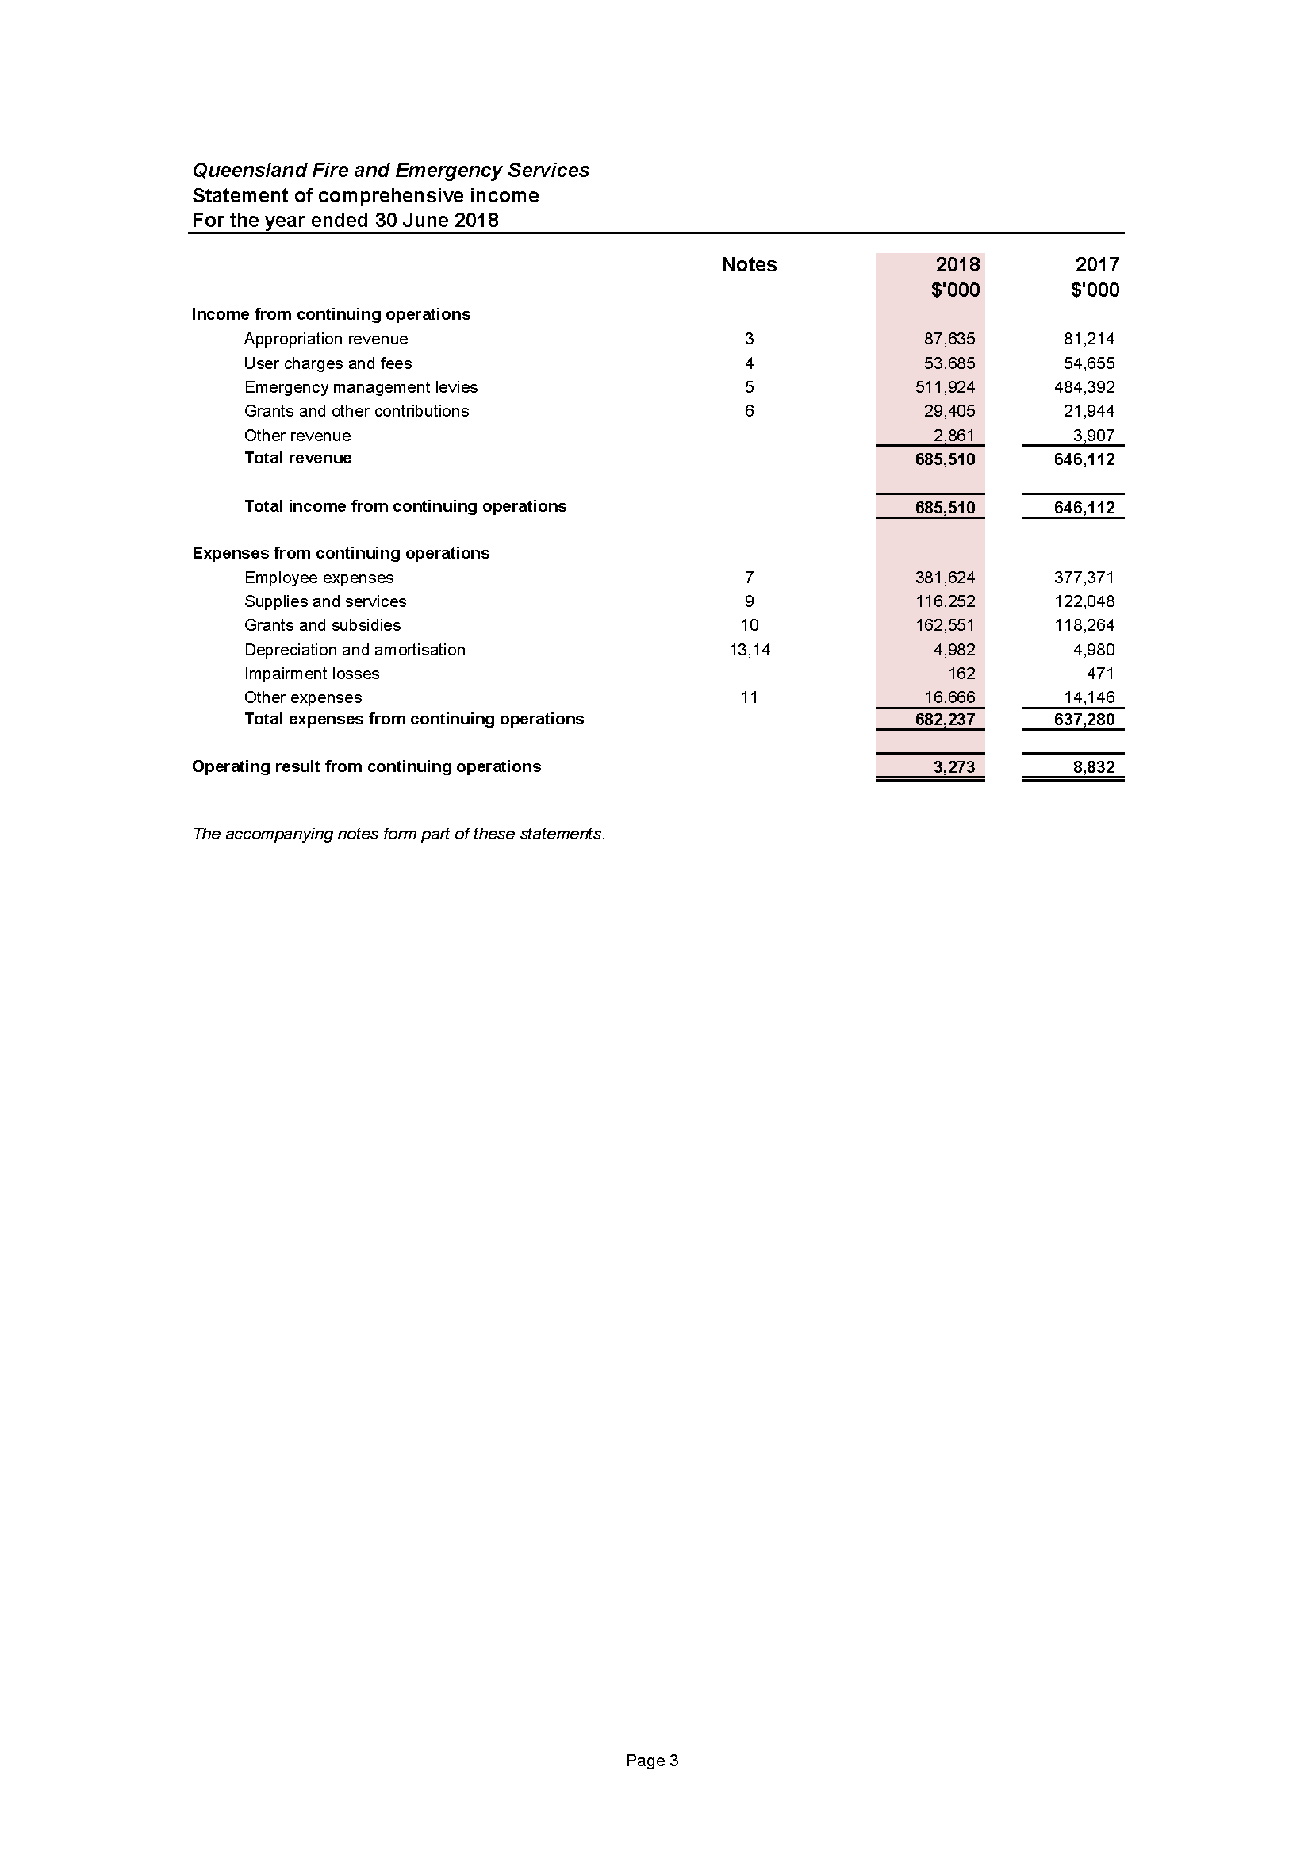

Statement of financial position
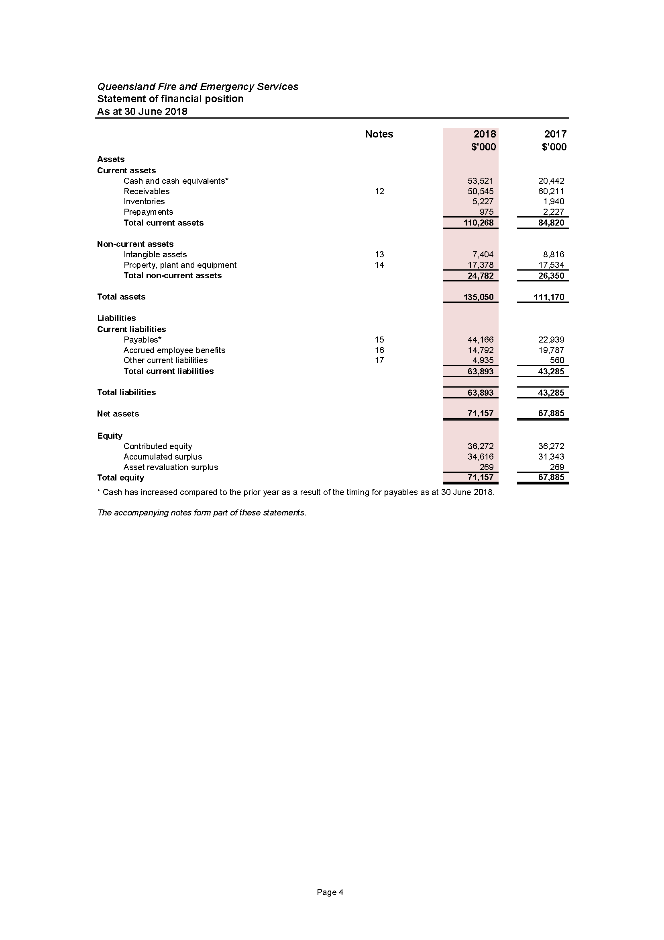

Statement of changes in equity
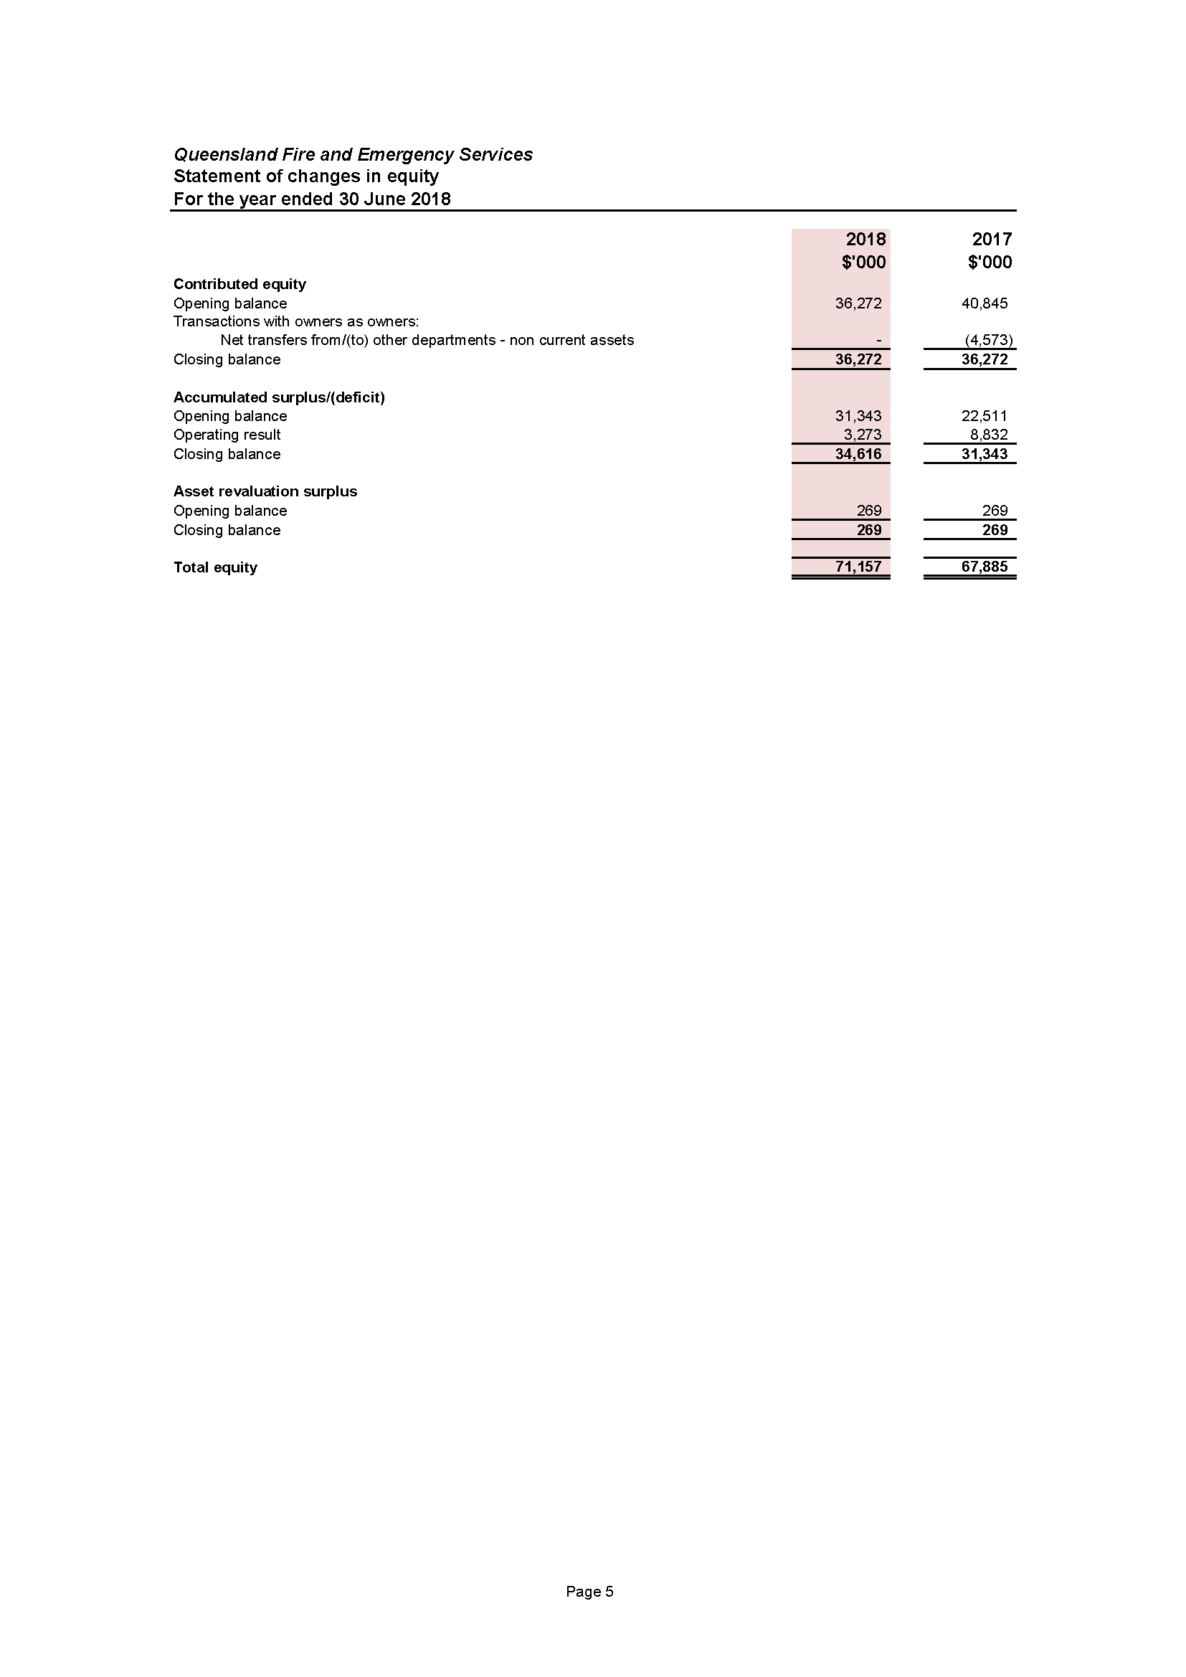

Statement of cash flows
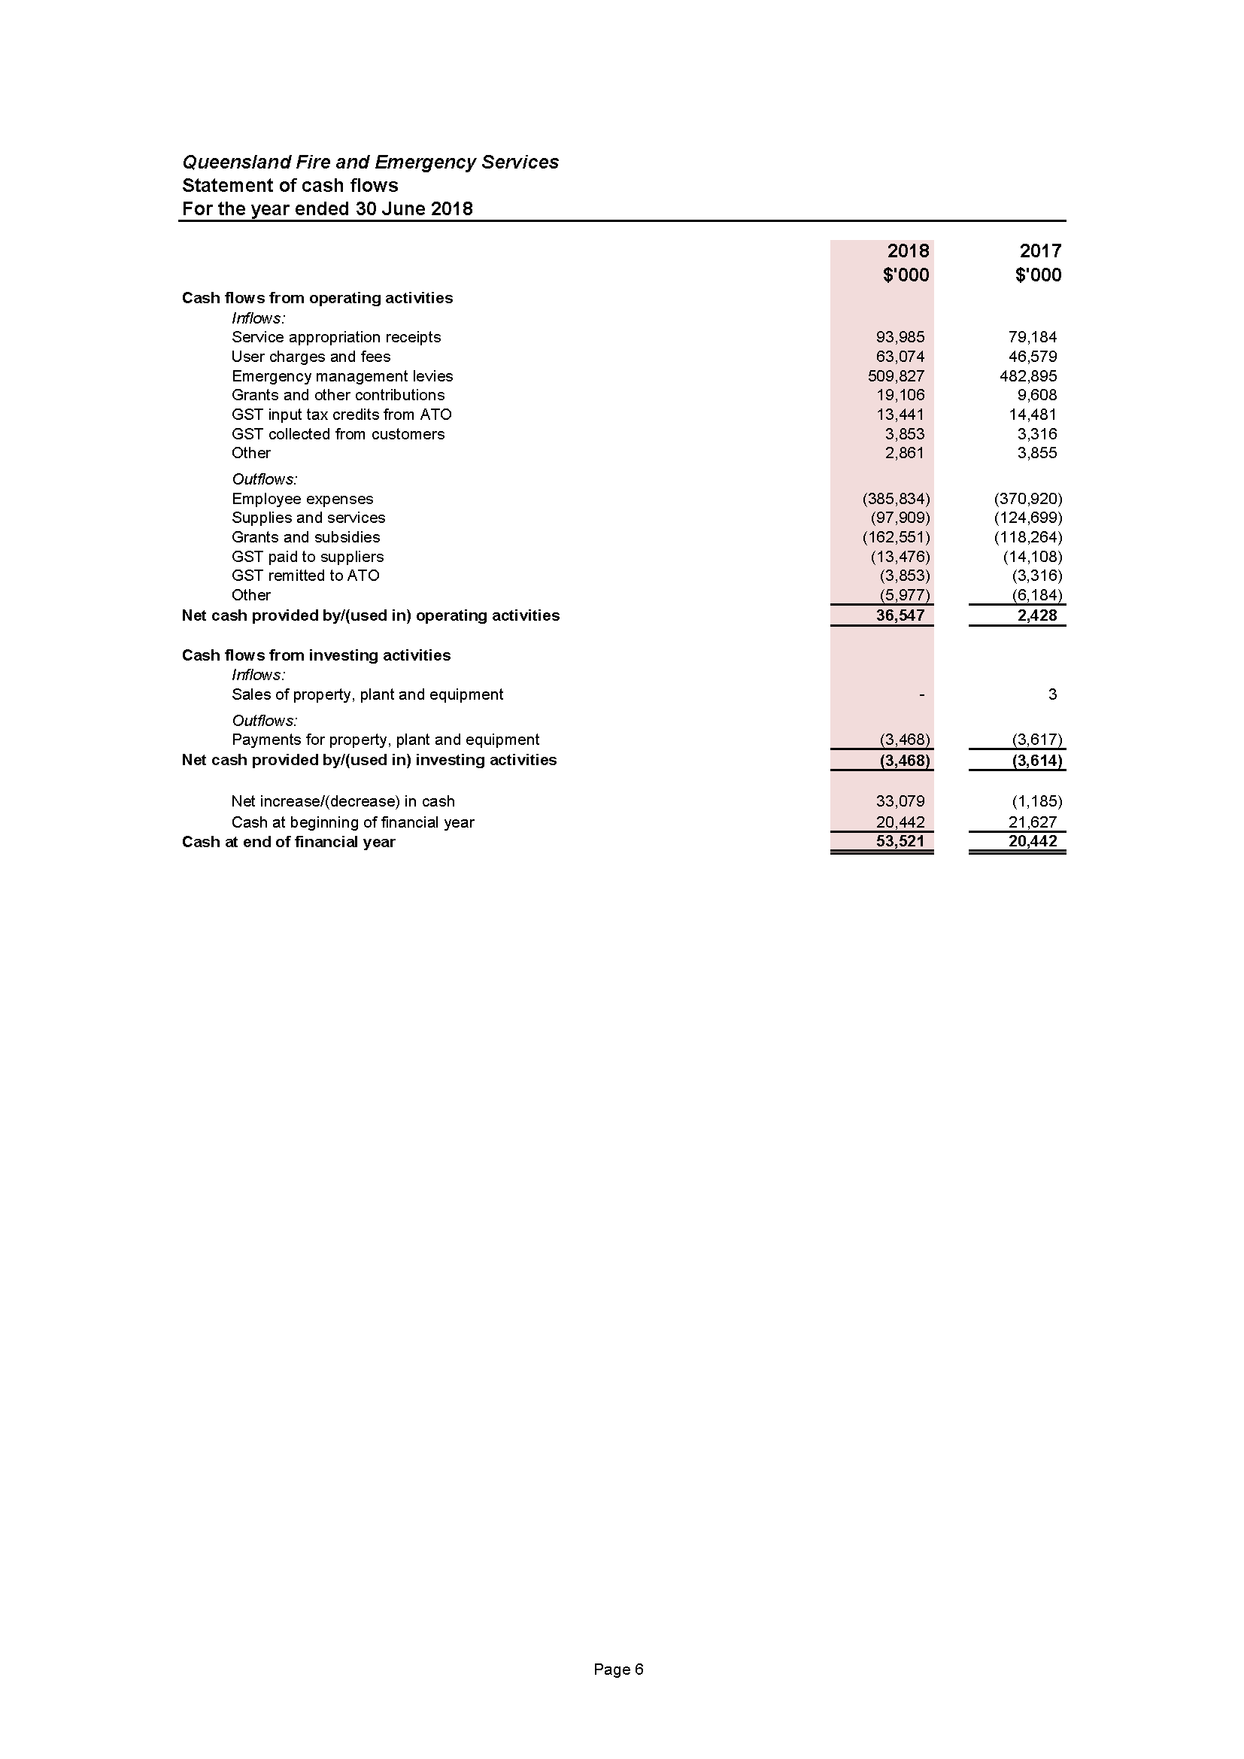

Notes to the statement of cash flows
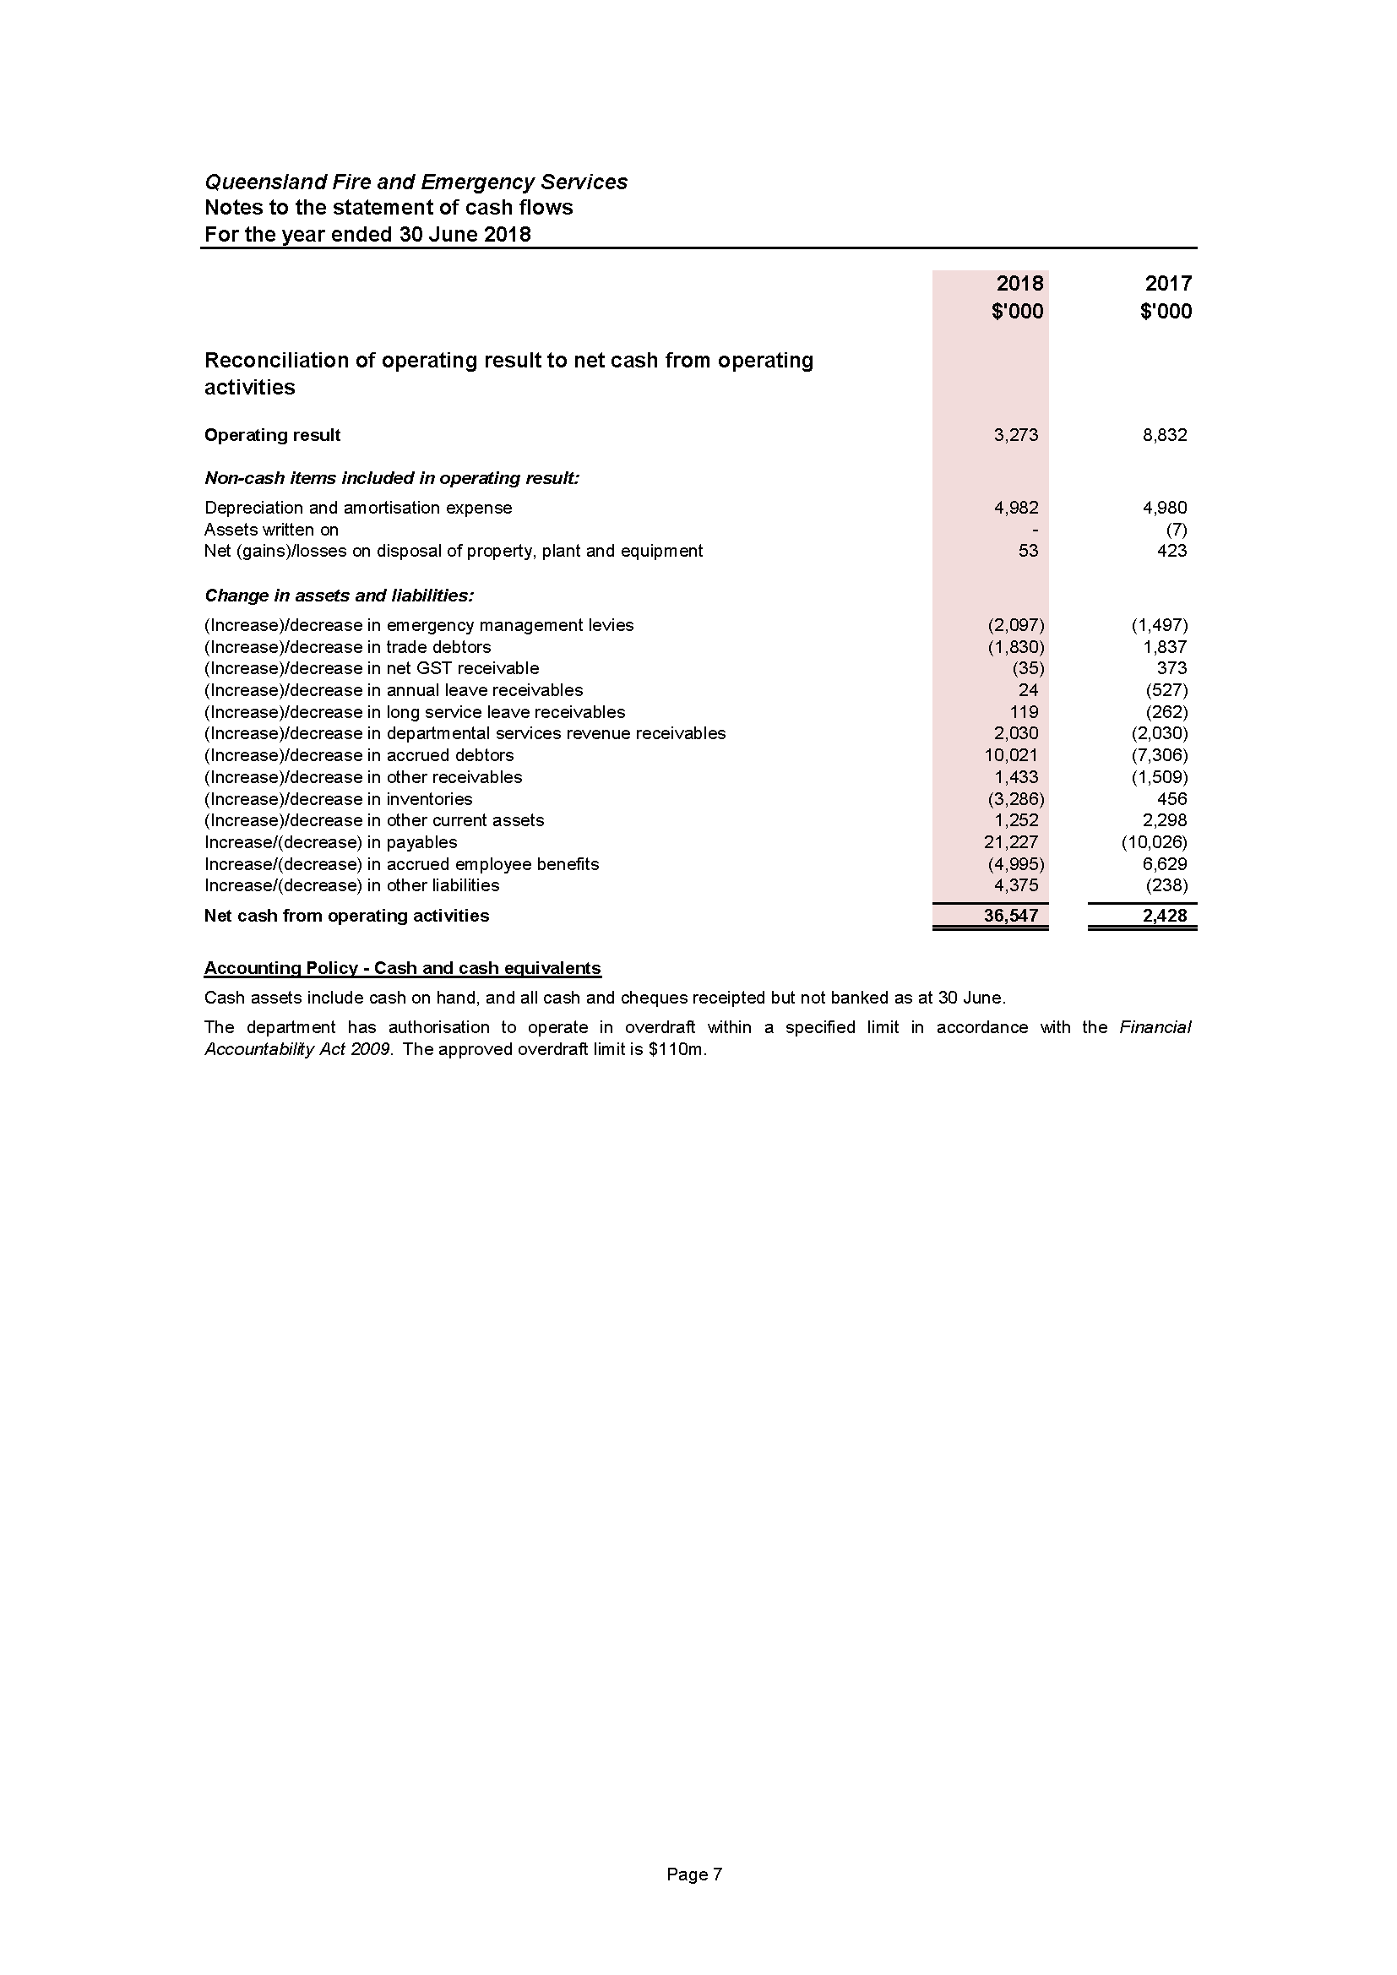

Notes to and forming part of the financial statements
2017–18
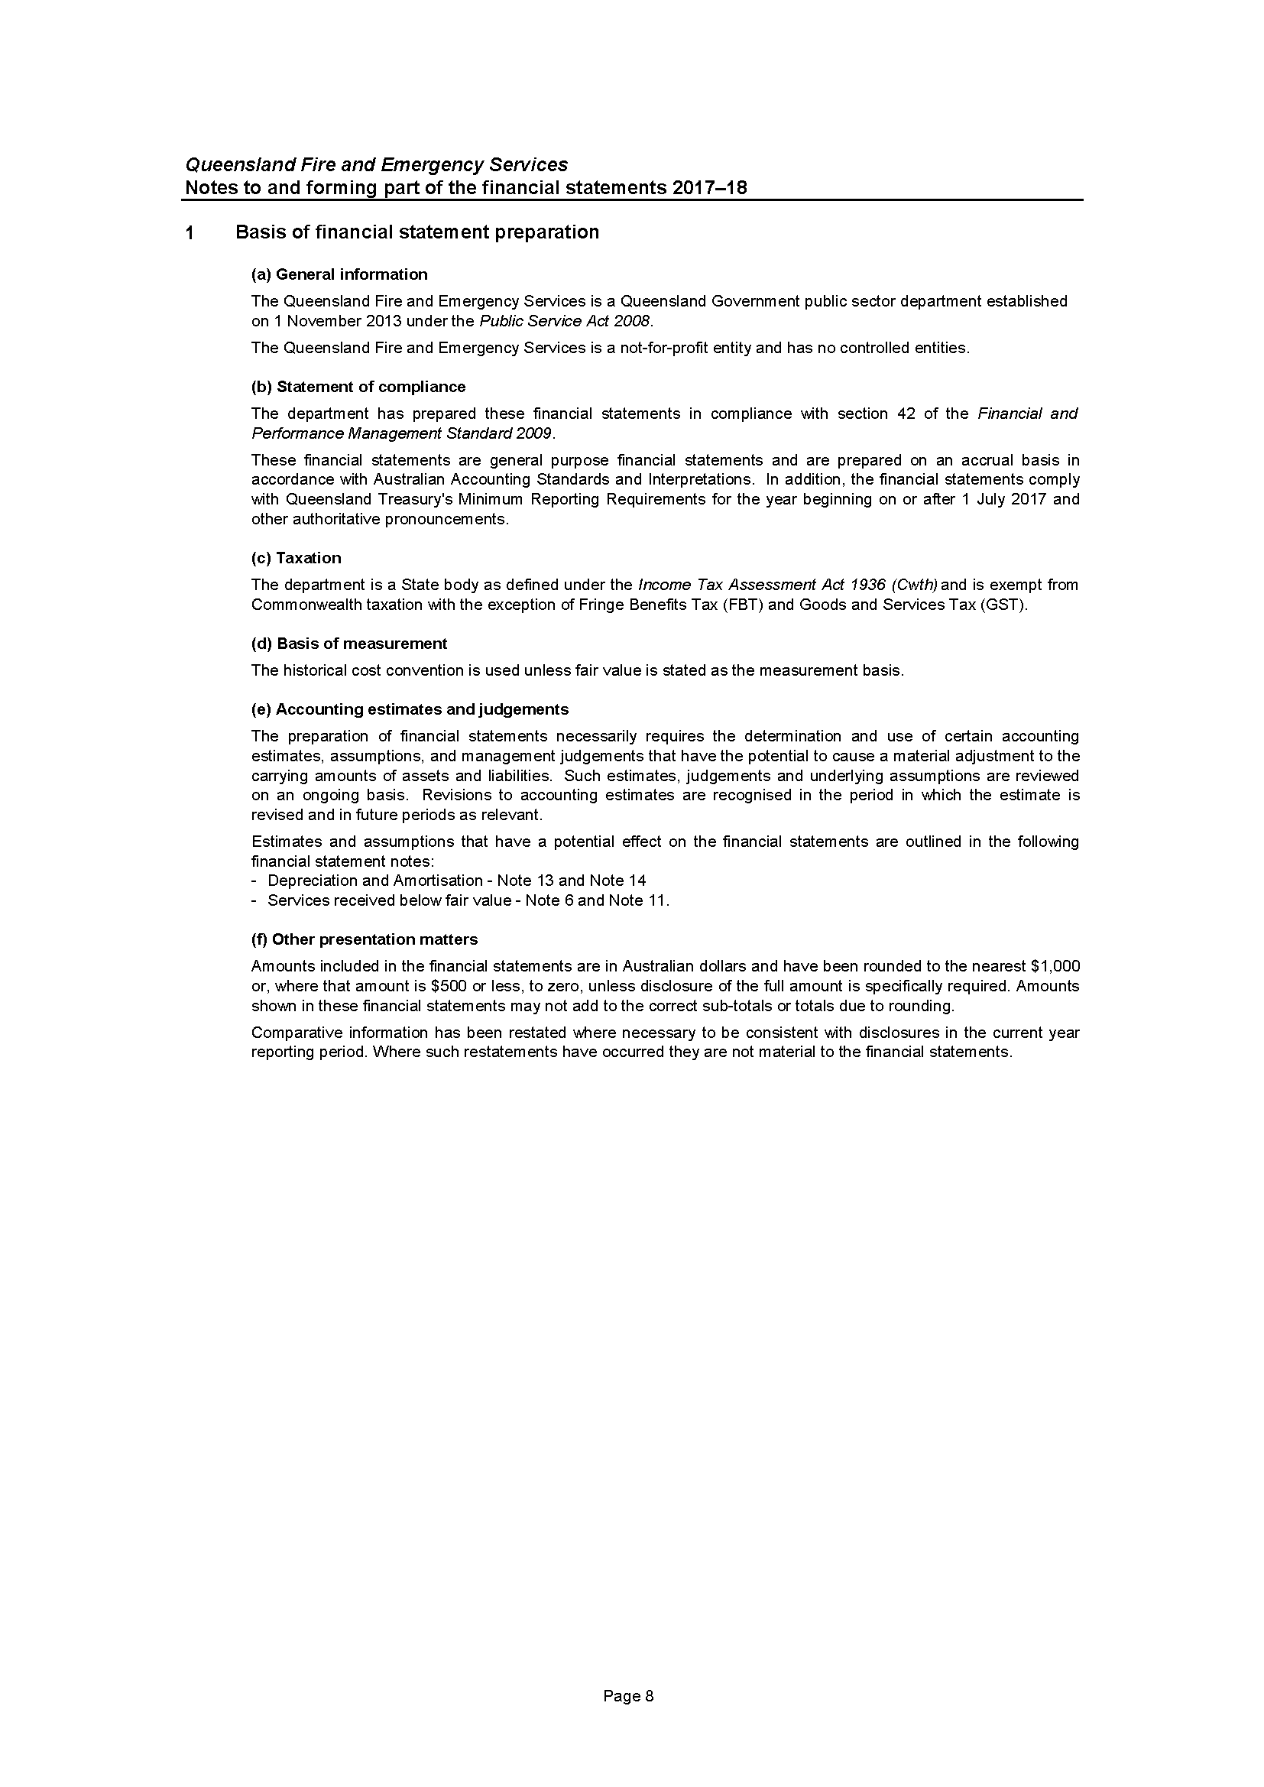
Notes to and forming part of the financial statements
2017–18 (cont’d)
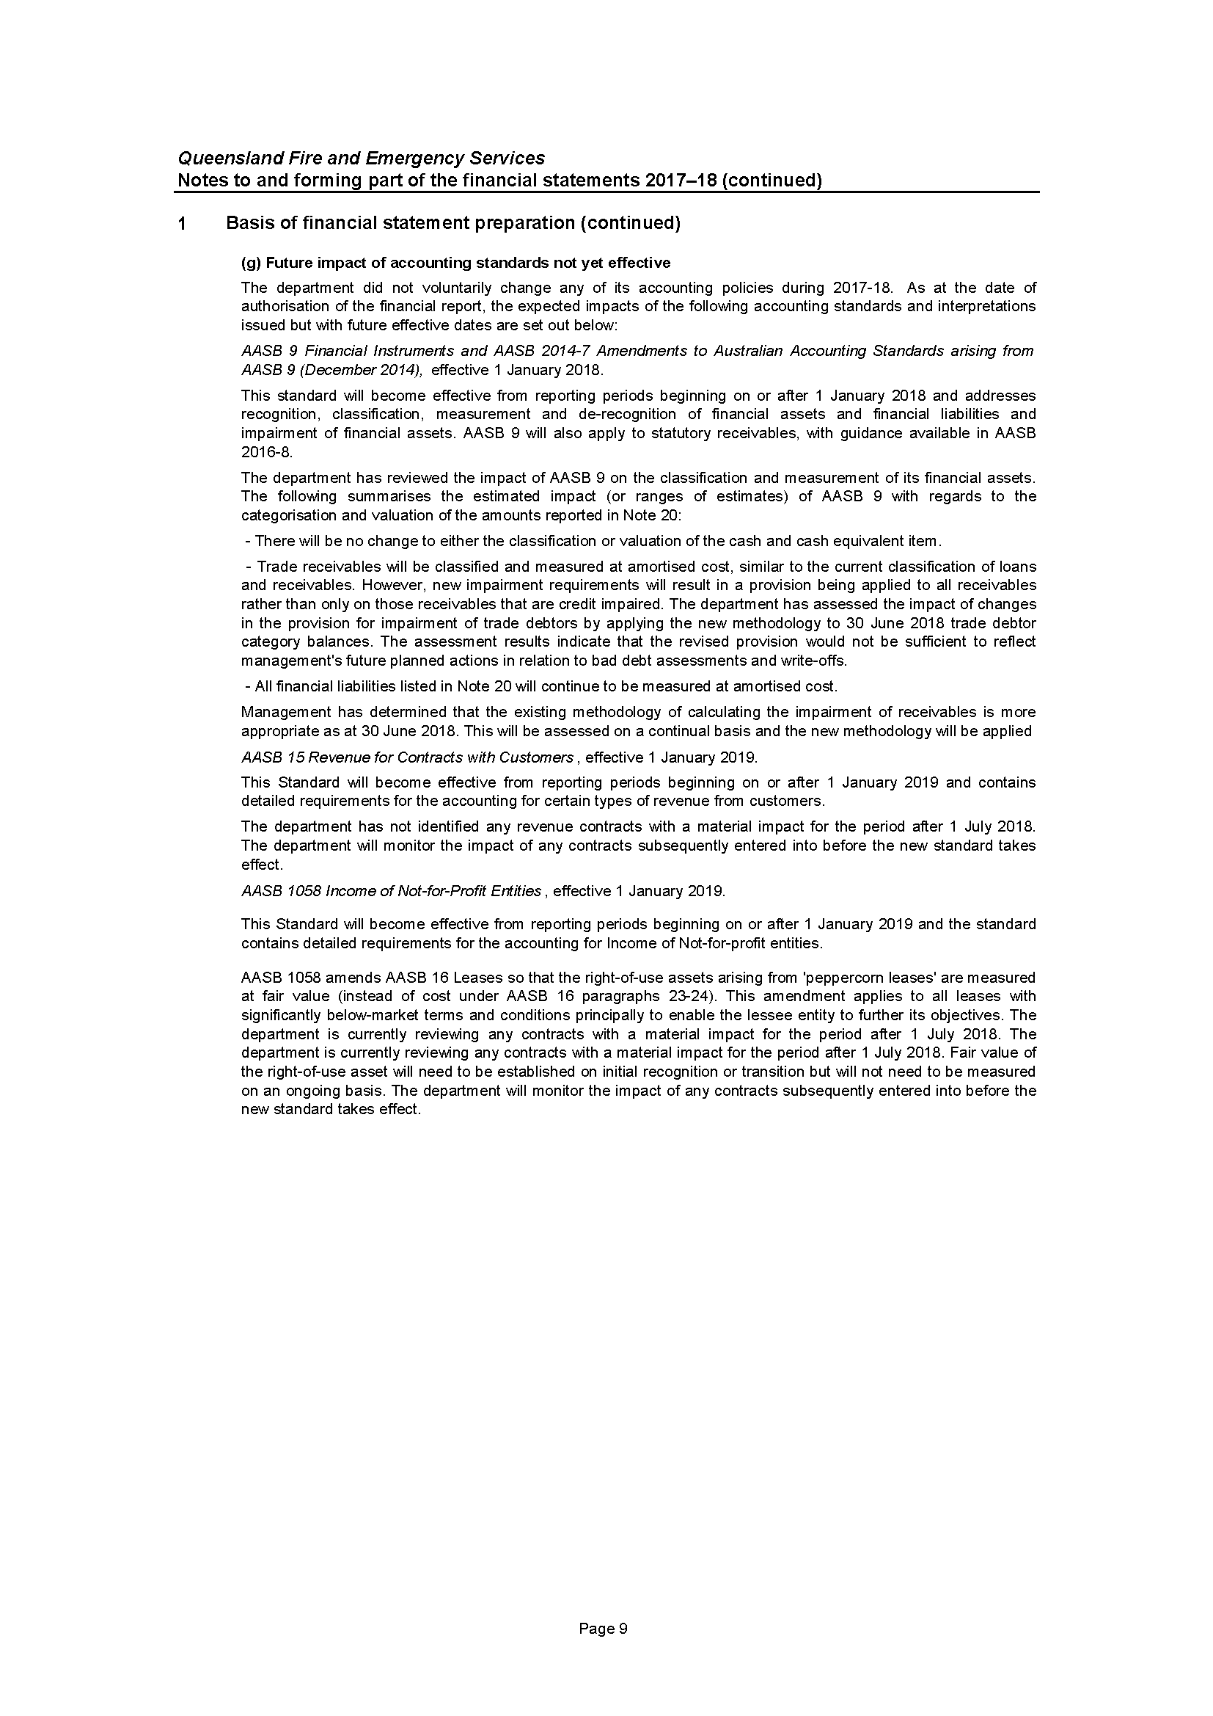
Notes to and forming part of the financial statements
2017–18 (cont’d)
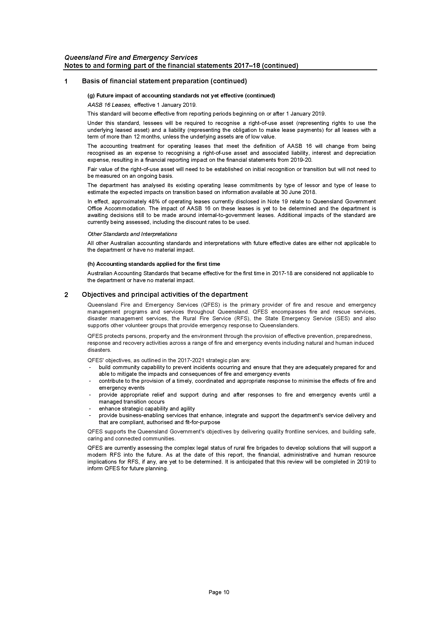
Notes to and forming part of the financial statements
2017–18 (cont’d)
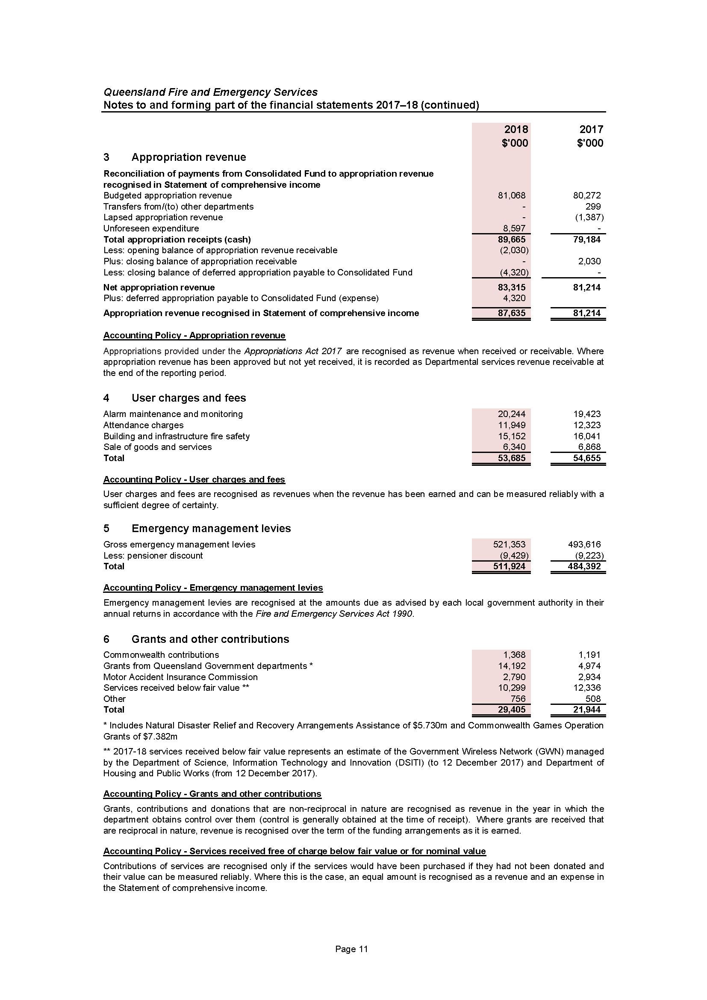
Notes to and forming part of the financial statements
2017–18 (cont’d)
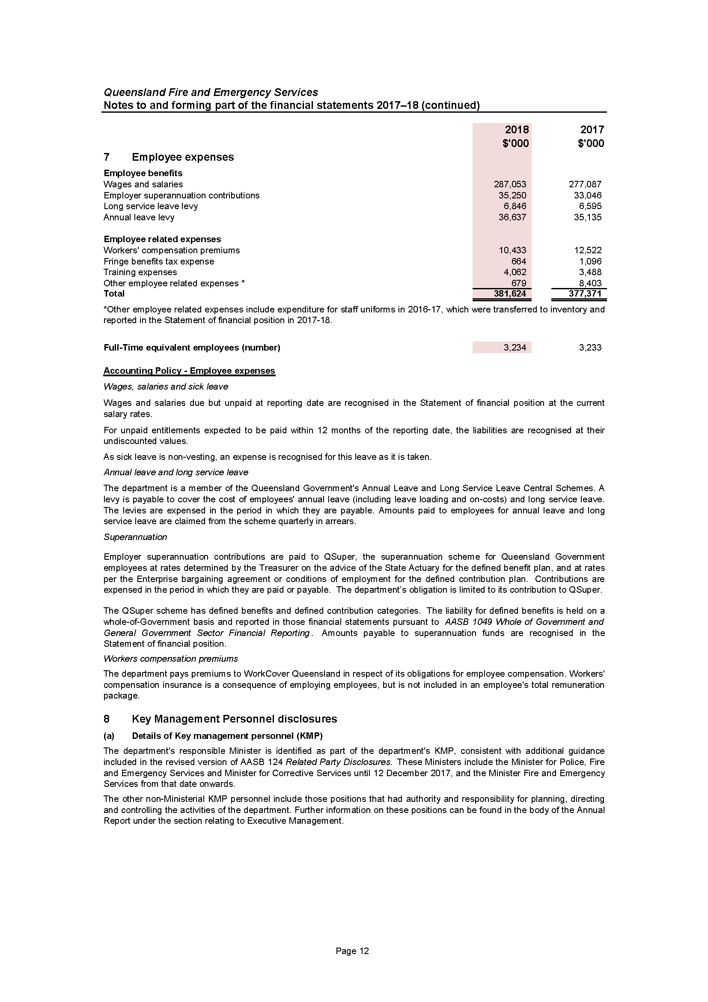
Notes to and forming part of the financial statements
2017–18 (cont’d)
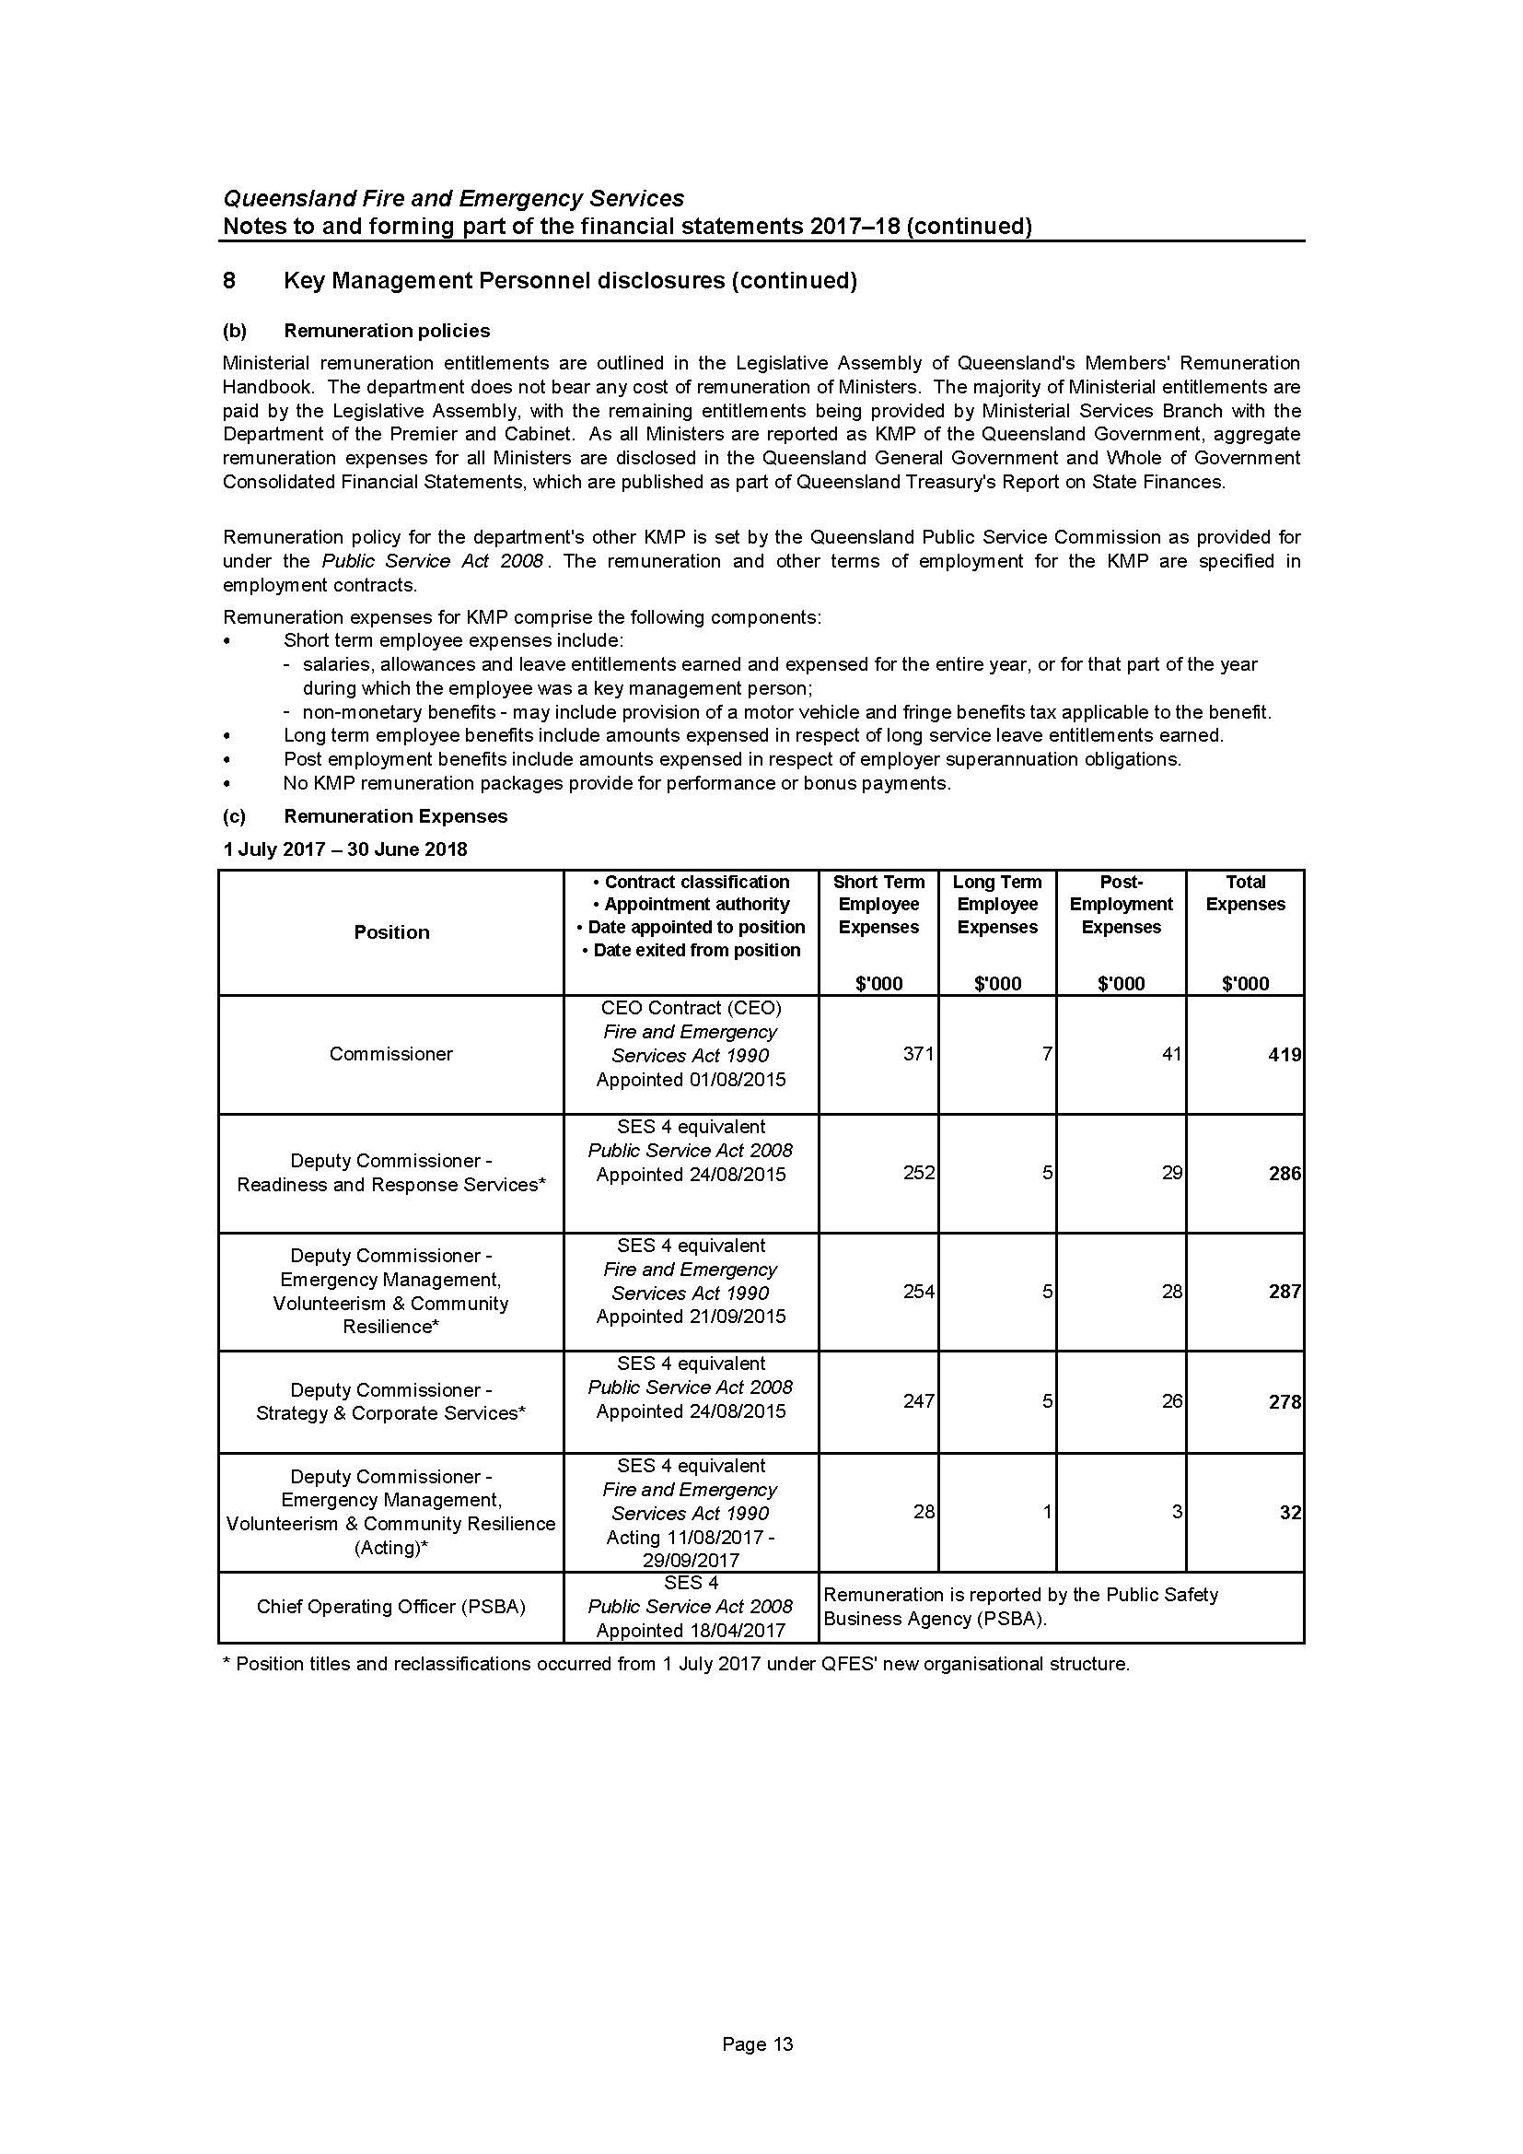
Notes to and forming part of the financial statements
2017–18 (cont’d)
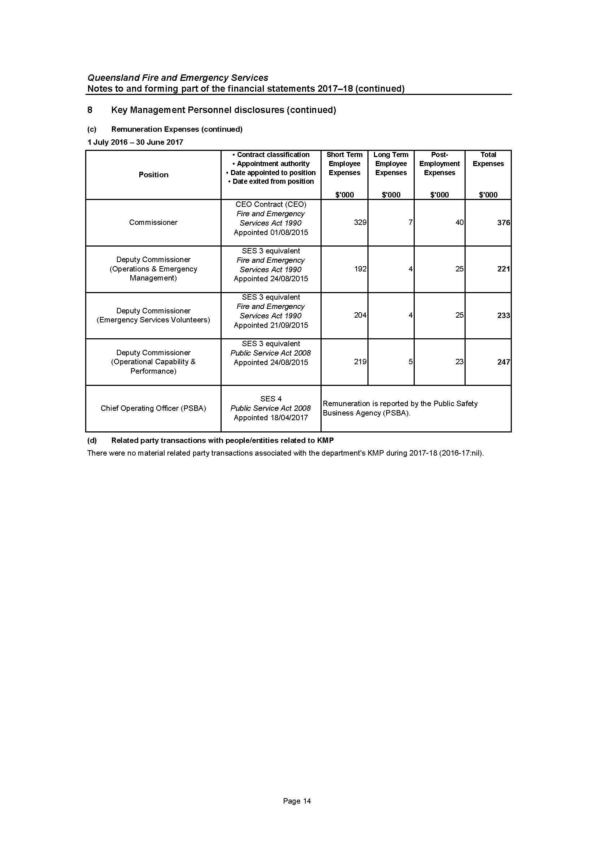
Notes to and forming part of the financial statements
2017–18 (cont’d)
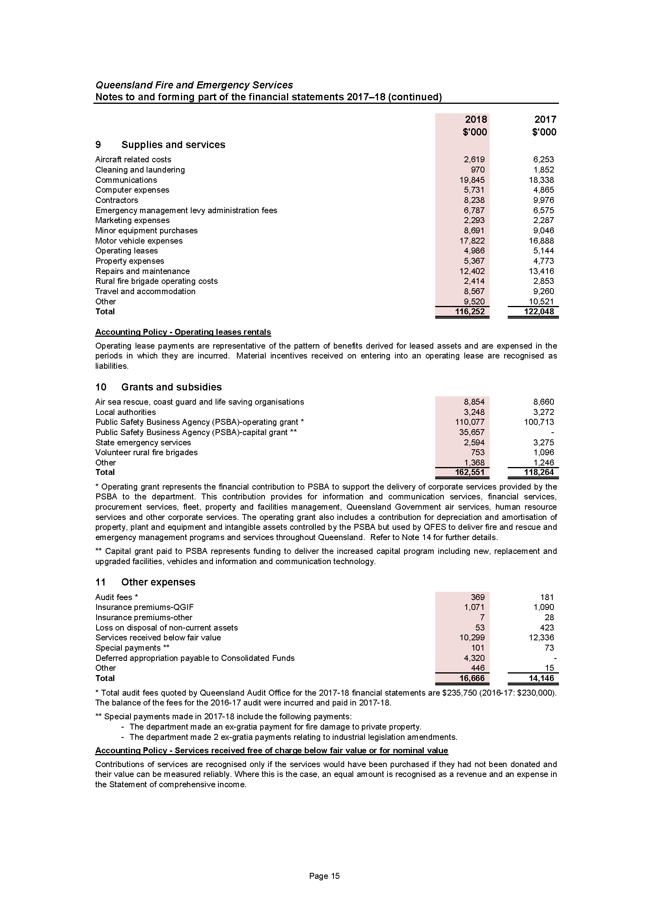
Notes to and forming part of the financial statements
2017–18 (cont’d)
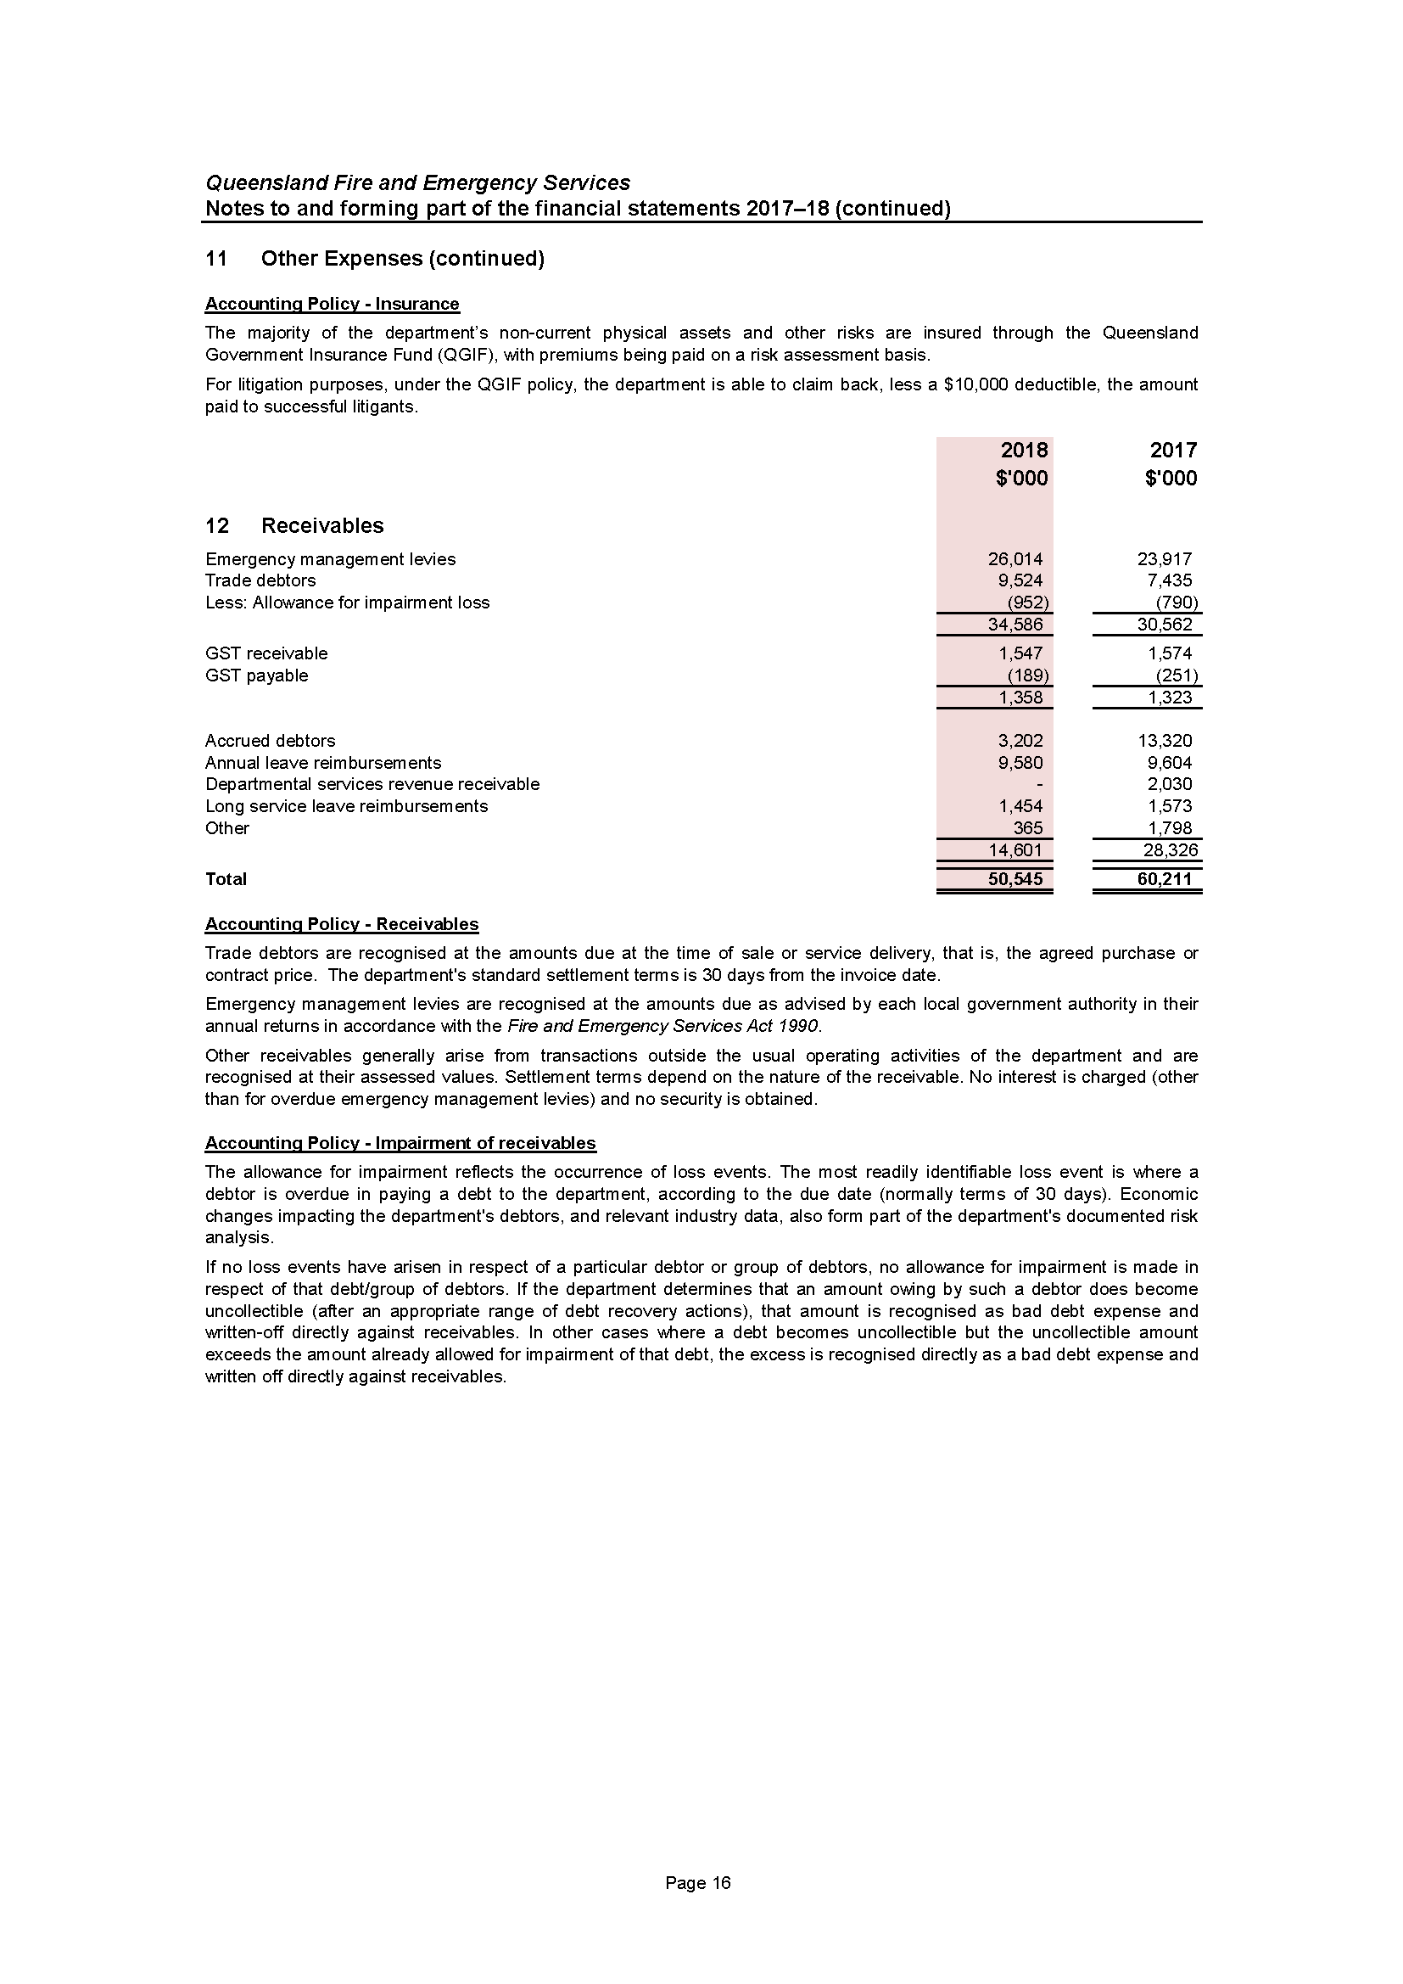
Notes to and forming part of the financial statements
2017–18 (cont’d)
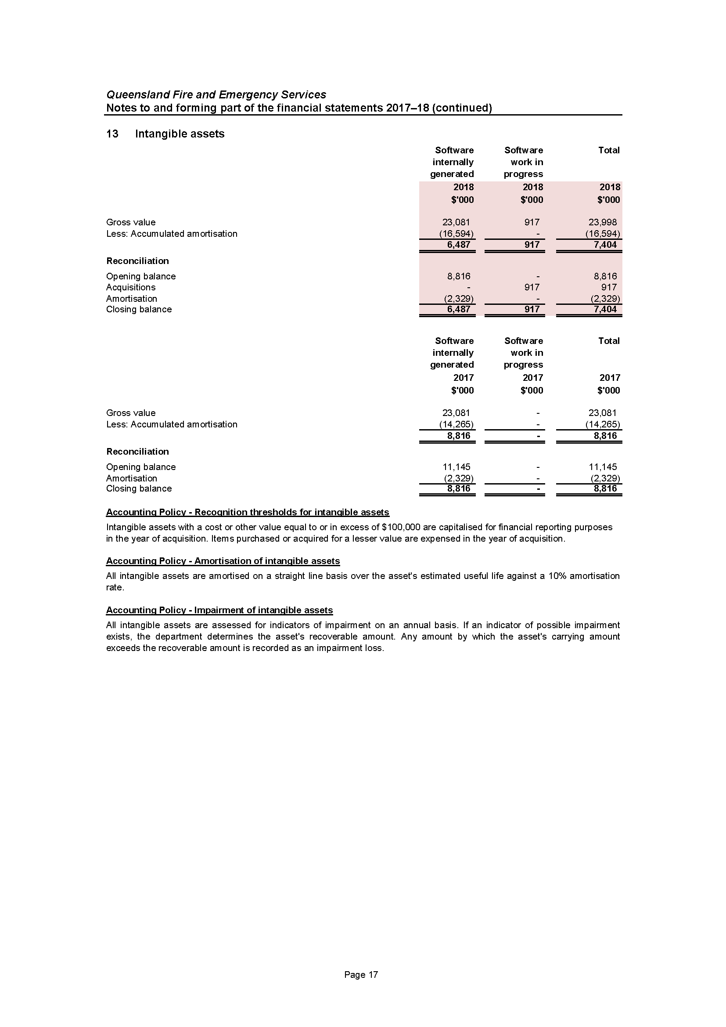
Notes to and forming part of the financial statements
2017–18 (cont’d)
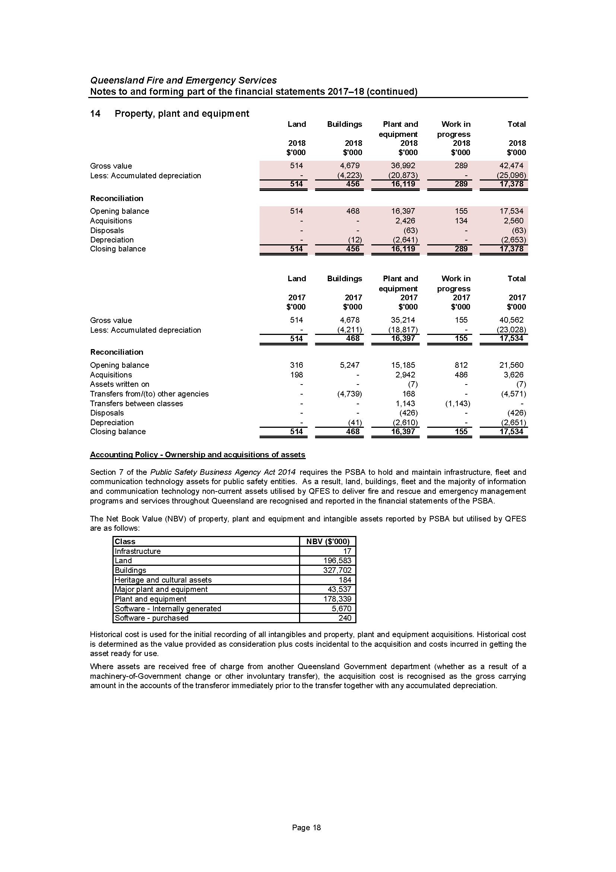
Notes to and forming part of the financial statements
2017–18 (cont’d)
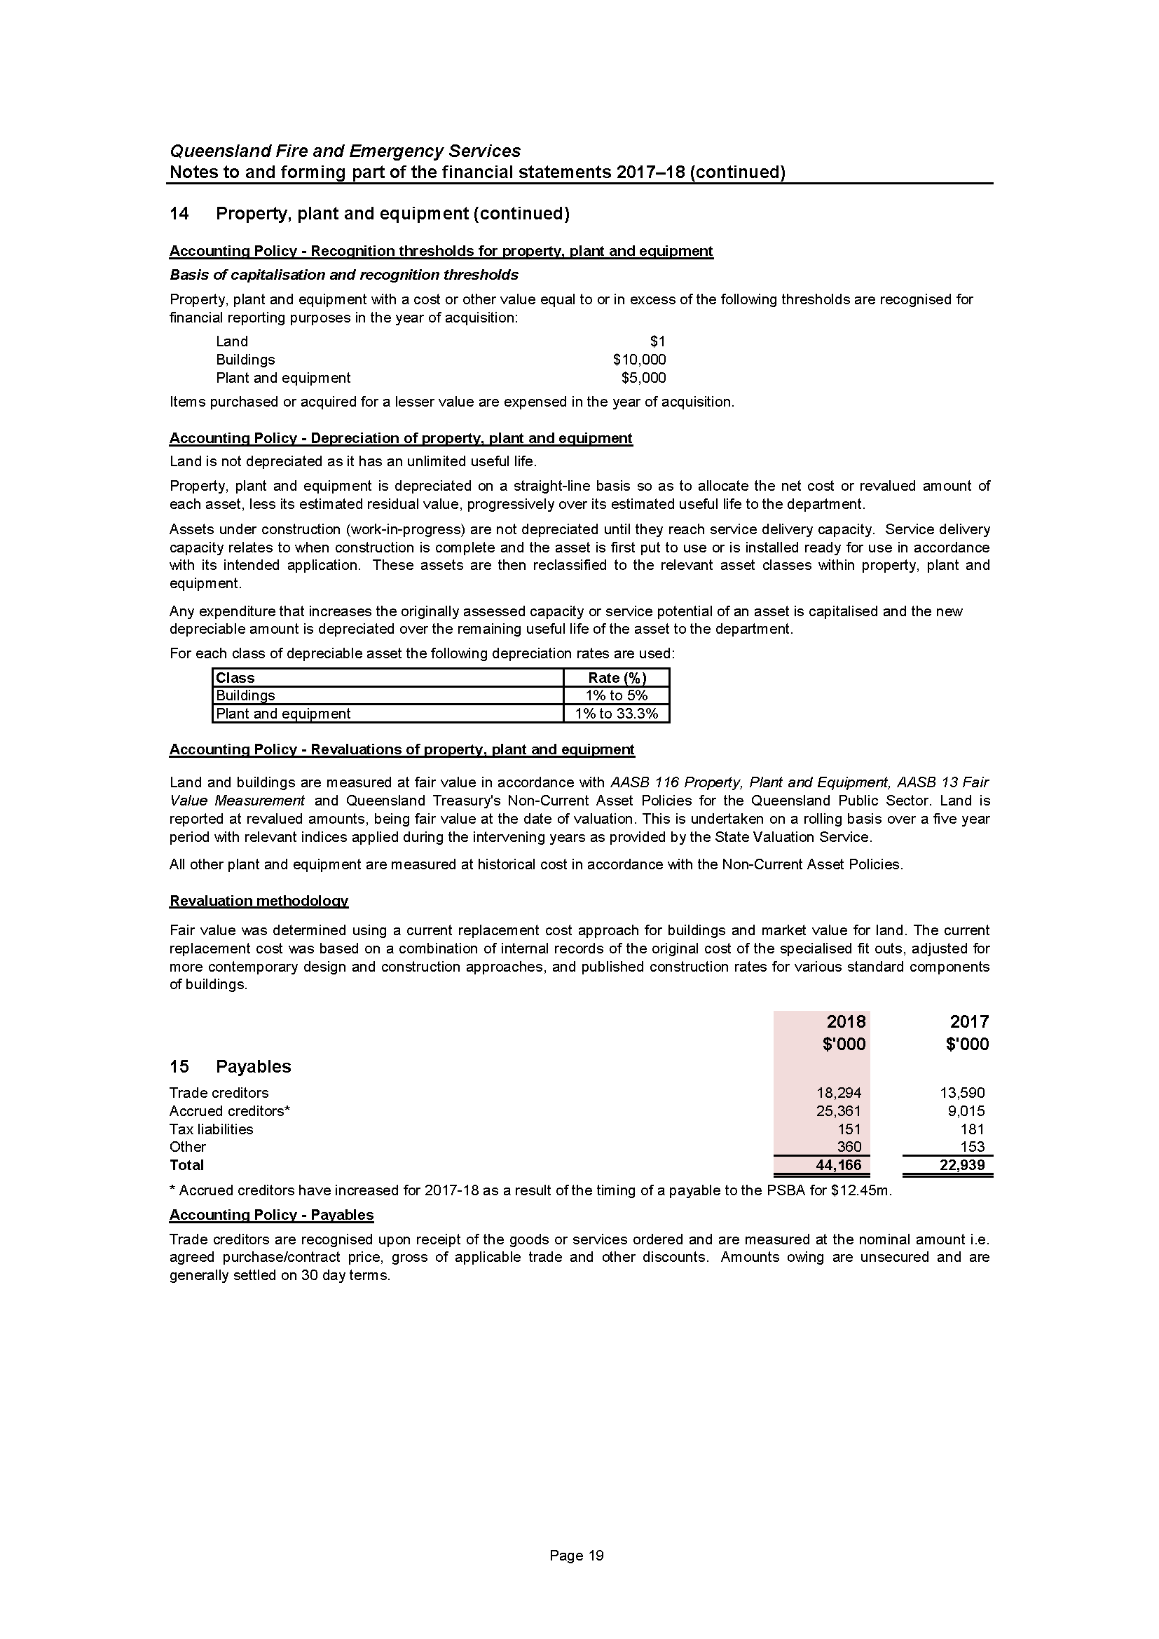
Notes to and forming part of the financial statements
2017–18 (cont’d)
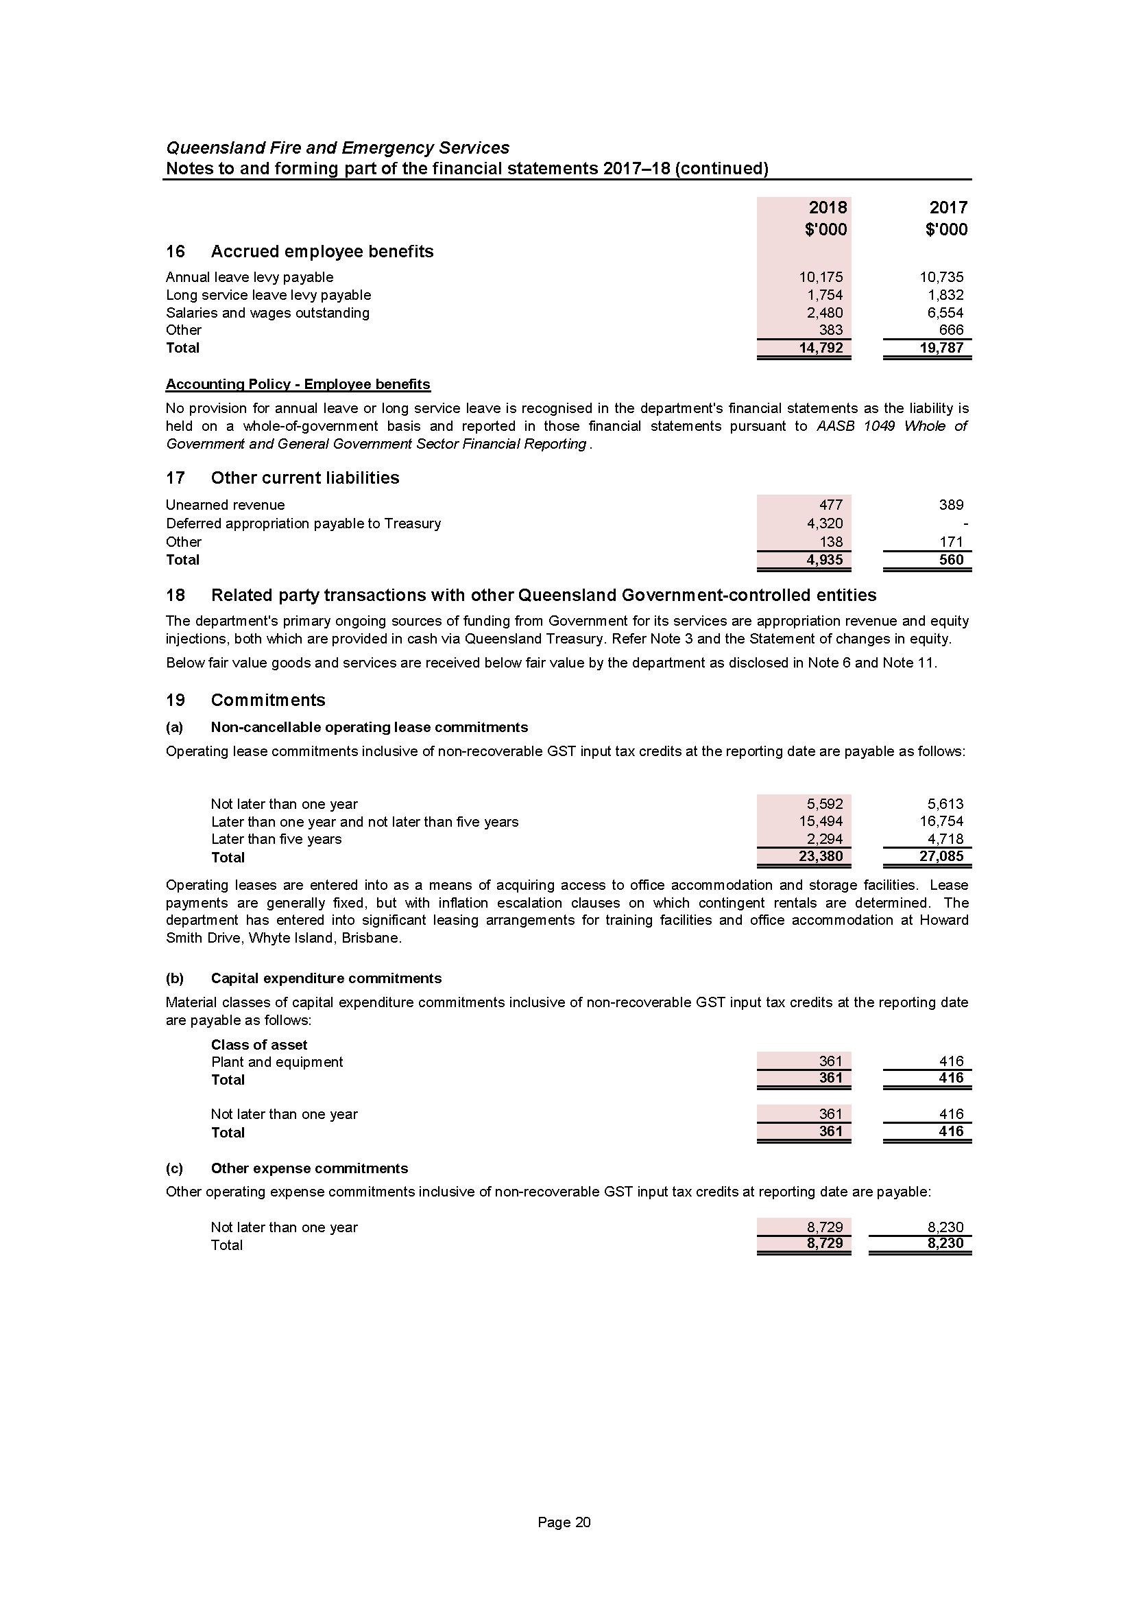
Notes to and forming part of the financial statements
2017–18 (cont’d)
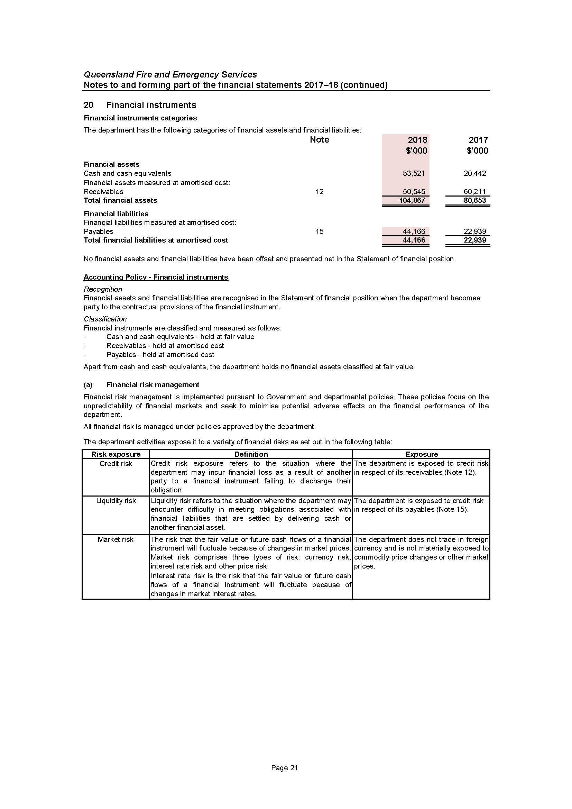
Notes to and forming part of the financial statements
2017–18 (cont’d)
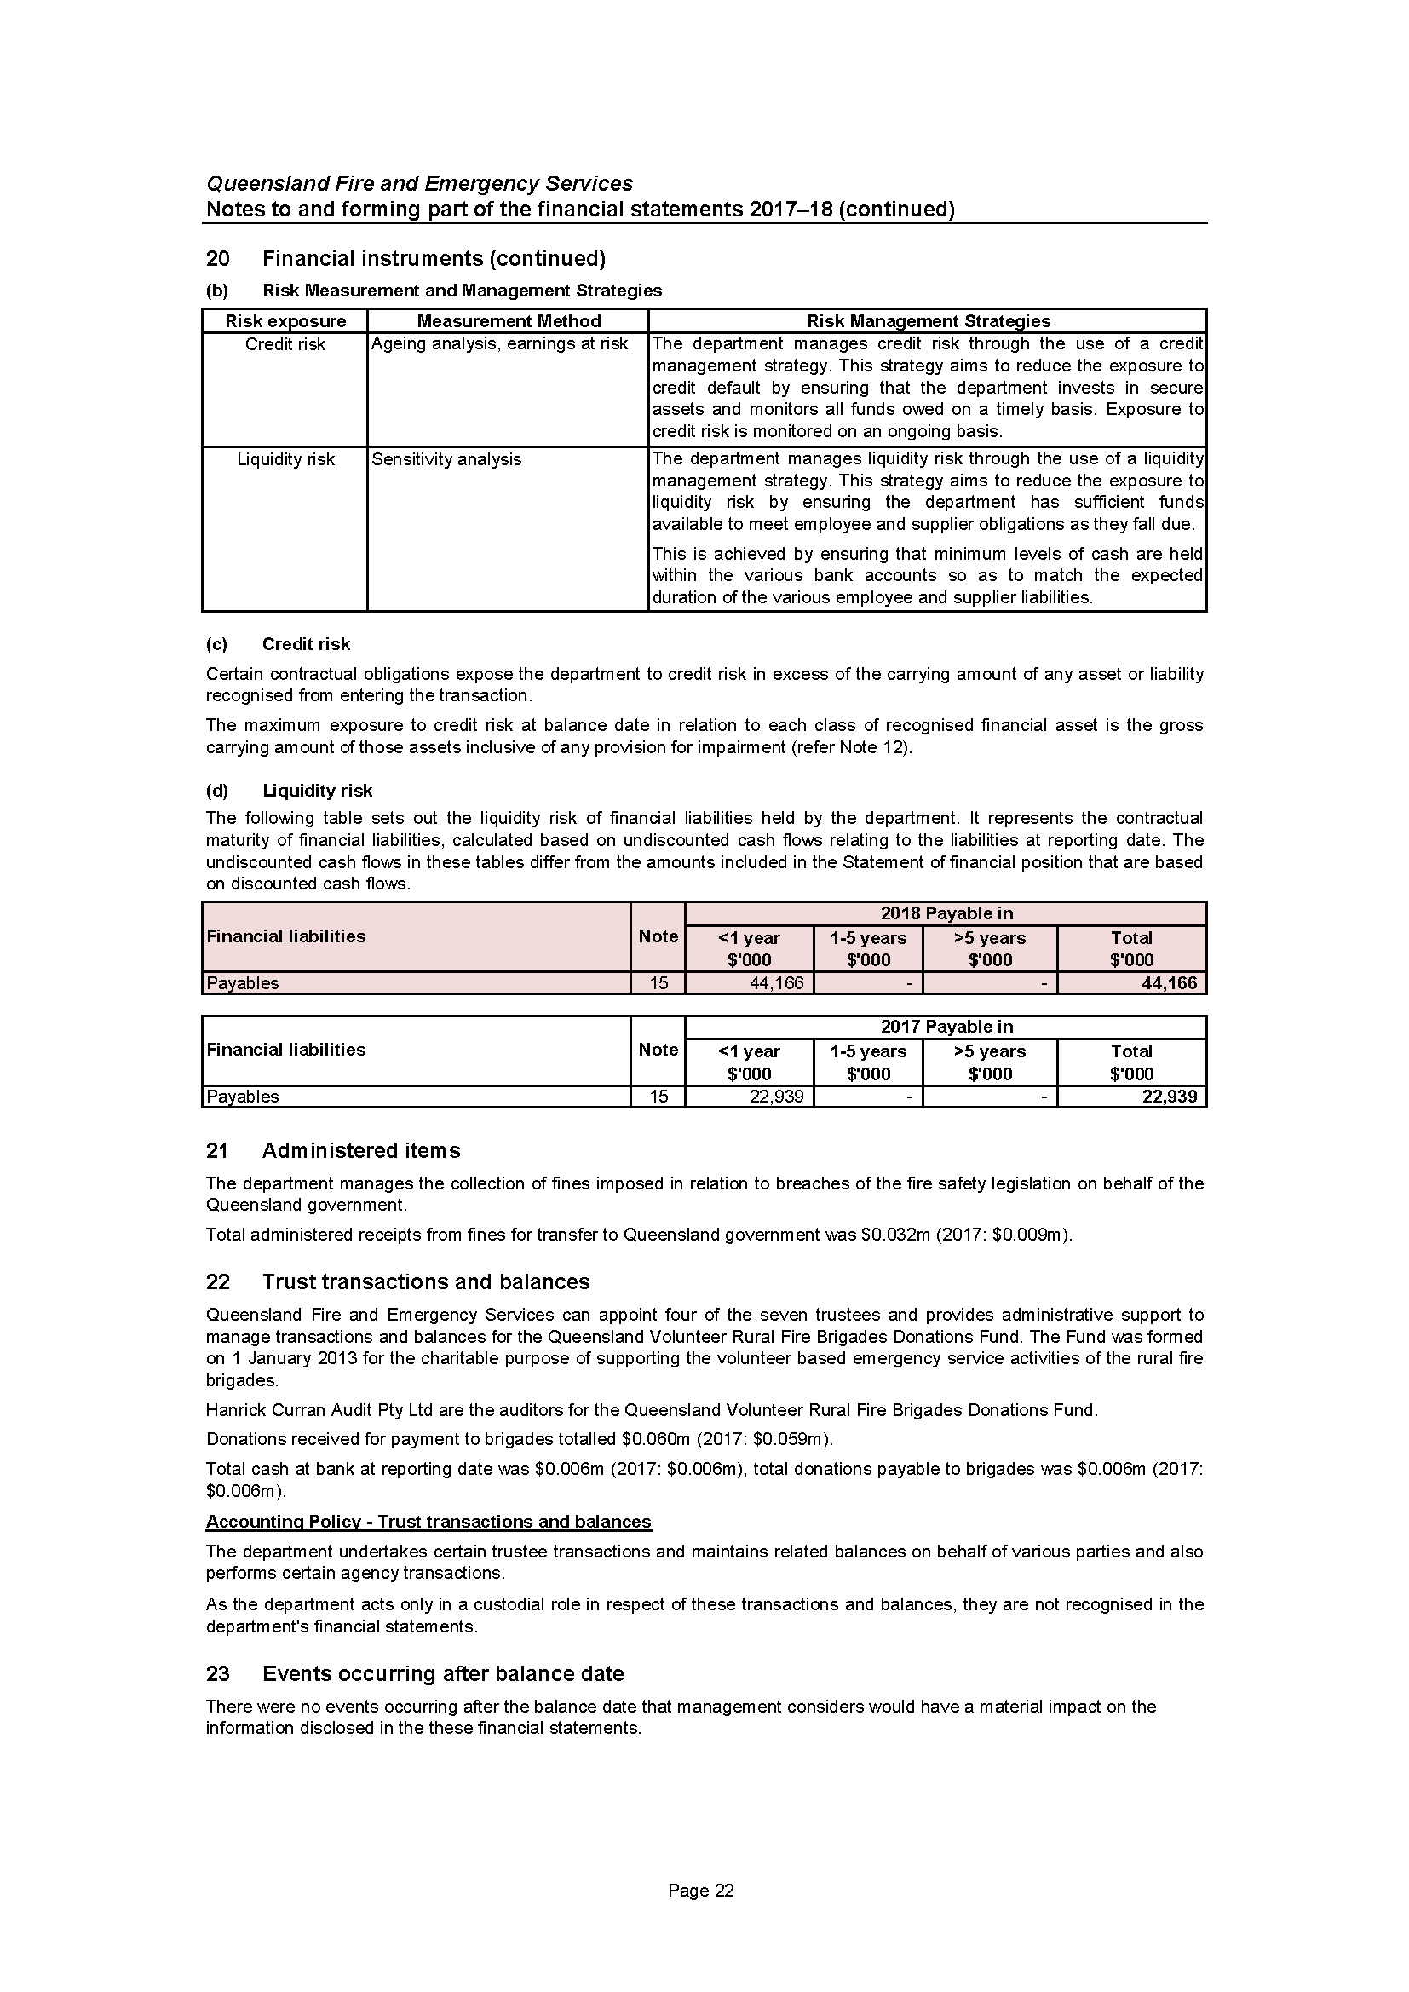
Notes to and forming part of the financial statements
2017–18 (cont’d)
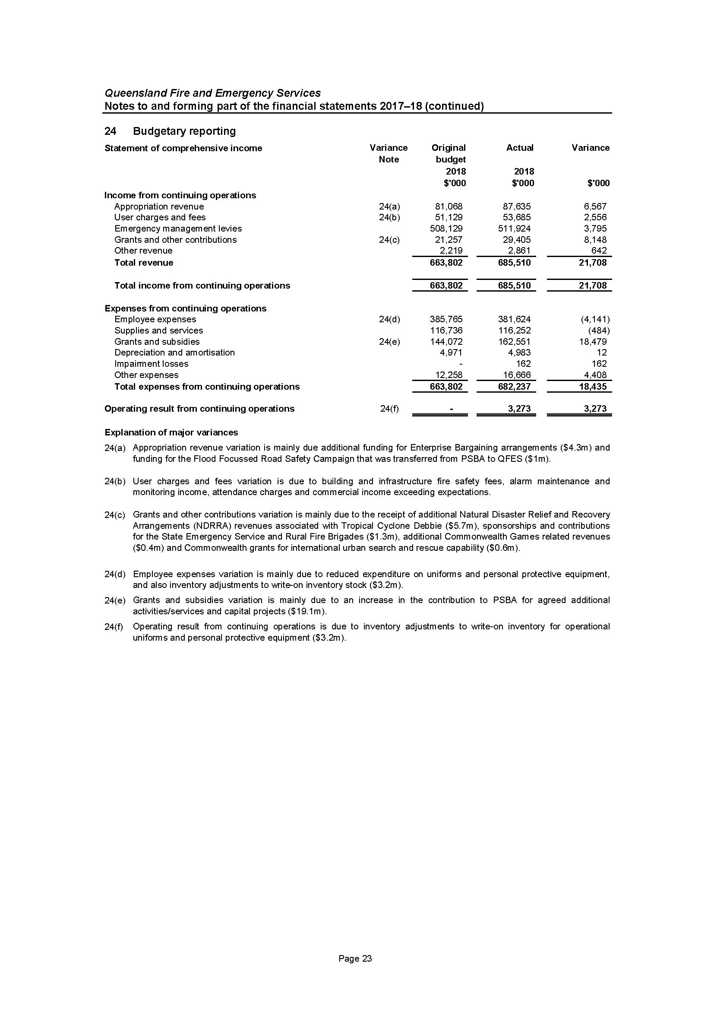
Notes to and forming part of the financial statements
2017–18 (cont’d)
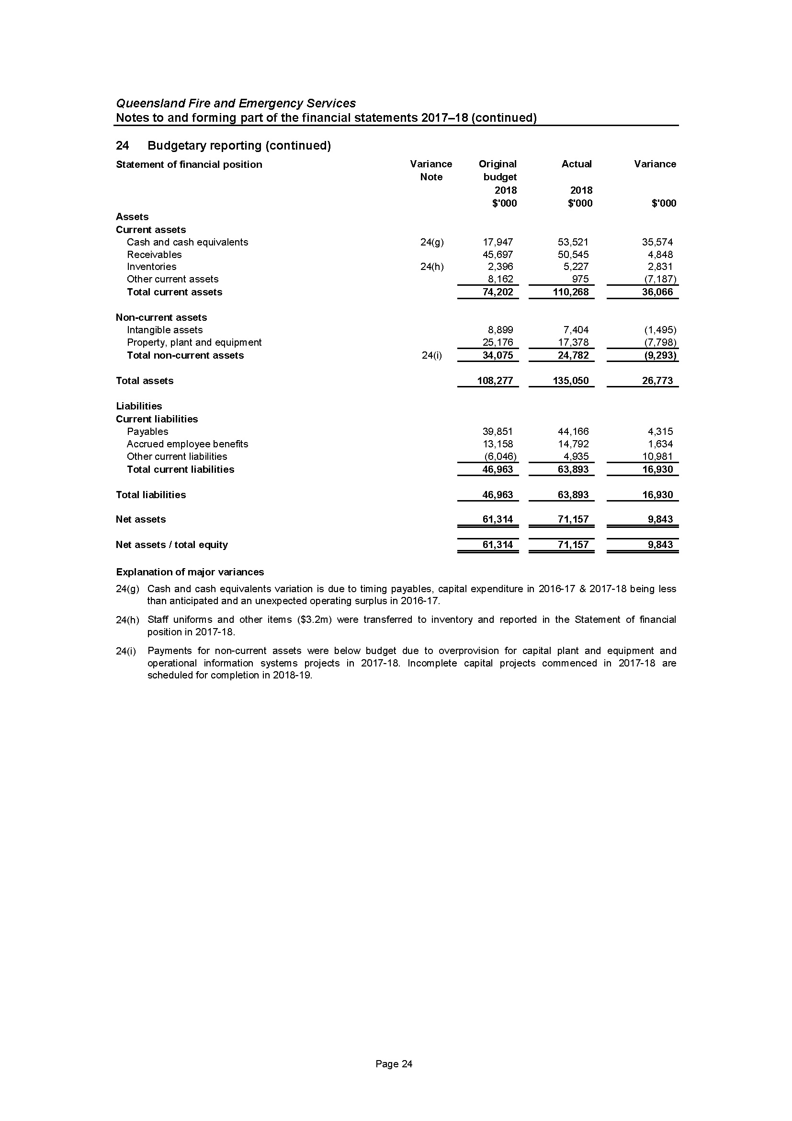
Notes to and forming part of the financial statements
2017–18 (cont’d)
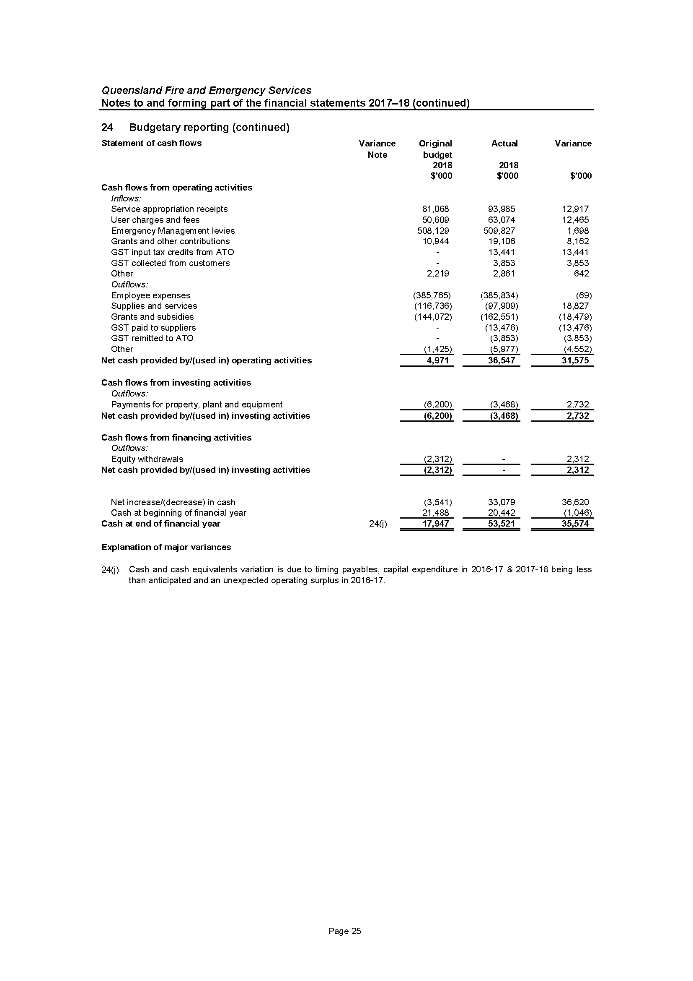

Management Certificate
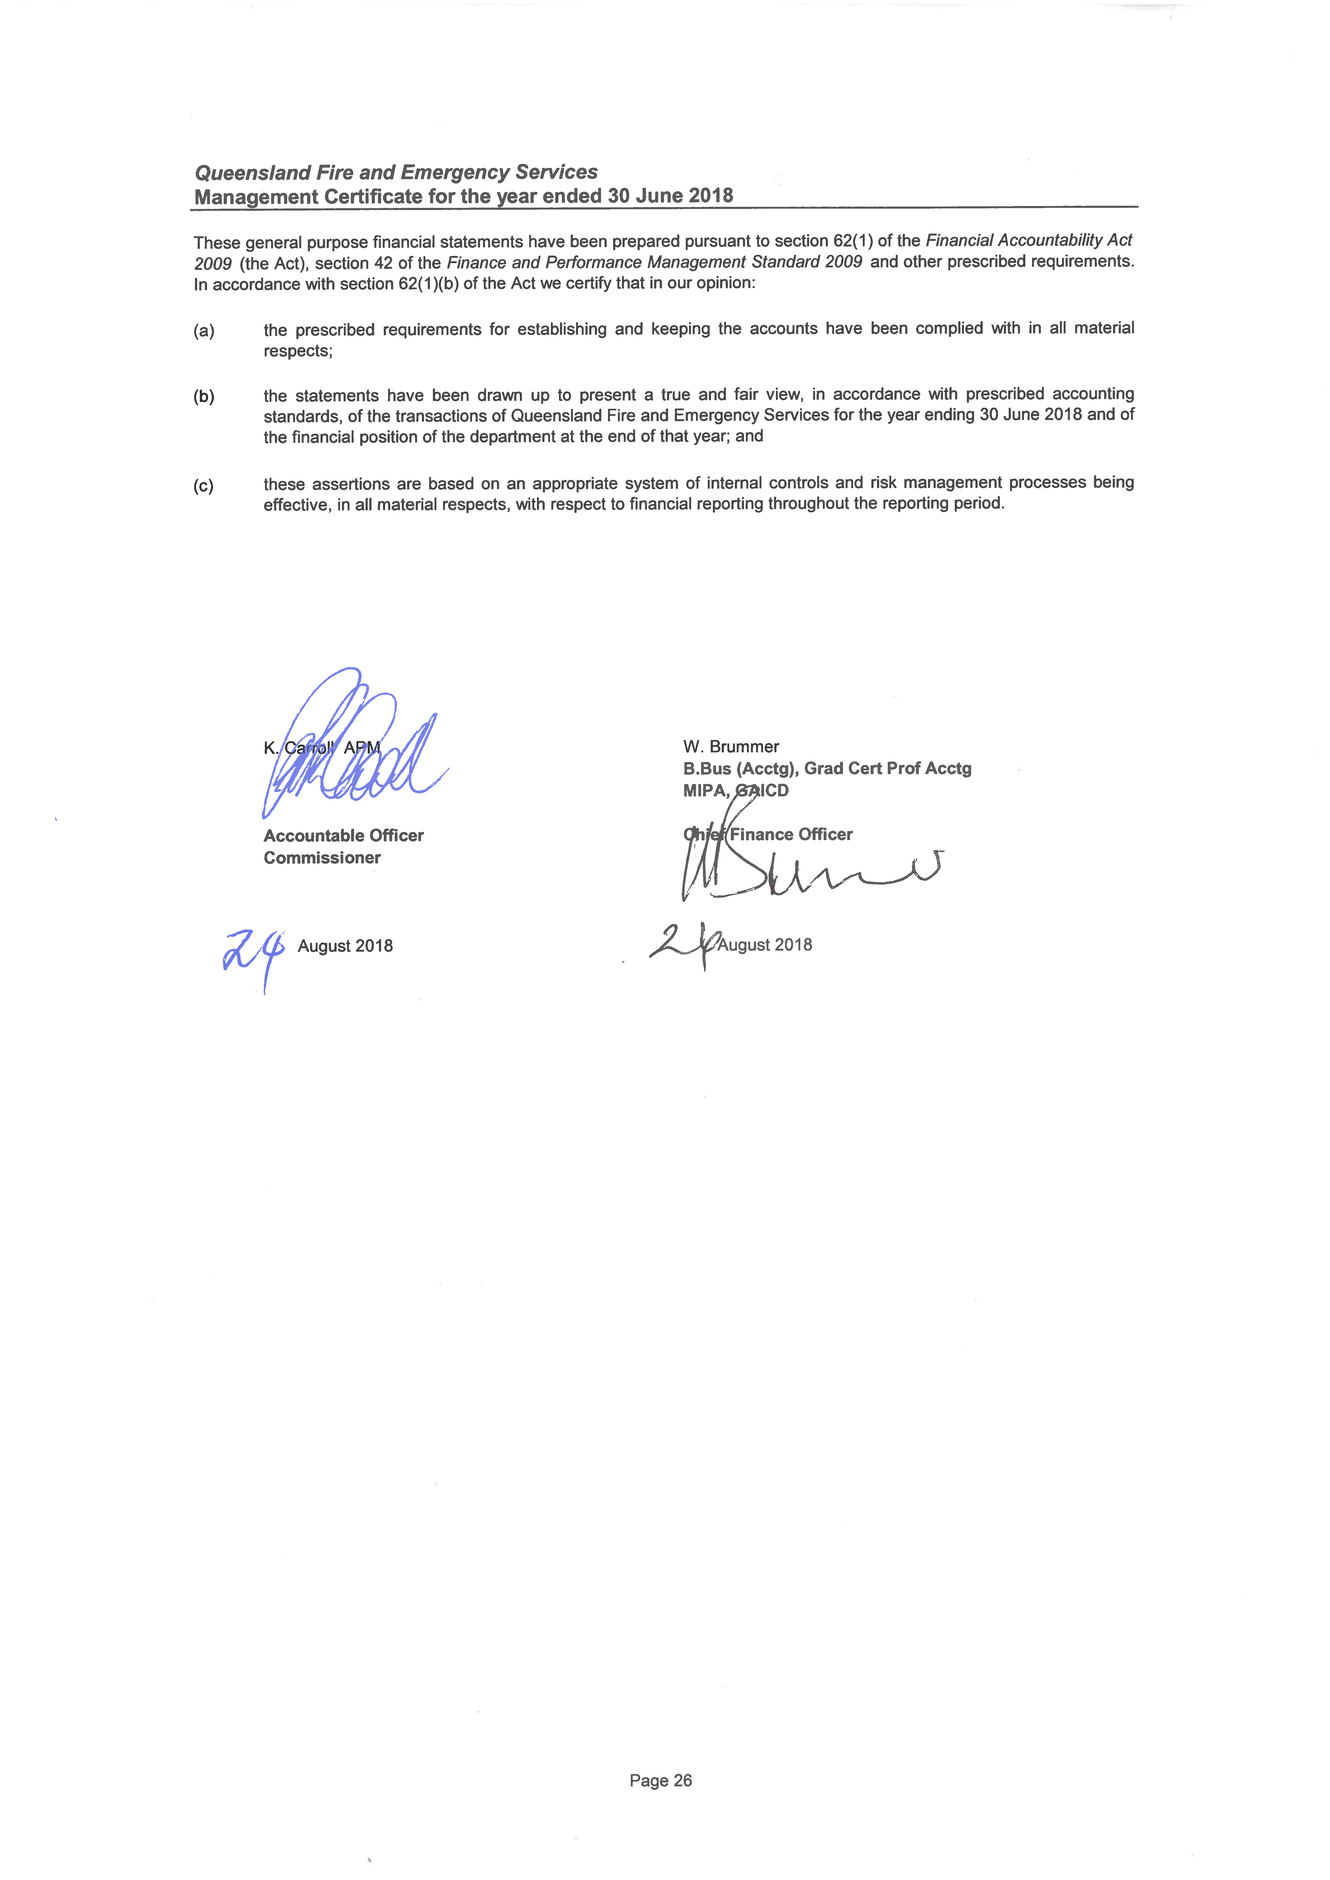

Independent Auditor’s report
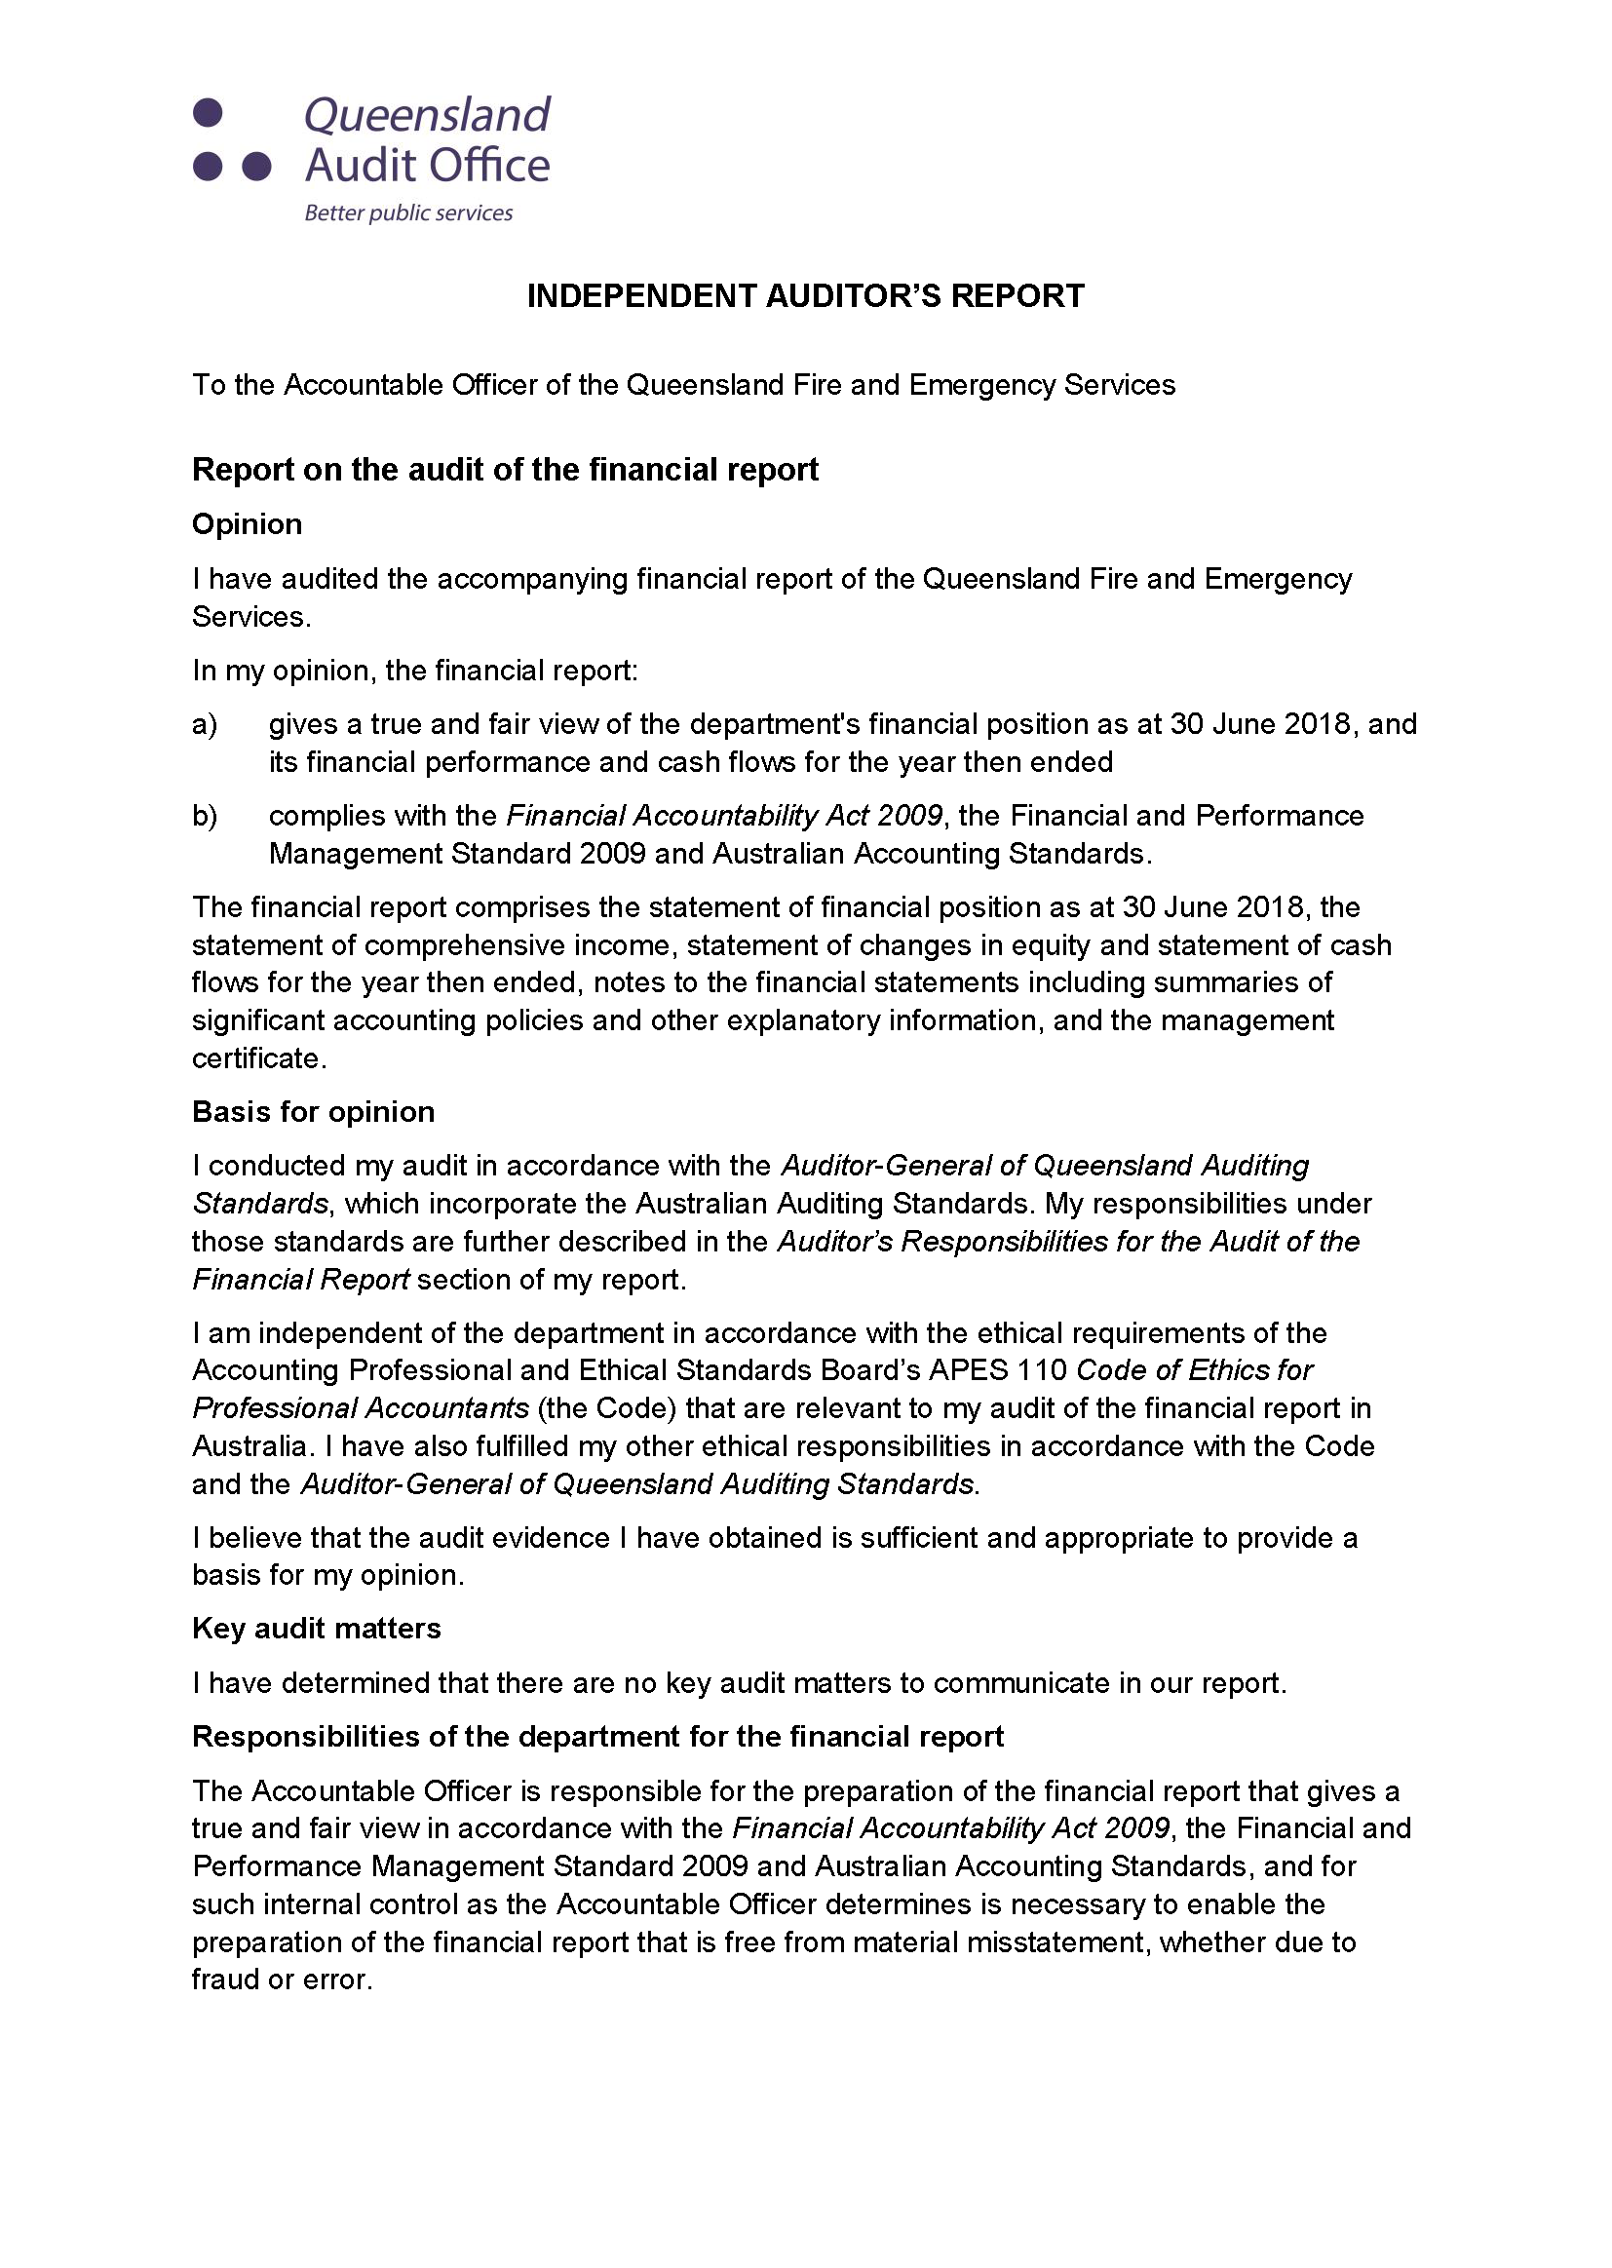
Independent Auditor’s report (cont’d)
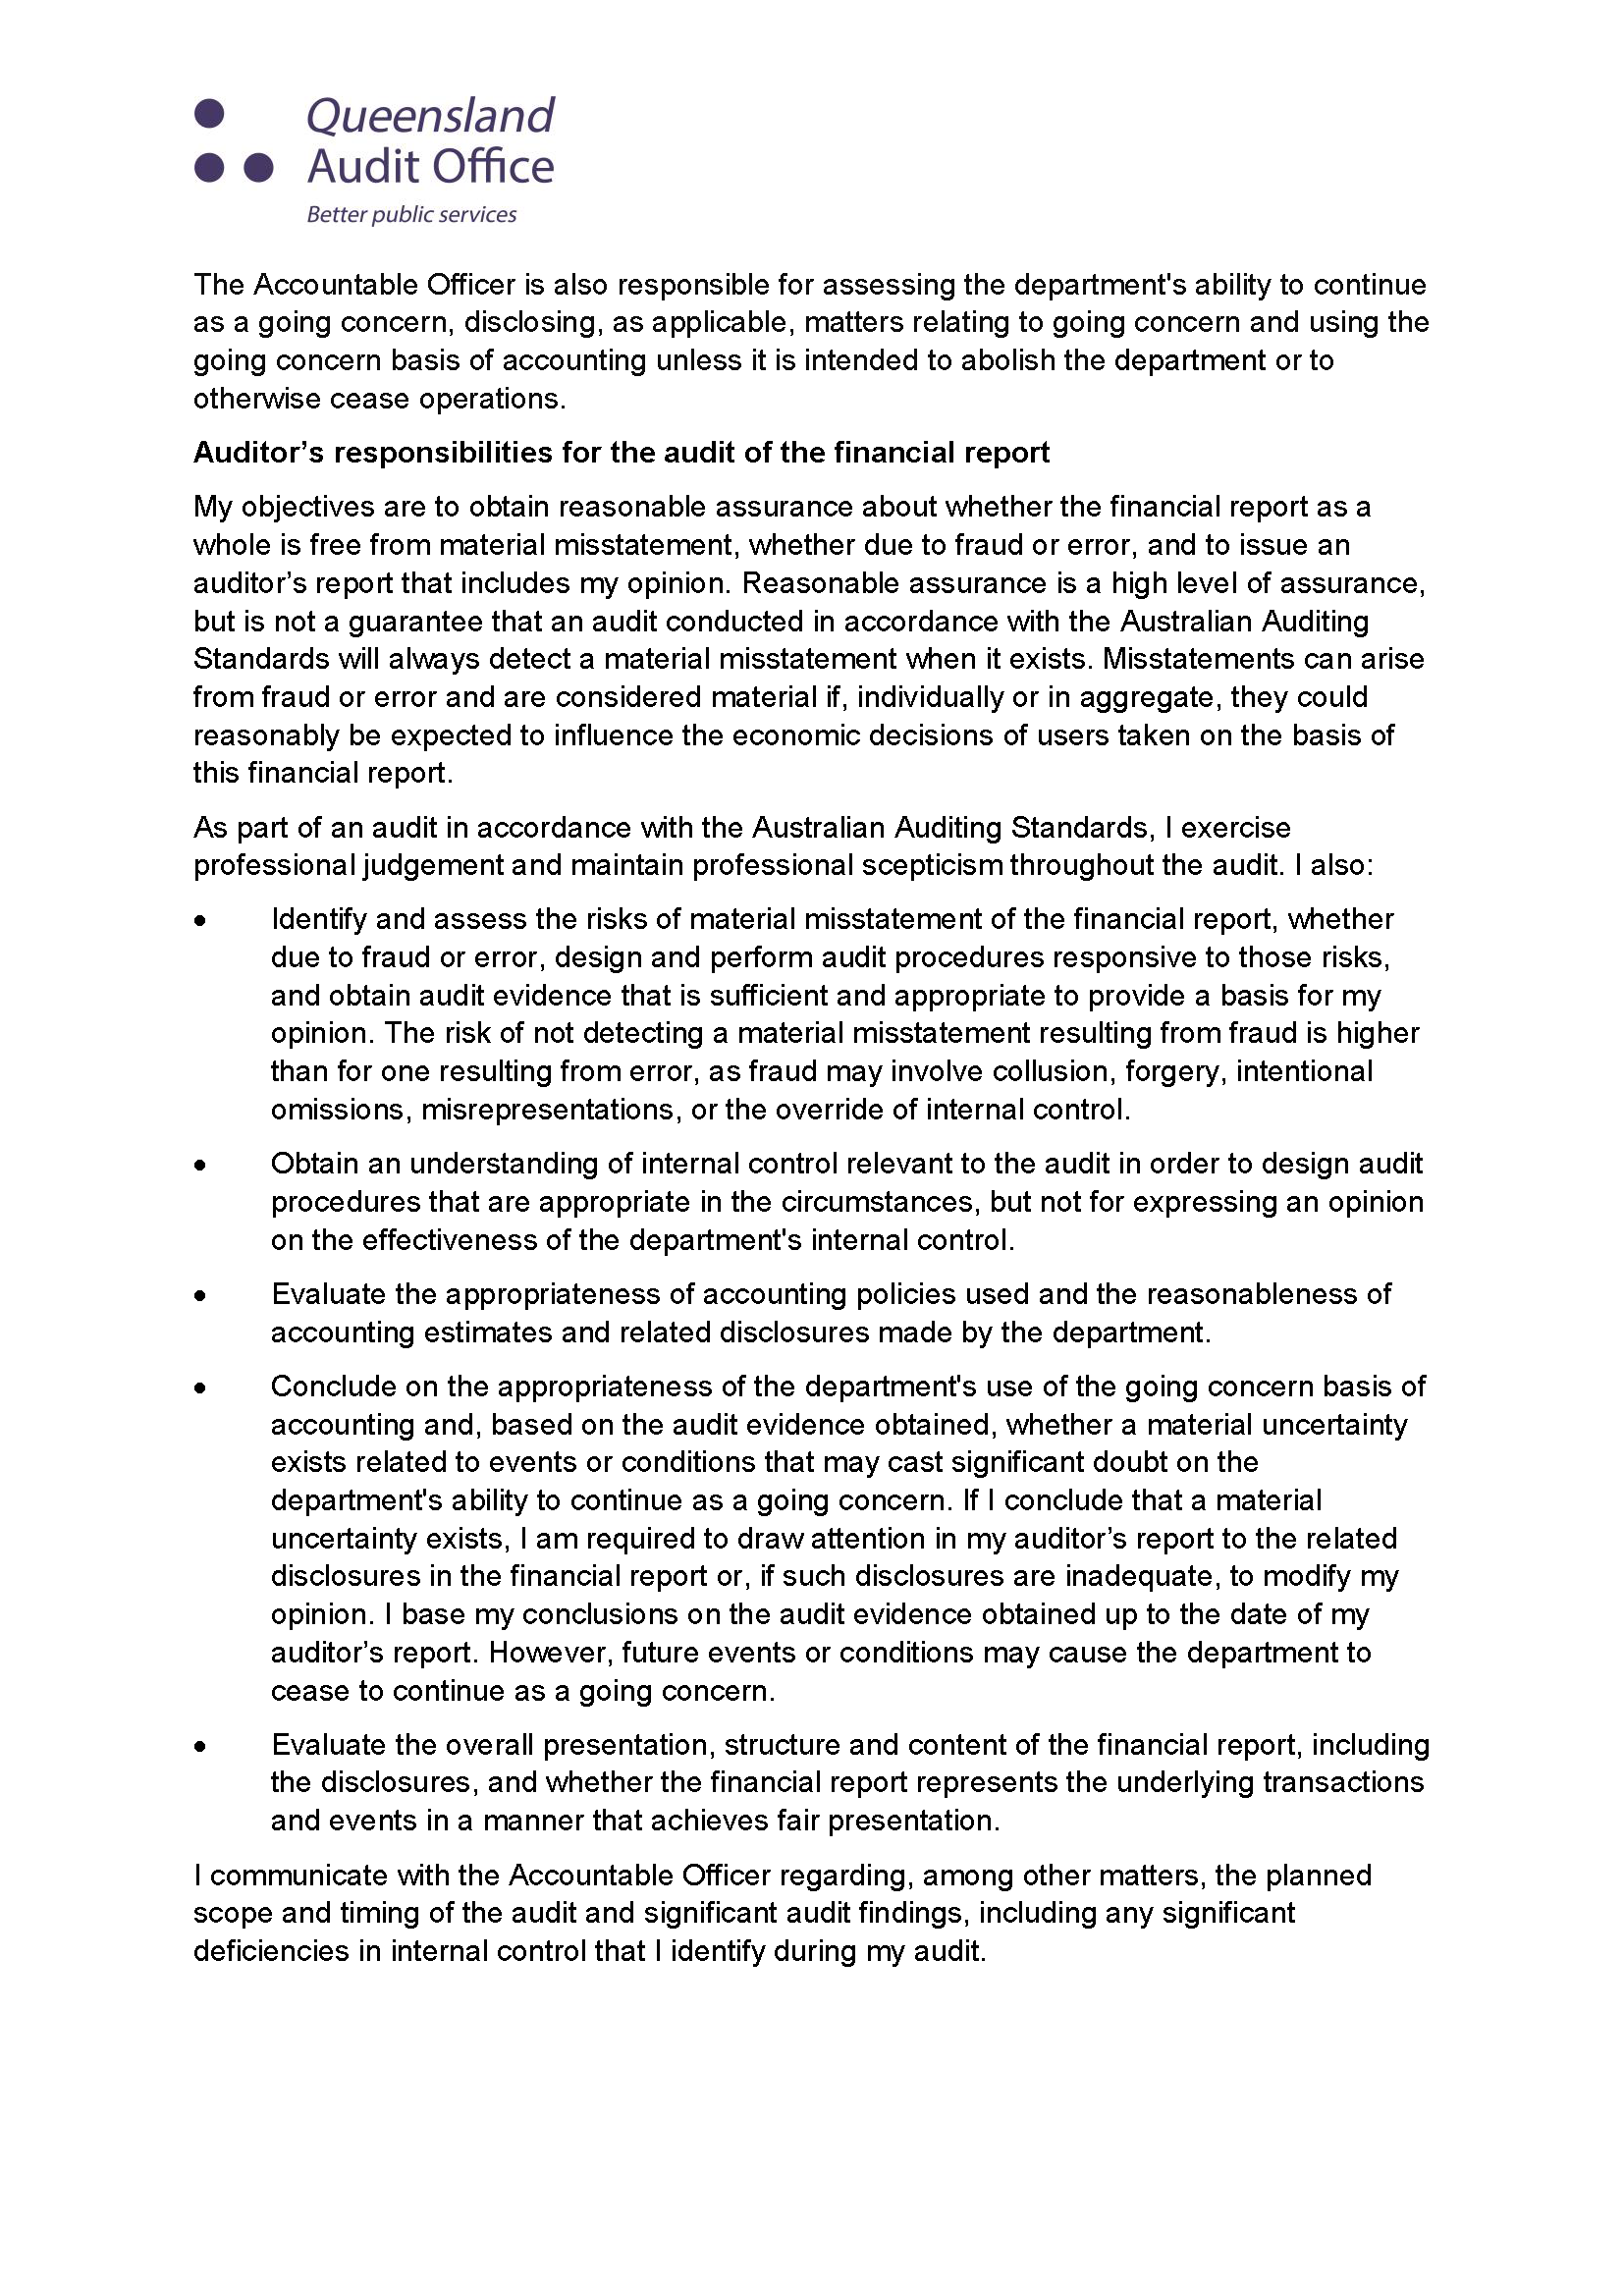

Independent Auditor’s report (cont’d)
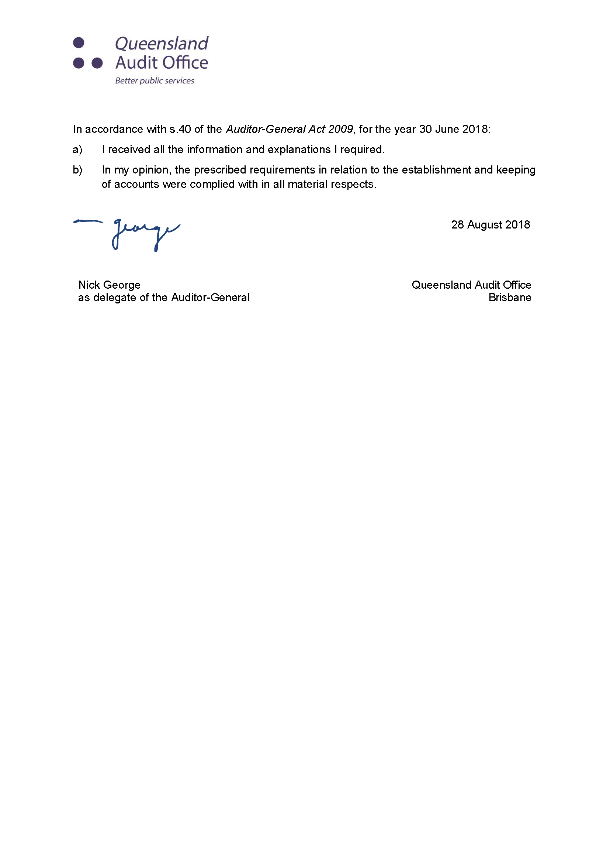

Appendices

Acronyms
AED | Automatic External Defibrillator |  | FESSN | Fire and Emergency Services Support Network
AFAC | Australasian Fire and Emergency Service Authorities Council |  | FFF | Fight Fire Fascination
AFFF | Aqueous Film Forming Foam |  | FRNSW | Fire and Rescue New South Wales
ANZEMC | Australia-New Zealand Emergency Management Committee |  | FRS | Fire and Rescue Service
ARCC | Audit, Risk and Compliance Committee |  | GC2018 | Gold Coast 2018 Commonwealth Games
ARRs | Annual report requirements for Queensland Government agencies |  | GST | Goods and Services Tax
AVCGA | Australian Volunteer Coast Guard Association |  | HCM | Human Capital Management
BAB | Budget Accommodation Building |  | HRIS | Human Resource Information Solution
BNHCRC | Bushfire and Natural Hazards Cooperative Research Centre |  | ICT | Information and Communication Technology
BoM | Board of Management |  | IGEM | Inspector-General Emergency Management
CAD | Computer Aided Dispatch |  | IMU | Information Management Unit
CAF | Compressed Air Foam |  | INSARAG | International Search and Rescue Advisory Group
CCC | Crime and Corruption Commission |  | LGAQ | Local Government Association of Queensland
DART | Disaster Assistance Response Team |  | MDA | Multicultural Development Australia Ltd
eDRMS | Electronic Document and Records Management System |  | MoU | Memorandum of Understanding
ELT | Executive Leadership Team |  | MSRC | Motorised Swiftwater Rescue Craft
EVP | Emergency Vehicle Priority |  | NAIDOC | National Aborigines and Islanders Day Observance Committee
Acronyms (cont’d)
NFDRS | National Fire Danger Rating System |  | RFS | Rural Fire Service
PCYC | Police-Citizens Youth Club |  | RIPE | Regional Integrated Planning Executive
PFAS | Per- and poly- fluoroalkyl substances |  | RLSSQ | Royal Life Saving Society Queensland
PPRR | Prevention, preparedness, response and recovery |  | RoGS | Report on Government Services
PSBA | Public Safety Business Agency |  | RPAS | Remotely Piloted Aerial Systems
QAO | Queensland Audit Office |  | SABRE | Simulation Analysis-based Risk Evaluation
QAS | Queensland Ambulance Service |  | SDCC | State Disaster Coordination Centre
QDMTF | Queensland Disaster Management Training Framework |  | SES | State Emergency Service
QERMF | Queensland Emergency Risk Management Framework |  | SFEST | School of Fire and Emergency Services Training
QFES | Queensland Fire and Emergency Services |  | SLSQ | Surf Life Saving Queensland
QLDSESVA | Queensland State Emergency Service Volunteer Association Inc. |  | SOC | State Operations Centre
QPS | Queensland Police Service |  | TEM | Training and Emergency Management
QPWS | Queensland Parks and Wildlife Service |  | UCC | USAR Coordination Cell
QRA | Queensland Reconstruction Authority |  | USAR | Urban Search and Rescue
QUT | Queensland University of Technology |  | VCE | Volunteer Community Educator
RAAP | Road Attitudes and Action Planning |  | VMRAQ | Volunteer Marine Rescue Association Queensland
REDI-PORTAL | Risk Evaluation and Disaster Information Portal |  | WBT | Workplace Behaviour Training
RFBAQ | Rural Fire Brigades Association Queensland Inc. |  | WfQ | Working for Queensland

Compliance checklist
Summary of requirement |  |  | Basis for requirement |  | Page reference
Letter of compliance | - A letter of compliance from the accountable officer to the Minister | ARRs – section 7 |  | iii
Accessibility | - Table of contents  - Acronyms | ARRs – section 9.1 |  | 1  122–123
 | - Public availability | ARRs – section 9.2 |  | ii
 | - Interpreter service statement | Queensland Language Services Policy  ARRs – section 9.3 |  | ii
 | - Copyright notice | Copyright Act 1968  ARRs – section 9.4 |  | ii
 | - Information Licensing | Queensland Government Enterprise Architecture – Information Licensing  ARRs – section 9.5 |  | ii
General information | - Introductory information | ARRs – section 10.1 |  | 2–15
 | - Machinery-of-government changes | ARRs – sections 31 and 32 |  | N/A
 | - Agency role and main functions | ARRs- section 10.2 |  | 4–15, 126
 | - Operating environment | ARRs – section 10.3 |  | 4–15
Non-financial performance | - Government’s objectives for the community | ARRs – section 11.1 |  | 6–7, 25–66
 | - Other whole-of-government plans/specific initiatives | ARRs – section 11.2 |  | 25–66
 | - Agency objectives and performance indicators | ARRs – section 11.3 |  | 6–7, 18–24
 | - Agency service area and service standards | ARRs – section 11.4 |  | 18–24
Financial performance | - Summary of financial performance | ARRs – section 12.1 |  | 16–17
Governance – management and structure | - Organisational structure | ARRs – section 13.1 |  | 13–14
 | - Executive management | ARRs – section 13.2 |  | 67–81
 | - Government bodies (statutory bodies and other entities) | ARRs – section 13.3 |  | N/A
 | - Public Sector Ethics Act 1994 | Public Sector Ethics Act 1994  ARRs – section 13.4 |  | 82–83
 | - Queensland public service values | ARRs – section 13.5 |  | 8

Compliance checklist (cont’d)
 |  |  |  | Summary of requirement |  |  | Basis for requirement |  | Page reference
 |  |  | Governance – risk management and accountability |  | - Risk management | ARRs – section 14.1 |  | 72–73, 80–81, 89
 |  |  |  |  | - Audit committee | ARRs – section 14.2 |  | 72–73, 80–81
 |  |  |  |  | - Internal audit | ARRs – section 14.3 |  | 87–88
 |  |  |  |  | - External scrutiny | ARRs – section 14.4 |  | 84–87
 |  |  |  |  | - Information systems and recordkeeping | ARRs – section 14.5 |  | 88–89
 |  | Governance – human resources |  |  | - Strategic workforce planning and performance | ARRs – section 15.1 |  | 90–93
 |  |  |  |  | - Early retirement, redundancy and retrenchment | Directive No.16/16 Early Retirement, Redundancy and Retrenchment (20 May 2016 – 10 May 2018)  Directive No.04/18 Early Retirement, Redundancy and Retrenchment (from 11 May 2018)  ARRs – section 15.2 |  | 93
 | Open Data |  |  |  | - Statement advising publication of information | ARRs – section 16 |  | ii
 |  |  |  |  | - Consultancies | ARRs – section 33.1 |  | https://data.qld.gov.au
 |  |  |  |  | - Overseas travel | ARRs – section 33.2 |  | https://data.qld.gov.au
 |  |  |  |  | - Queensland Language Services Policy | ARRs – section 33.3 |  | https://data.qld.gov.au
Financial statements |  |  |  |  | - Certification of financial statements | Financial Accountability Act 2009 – section 62  Financial and Performance Management Standard 2009 – sections 42, 43 and 50  ARRs – section 17.1 |  | 118
 |  |  |  |  | - Independent Auditor’s Report | Financial Accountability Act 2009 – section 62  Financial and Performance Management Standard 2009 – section 50  ARRs – section 17.2 |  | 119–121

Contacts and key locations
State Office | Emergency Services Complex  Cnr Park and Kedron Park Roads  Kedron Qld 4031 |  | GPO Box 1425  Brisbane Qld 4001 | 13 QGOV  (13 74 68)
Brisbane Region | Emergency Services Complex  Cnr Park and Kedron Park Roads  Kedron Qld 4031 |  | GPO Box 2953  Brisbane Qld 4001 | (07) 3635 1921
Central Region | Level 3  34 East Street  Rockhampton Qld 4700 |  | PO Box 1531  Rockhampton Qld 4700 | (07) 4938 4891
Far Northern Region | Level 8  William McCormack Place 2  5b Sheridan Street  Cairns Qld 4870 |  | PO Box 920  Cairns Qld 4870 | (07) 4032 8759
North Coast Region | 98 Lennox Street  Maryborough Qld 4650 |  |  | (07) 4190 4818
Northern Region | Level 1  Citypoint Building  101 Sturt Street  Townsville Qld 4810 |  | PO Box 5845  Townsville Qld 4810 | (07) 4796 9023
South Eastern Region | 32 Tansey Street  Beenleigh Qld 4207 |  | PO Box 927  Beenleigh Qld 4207 | (07) 3287 8510
South Western Region | 19 Steger Road  Charlton Qld 4350 |  |  | (07) 4592 5201
RFS | Emergency Services Complex  Cnr Park and Kedron Park Roads  Kedron Qld 4031 |  | GPO Box 1425  Brisbane Qld 4001 | (07) 3635 3834
SES | Emergency Services Complex  Cnr Park and Kedron Park Roads  Kedron Qld 4031 |  | GPO Box 1425  Brisbane Qld 4001 | (07) 3635 3441
Flood/Storm Emergency |  | www.132500.qld.gov.au |  | 132 500
Area offices and local stations: QFES has a network of area offices and fire and rescue stations located throughout Queensland. You can locate or contact your nearest office or station by calling 13 QGOV (13 74 68).
SES and rural fire brigades: for information relating to the SES and rural fire brigades contact 13 QGOV (13 74 68) or visit www.ruralfire.qld.gov.au or www.ses.qld.gov.au



